**How to Upload a Document**

For example, if you want to upload a document for a committee you are working on. This will be done by completing the following steps:

1. Go to the menu items at the top of the NCCSD website and select Documents
2. Then select the ***Committees***, in this example I select the ***Policy and Rules Committee,*** then select the folder, I select ***Reports*** folder.
3. Click the ***Import Document*** icon, select the document from your computer to upload to the reports folder.

_________________________________________________________________

* Select Documents on this screen select ***Committees***.  
    
  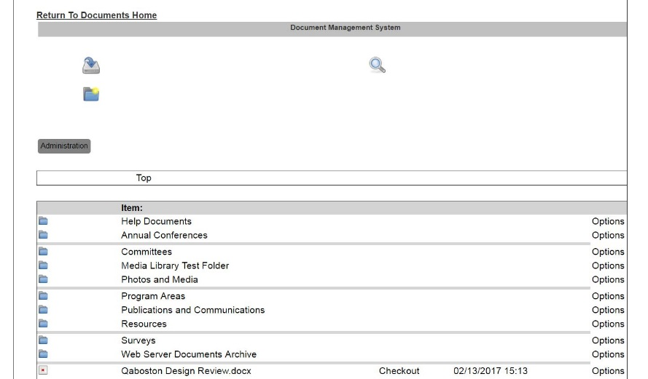
* Select the committee folder where you want to store the document you are uploading. I am selecting ***Policy and Rules Committee***.  
  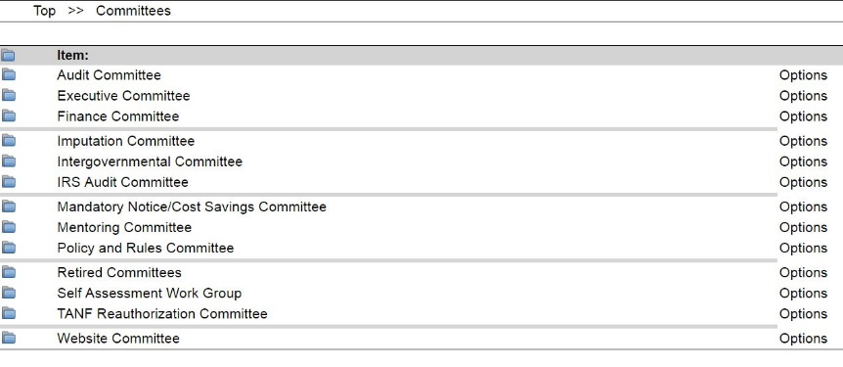
* Select the folder type where you want to store your document. I am selecting ***Reports***.  
  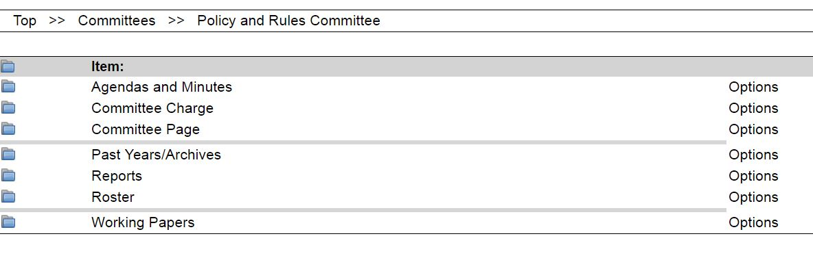
* Click on the Import Document Icon.

C:\Users\llg41795\Desktop\Import Document icon.JPG.

* Click on the ***Choose File*** button and select the document from your computer that you want to upload to your committee folder. Fill in   
    
  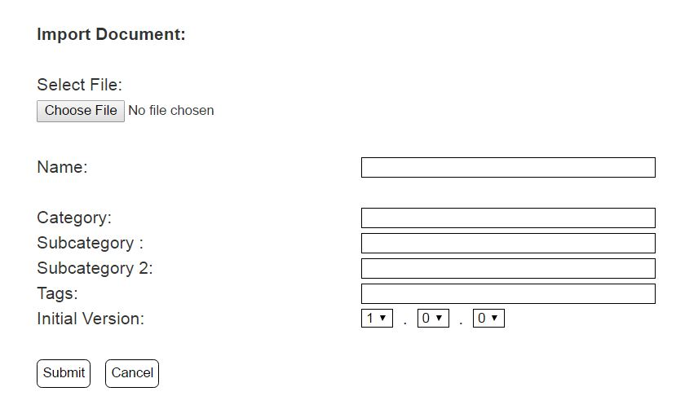
* Fill in the Name of the document, and then go to the documents menu on the website. Click on committees, click on website committee, click on working papers, click on website taxonomy.xlsx, this will download the taxonomy document, print for future reference. Use the taxonomy spreadsheet to fill in the Category, Subcategories, and tags.
* Congratulations, you have uploaded your document!