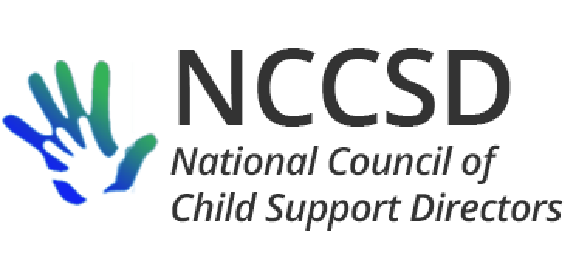

*August 8, 2019*

Invitation to Present an Educational Session for IV-D Directors

In 2018, the National Council of Child Support Directors (NCCSD) formed a workgroup to research current trends in statewide systems modernization, and provide guidance and recommendations to state IV-D programs on this topic.

In many instances, state program offices are the drivers in IT modernization to support their programs’ needs, but may lack the technological experience or expertise within their department to initiate such activity. The workgroup has been conducting research activities as well as collaborating with OCSE representatives regarding the current options and processes for system modernization. The workgroup believes that the involvement and input of our vendor community is an important knowledge base for us.

Therefore, the NCCSD Systems Modernization workgroup is interested in hosting vendor webinars on two different trends: 1) replatforming/refactoring and 2) “low code” COTS platforms. The audience for these webinars would be IV-D Directors and their IT leaders as well as OCSE DSTS staff. Please note that our purpose is strictly educational and not related to any type of procurement activity. This invitation is being sent to multiple vendors that the committee believes have expertise in these one or both of these two areas.

The workgroup has asked the IV-D Directors to hold the dates of October 18, 25 and November 1 between 1 and 4:30 pm EST. Each company who is interested would present in individual sessions for approximately 45 minutes, and would receive questions to be answered in advance. Demonstrations that would assist in the education purpose are welcome, but please note that these webinars are not to be seen as a sales opportunity. If your company is interested in participating, please complete and email the scanned document to cynthia.longest@acf.hhs.gov.

*Our company has experience in one or both of these approaches, and would be interested in presenting under the circumstances delineated above.*

*Company Name: ____________________________________*

*Company contact information: Contact Name: ________________________________*

*Email: ______________________________ Mobile: ____________________________*

*Please check one or both, as appropriate:*

*________ Refactoring and/or Replatforming*

*________ “Low code” COTS platforms*

If you have questions about this invitation prior to responding, please contact Cynthia Longest at the email address above. We look forward to hearing from you.

Sincerely,

Robin Arnell Carla West

Vermont IV-D Director North Carolina IV-D Director

Co-Chairs NCCSD Systems Modernization Workgroup

### President

Erin P. Frisch, Director

Office of Child Support

MI Dept. of Health and Human Services

201 N. Washington Ave., Suite 401

Lansing, MI 48933

(517)335-3519; (517)243-5998(cell)

[FrischE@michigan.gov](mailto:FrischE@michigan.gov)

#### Vice-President

James C. Fleming, Director

Child Support Division

Department of Human Services

P.O. Box 7190

Bismarck, ND 58507-7190

(701)328-7501; (701)328-6575 (fax)

[jfleming@nd.gov](mailto:jfleming@nd.gov)

## **Secretary**

Michele Cristello, Director

Child Support Enforcement Division

Department of Revenue

P.O. Box 9561

Boston, MA 02114-9561

(617)626-4042

[cristellom@dor.state.ma.us](mailto:cristellom@dor.state.ma.us)

**Treasurer**

Liesa Stockdale, Director

Office of Recovery Services

515 E 100 S, Ste 100

Salt Lake City, UT 84102

(801)536-8901

[lcorbri2@utah.gov](mailto:lcorbri2@utah.gov)