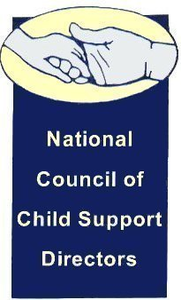

**Special Executive Committee Call**

**Monday April 6, 2015**

**4:30pm to 5:30 pm EDT**

**Dial-in: 877-679-7915 / Participant ID: 41038213**

**MINUTES**

1. Roll Call

Present were:

Sharon Santilli – President

Carol Eaton- Vice President

Jim Fleming - Treasurer

Region 1 – Mary Weatherill

Region 4 – Ann Coffin for Charles Bryson

Region 5- Erin Frisch

Region 7 – Byron Van Patten

Region 8 – Liesa Stockdale

Region 10 – Carol Beecher



1. **Vote-** Honorarium for Larry Desbiens’ wife Janice who passed away on April 2nd. Sharon made a motion to donate $100.00 to one of the charities listed in the obituary, “Imagine” for disabled children in honor of Janice Desbian. Carol Eaton seconded the Motion. All approved. The Motion carried. The committee discussed a possible amendment to the bylaws to include a provision for honorariums defining the relationships and specified amounts.
2. In the absence of Chair Wally McCLure, James Fleming presented a summary of the draft letter to OCSE regarding the Report to Congress and guided the discussion. Jim recorded comments made and will present a draft of changes, incluisng Ann Coffin’s rewrite of the IRS section, to Chair Wally McClure upon his return on April 13th. Sharon will then send the final draft to the Executive Committee for an email vote.
3. Meeting adjourned at 5:20.