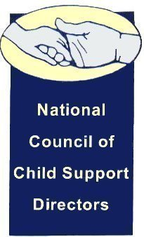

NCCSD Imputation Committee

September 1, 2015

4:00 PM Eastern

712-775-7031

Access Code 703338

AGENDA

1. Roll Call

__ Craig Burshem

__ Alisha Griffin

__ Jeff Jorgenson

__ Wally McClure

__ Rebecca Perez

__ Kate Richardson

__ Benidia Rice

__ Sharon Santilli

__ Steven Smith

__ Eileen Stack

__ Liesa Stockdale

__ Jim Fleming (chair)

1. Review Meeting Notes
   1. August 12, 2015
   2. August 19, 2015
2. Review Michigan imputation policy
3. Develop Structure of State Survey
   1. Procedures for establishing and modifying orders
      1. Opportunity for customer input
      2. Efforts to reduce defaults due to lack of participation
      3. Review of all available information and databases
   2. Imputation of income under state guidelines
      1. Number of hours
      2. Hourly rate
      3. Use as a last resort
      4. Formula versus case specifics
4. Next meeting September 15, 2015, at 4:00 Eastern