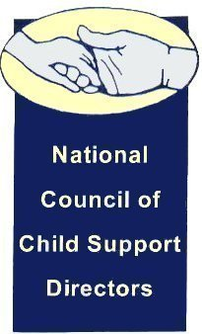

NCCSD Imputation Committee

November 24, 2015

4:00 PM Eastern

712-775-7031

Access Code 703338

AGENDA

1. Roll Call

__ Craig Burshem

__ Alisha Griffin

__ Jeff Jorgenson

__ Wally McClure

__ Rebecca Perez

__ Kate Richardson

__ Benidia Rice

__ Sharon Santilli

__ Eileen Stack

__ Liesa Stockdale

__ Jim Fleming (chair)

1. Washington Post story
2. Upcoming plenary and breakout session at 2016 NCSEA Policy Forum
3. Review New Draft of State Survey
4. Next meeting – date and time to be determined (December 8 will not work for the chair)