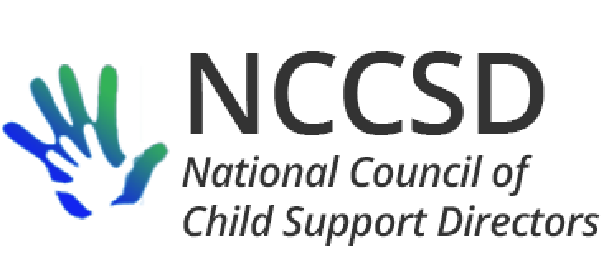

**To:** NCCSD Members

**From:** Jim Fleming

**Re:** October President’s Report

**Date:** October 17, 2019

This monthly report may include information which OCSE is not authorized or prepared to make public at this time. To promote continued candor between OCSE and NCCSD, please do your best to keep this report at director-level only.

The new NCCSD year is already off to a quick start.

Surveys: The Public Relations survey and the Aspen Institute survey facilitated by Vicki Turetsky were re-opened, and all directors are encouraged to respond by October 25. In addition, OCSE has indicated the United States needs to respond to the Hauge Special Commission on certain aspects of implementing the Hague Convention. To prepare the response, OCSE will be surveying the states with the largest international caseloads with specific questions. I will send an e-mail to all states so any specific examples in the surveyed areas can be offered to OCSE. The “Knowledge Works” website is operational, and any directors who have not responded to the survey gathering source information for the website will be invited again to respond.

WICSEC: Commissioner Lekan shared a private lunch with the IV-D directors who attended WICSEC, which was made more interesting by the recent announcement of his job change. Thank you to Liesa Stockdale for coordinating the meeting. Among other topics, Scott confirmed there was still a proposed rulemaking which has yet to be finished pertaining to “technical changes,” including the meaning of “concurrent benefits.” Of perhaps the most interest, Scott indicated his office was exploring and considering the impact of a possible change in federal regulations regarding the mandate to conduct reviews for parents incarcerated for more than 180 days if the incarceration stems from a crime against a child or crime of violence. Scott also indicated he has selected a candidate for Deputy Commissioner, but the Office of Personnel Management completes the process of extending the offer, and that can take several months. Expedited processing has been requested.

Monthly Leadership Call: Vice President Michele Cristello and I met with OCSE leadership for our monthly call on Tuesday October 15. The agenda and three attachments will be distributed along with this report: 1) informal OCSE Commissioner talking points on feasibility studies, 2) an updated OCSE organizational chart, and 3) a new document showing the Division of Regional Office staff and their state/territory/tribe assignments.

The call went very well. It focused predominantly on recapping the 2019 annual NCCSD meeting, especially the closed-door meeting with directors. Joey and Cynthia continue to work on developing reports that states can use via Tableau Reader. Regarding a national employer table, continued work to develop the concept will occur without being limited to the states who volunteered at the closed-door meeting. Linda Boyer’s team is working to see if the OCSE and IRS security videos can be combined and updated. It was decided that there will not be another state systems symposium in conjunction with the 2020 NCSEA Policy Forum; rather, there will be webinars.

Perhaps under the heading of saving the best for last, Audit Director Mona Ferrell described many internal discussions on the audit process which have occurred in the last month to address inconsistencies, track issues, and expand state understanding of the audit process. When asked whether those discussions included what OCSE plans to do regarding differences in interpretation between OCSE and States on the meaning of a regulation or the instructions to the 157, Ms. Ferrell stated yes: when existing regulations and instructions are subject to interpretation, OCSE will not mark the case as an error. This is extremely good news, at least for my state and likely many others.

To close the conversation on audits, OCSE asked us to remind all directors of [DCL‑19‑11](https://www.acf.hhs.gov/css/resource/submittal-of-ocse-157-for-fy-2019) and the process for submitting corrected information by December 31, 2019. In particular, OCSE warned states to be sure that the official submitting revised information has the proper authority to submit revised data in the OLDC system. They also noted that states should be sure that the audit trails match the timeframe being audited.

2020 Annual Meeting: The week of July 12 is during the peak season in Medora, so the Foundation which manages most of the town’s amenities and the local Community Center are seeking a commitment now to hold the meeting room and hotel block for us. There will be two hotel options. I have reviewed the incoming flight schedule for Bismarck and Dickinson to determine the optimal time and location for the director-only meeting. It appears we will suggest that attendees fly to Bismarck rather than Dickinson, which has very few flights per day. Our conference plan will include buses to transport attendees 140 miles each way from Bismarck to Medora. Likely, our director-only meeting will occur late Sunday July 12 in Bismarck, with a casual evening event of some kind in Bismarck. Directors will travel by bus to Medora the morning of July 13 and have the option to enjoy an 18-hole golf outing or a three-hour bus tour of the badlands at the Theodore Roosevelt National Park – South Unit. Other conference attendees will arrive Monday in Bismarck and travel by bus to Medora in time for us all to gather for a BBQ reception on Monday night. The evening social will be outdoors Tuesday night, with the option to postpone to Wednesday if there is rain. The usual 2½ day meeting format will follow, with buses departing Medora on Thursday in time to return to Bismarck by 3:00 PM Central. More details to follow when available.

Respectfully submitted,

**Jim**

Jim Fleming, 2019-20 NCCSD President