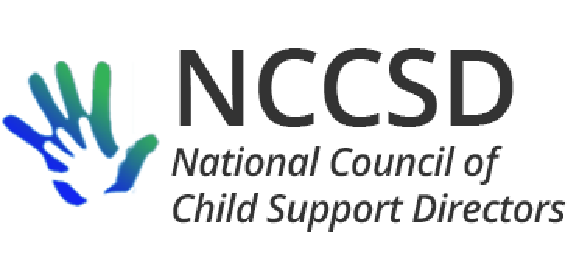

**TO:** NCCSD Executive Committee

**FROM:** Jim Fleming, NCCSD President

**DATE:** November 21, 2019

**RE:** Monthly President Report

Internal Operations

The process of reforming our committees for the upcoming year is nearly complete, including appointing NCCSD designees to the NCSEA-OCSE-NCCSD Joint Public Relations Committee and obtaining employer volunteers for the Child Support Employer Advisory Group.

Tribal Offset Access

Accompanying this report (Attachment 1) is a final copy of the NCCSD letter of support for tribes to obtain direct access to federal offset services. At the request of the tribal child support representatives who requested the letter, the paragraph regarding the opportunity to improve other aspects of federal law was clarified without changing the overall meaning.

OCSE Leadership Meeting

The monthly meeting between NCCSD and OCSE leadership was held on November 4 with Michele and Jim participating on behalf of NCCSD. A revised organizational chart was provided reflecting the new deputy commissioner (Attachment 2). As previously requested by NCCSD, OCSE provided a list (Attachment 3) of current exemptions approved by OCSE for IV-D programs to use incentive dollars for non-IV-D activities. OCSE agreed to develop and disseminate similar matrices on Section 1115 waiver projects and required state law exemptions.

At the request of some directors from Region 1, two training proposals were brought forward by NCCSD to OCSE for consideration. The first is training on the OLDC system. The second is a list of financial topics (Attachment 4). OCSE agreed to consider both requests.

Scott Hale will be collaborating with Melissa Johnson and Division of Regional Operations to have regional specialists reach out to states to share information about an upcoming State Department Passport Revocation pilot. Scott will develop and share through the specialists the proof of concept/pilot project overview and data criteria to enhance possibilities for a successful outcome. Original participation will include a fairly small number of cases per state. To demonstrate the potential for the project, it would be helpful for states to identify cases where passport revocation would pose the greatest chance of success in terms of yielding collections. OCSE provided a sample of what State Department’s revocation notice would look like (Attachment 5).

Cynthia Longest continues to work on a state system comparison matrix reflecting key significant characteristics of state child support programs and computer functionality.