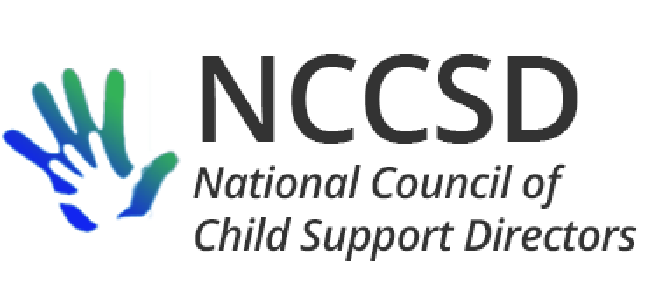

**TO:** NCCSD Executive Committee

**FROM:** Jim Fleming, NCCSD President

**DATE:** December 19, 2019

**RE:** Monthly President Report

Audits

It sounds like several states have been relatively successful working through their audit issues with OCSE based on the new understanding that there may be times when OCSE and a state need to agree to disagree and avoid an error finding until the 157 Report or instructions can be clarified. I think this will place a premium on NCCSD being deeply involved in commenting the next time the OCSE-157 and instructions come up for comment and revision.

Pending or Potential Legislation

The biggest news of the last month may be the introduction of [Senate Bill 3025](https://www.congress.gov/116/bills/s3025/BILLS-116s3025is.pdf). Highlights of the bill include extending the new hire reporting requirements in federal law to independent contractors for whom a “service-recipient” engaged in a trade or business who is required to make a return under Internal Revenue Code section 6041A(a). On page 18 of the bill, such reporting would be required no later than 20 days after the earlier of “first making payments as a consequence of which a return … is required to be made” or “entering into a contract providing for such payments.”

Another highlight of the bill is requiring states and financial institutions to give full faith and credit to other state’s levies, as well as liens, using a form created by the US Department of Health and Human Services (HHS). Upon request of a state, HHS would be authorized to assist in the lien and levy process. Finally, in-state banks would be authorized to participate in MSFIDM through HHS if they choose.

Other legislative proposals being discussed in draft in the Senate but not yet introduced include extending federal offset services to tribes (including clarification of authority to share FTI with contractors engaged in IV-D activity), authority to use incentives for parenting time without needing to request a waiver from OCSE, and authority to use FFP for work activities.

A question for NCCSD and the Executive Committee would be our level of interest in commenting on pending or potential legislation.

OCSE Leadership Meeting

The monthly meeting between NCCSD and OCSE leadership was held on December 9 with Michele and Jim participating on behalf of NCCSD. OCSE asked me to remind directors of the deadlines in DCL-19-11 for submitting any corrections to their OCSE-157 (December 31, 2019) and in DCL-19-14 for uploading the universe and performance indicator audit trails for FY 2019 (January 31, 2020).

OCSE acknowledged that there are several overlapping initiatives within HHS to collect state information about employment programs, but since the sponsors are different parts of the agency, OCSE encouraged states to respond to both the Knowledge Works survey and the HHS-ACF Office of Planning, Research, and Evaluation request for information.

OCSE indicated they are currently not able to advise states whether a potential candidate for passport revocation has been issue a passport, and thus recommends states consider the noncustodial parent’s history of employment or residence.

NCCSD mentioned interest in preventing the reduction of tax offsets under the upcoming revisions to the W-4 withholding form by providing for an increased level of withholding for employed noncustodial parents with arrears. OCSE agreed to provide offset collection data in Spring 2020 to facilitate further discussion of collection trends for federal tax offset.

OCSE will be sending reminder letters through the Division of Regional Operations to state who have not yet submitted plan amendments required by the FEM rule changes.

OCSE expressed an interest in extending the length of the closed-door OCSE-NCCSD meeting at the next annual NCCSD meeting in Medora North Dakota.

Next monthly meeting between OCSE and NCCSD is scheduled for January 13, 2020, at 3 PM Eastern.