



2019 Employer Symposium

Contents

Overview 3

Purpose 3

Background 3

Format 3

Participants 4

Recommendations from Prior Symposiums and Survey 4

Symposium Goals 4

Discussion and Action Items 5

Additional Presentations 6

Action Items by Topic Area 6

New Hire Reporting 7

Verification of Employment (VOE) 8

National Employer Database 8

Forms and Automation 8

Lump Sum Reporting and Withholding 9

Improve Communication and Information Exchange 10

GIG Economy 10

miscellaneous action items 11

Appendix A – Symposium Handouts 12

A-1: Symposium Agenda 12

A-2: IV-D Directors Survey 13

A-3: - Standard VOE Response Form 20

A-4: OCSE Child Support Portal 25

A-5:Daily Pay 26

Appendix B - Participants 27

Appendix c - Poll Questions and Results 31

# Overview

## Purpose

|  |  |
| --- | --- |
|  | The Employer Symposium brought experts from the child support and employer communities together to discuss ways to improve communication, cooperation and processes between the child support program and employers. |

## Background

|  |  |
| --- | --- |
|  | The federal Office of Child Support Enforcement (OCSE) hosted the first Employer Symposium in August [2005](https://www.acf.hhs.gov/archive/css/css/resource/css/resource/report-on-the-employer-symposium-of-august-2005). Since then there have been Employer Symposiums in [2011](https://www.acf.hhs.gov/archive/css/css/resource/css/resource/employer-symposium-2011-report), [2014](https://www.acf.hhs.gov/archive/css/css/resource/css/resource/2014-employer-symposium-report) and [2016](https://www.acf.hhs.gov/css/resource/2016-employer-symposium-report). |

### In 2018, the National Council of Child Support Directors (NCCSD) established an Employer Lump Sum Collaboration Workgroup and decided to host an Employer Symposium immediately after its annual conference in September 2019. This symposium was different from the others because many of the child support participants were the directors who are the decision makers for their programs.

## Format

|  |  |
| --- | --- |
|  | The Employer Symposium was a one and a half-day session following the 2019 NCCSD annual conference. |

### Erin Frisch, Michigan Chief Deputy Director for Opportunity and Scott Lekan, Commissioner of the Office of Child Support Enforcement welcomed participants and set the stage for the Employer Symposium to be an open forum to encourage discussion and collaboration and to identify action items to accomplish the overall objective to improve communication and processes between stakeholders.

### Representatives from child support agencies, including some of their vendors, employers and the OCSE led discussions and encouraged participant input, feedback and recommendations. The symposium agenda (Appendix A:1) and handouts are in Appendix A.

## Participants

|  |  |
| --- | --- |
|  | 73 individuals participated in the symposium, including representatives from 31 states and territories, 29 employers, 7 vendors and OCSE. A table with the list of participants is in Appendix B. Many of the child support agency participants were the state child support directors. A variety of employers ranging from large to small and payroll processors, including one who pays 1 in 5 individuals in the United States, attended. |

## Recommendations from Prior Symposiums and Survey

|  |  |
| --- | --- |
|  | Participants reviewed recommendations from previous symposiums and voted on whether the recommendation should be considered further, marked as complete, or closed out.Prior to the symposium, NCCSD sent a survey to all state child support directors to gather state-specific information about policy, procedures and statistics. The survey identified commonalities and differences across states. Presenters shared highlights from the survey results during discussion of each topic area.A table with the prior symposium recommendations and results of the poll is in Appendix C. |

## Symposium Goals

|  |  |
| --- | --- |
|  | Erin Frisch, NCCSD president, asked participants to share what they hoped to accomplish during the Symposium. The results are captured below: |

* Make employers aware of state resources available to them such as the Georgia Employer Hub
* Identify and address major pain points for employers such as:
  + Too many identifiers on IWOs (Case ID, Order ID, Remittance ID)—Can there be only one identifier?
  + Receiving returned payments from child support agencies without an identifier.
  + Receiving IWOs that are not on the required, standard form—Non-IV-D orders seem to be the biggest issue.
  + Improving internal communication at the state level—for example, ensuring all staff know about the e-IWO process.
  + Receiving paper IWOs when an employer is participating in e-IWO.
* Discuss improvements to lump sum reporting and withholding
  + Increase consistency across states.
  + Standardized elements for information exchange.
  + Potential for automation.
* Address non-IV-D withholding orders
  + How to terminate non-IV-D withholding orders?
  + Opt in vs. opt out for IV-D services—increase IV-D caseload and increase the number of orders sent to employers via e-IWO
* Learn more about the gig economy and on demand pay
  + Identifying independent contractors and address compliance issues for organizations not honoring IWOs for non-employees.
* Identify ways to make complying with new hire reporting easier and add more data elements
* Simplify medical support compliance for employers
  + Struggling with calculations (section 125 implications)
  + Automating the National Medical Support Notice (NMSN)
  + Releasing/terminating NMSN
    1. As of 10/4/19, the revised NMSN can be used to terminate medical support

## Discussion and Action Items

|  |  |
| --- | --- |
|  | Symposium participants discussed the following topic areas and identified possible enhancements to improve information, communication and/or data exchange and also highlighted best practices: |

* New hire reporting
* Verification of employment (VOE)
* Potential for a national employer database
* Forms and automation
  + IWO/e-IWO
  + NMSN
* Lump sum reporting and withholding
* Improve communication and information exchange
* Gig economy

## Additional Presentations

|  |  |
| --- | --- |
|  | New Hire Reporting – Two vendors presented best practices for new hire reporting. Some of the highlights from the presentation: |

* Handbook for employers
* Employer portals
  + Chat feature on portal
* Employer Participation Project reports
* Address scrubbing
* Compliance letters
* Target newly registered employers

|  |  |
| --- | --- |
|  | Gig economy – Daily Pay presentation – flyer in Appendix A-5 |

# Action Items by Topic Area

Below is a summary of the action items by topic area identified during the symposium. NCCSD will establish a Child Support-Employer Collaboration Workgroup that will discuss the action items and determine next steps needed to accomplish them. The list of workgroup tasks and discussion topics is not all-inclusive, but rather may be used to initiate discussion for each action item.

## New Hire Reporting

|  |  |
| --- | --- |
|  | Action Item: Review the data elements most states either request or require employers to provide in addition to the federally required ones and determine the feasibility of requiring employers to provide the information within the new hire reporting timeframes. |

### Workgroup Tasks and Discussion Topics:

* Identify data elements that may decrease the need for child support agencies to issue a VOE.
* Add employer contact information such as a team email address, as a required data element.
* Require employers to report the IWO address—currently it is an optional field.
* Add a field to the NDNH to accept an indicator from SDNHs that identify independent contractors.
* Add employer-provided medical insurance indicator both at the employer and employee level in the New Hire record.
* Collaborate with other state agencies communicating with employers to provide information about their roles and responsibilities in the child support program such as new hire reporting, income withholding and responding to NMSNs regarding health insurance.
* Establish as a best practice for employers to use a check list to identify responsibilities associated with the child support program when there is turnover in payroll and/or human resources.

|  |  |
| --- | --- |
|  | Action Item: Pursue legislation to allow employer new hire reporting to OCSE (one stop for employers). |

### Workgroup Tasks and Discussion Topics:

* Identify the pros and cons associated with this action item.
* Determine what entity(ies) would pursue legislation.
* Discuss impact on child support agencies, other stakeholders, and OCSE.

## Verification of Employment (VOE)

|  |  |
| --- | --- |
|  | Action Item: Simplify, streamline and automate the VOE process. |

### Workgroup Tasks and Discussion Topics:

* Review existing automated data available to child support agencies.
* Create VOEs for specific purposes and look at ways to simplify or limit the data needed. Review the Standard Verification of Employment Response Form. Appendix A:3
* Use the OCSE Child Support portal to exchange information. Appendix A:4
* Use e-IWO model for VOE information exchange.

## National Employer Database

|  |  |
| --- | --- |
|  | Action Item: Establish a national employer database that includes information about employers that child support agencies need to direct communication and documents to the right address and reach the appropriate employer contact. |

### Workgroup Tasks and Discussion Topics:

* Explore options to manage employer information across states.
* Discuss known issues with information discrepancies reported for a single FEIN
  + Name and address variations
  + Completely different names and addresses
* Storing multiple address and contact types for a single FEIN, for example:
  + IWO
  + NMSN
  + VOE
* Reporting new hires and quarterly wages using the same FEIN.
* Linking FEINs for parent/subsidiary and third party/customer relationships.

## Forms and Automation

|  |  |
| --- | --- |
|  | Action Item: Increase the number of IWOs (both IV-D and non-IV-D) sent electronically to employers. |

### Workgroup Tasks and Discussion Topics:

* States adopting an opt-out vs. opt-in process for IV-D services.
* Allow states to issue IWOs for non-IV-D orders as a limited service.
* Allow courts and attorneys to use e-IWO.

|  |  |
| --- | --- |
|  | Action Item: Improve IWO termination. |

### Workgroup Tasks and Discussion Topics:

* Require states to use the IWO to terminate an existing IWO.
* Use the EFT termination indicator in the NACHA payment record to notify states about employee terminations.

|  |  |
| --- | --- |
|  | Action Item: Increase and improve form automation. |

### Workgroup Tasks and Discussion Topics:

* Identify steps child support agencies can take to ensure e-IWO employers receive orders electronically and only electronically.
  + Ensure IWOs have employer FEINs
  + Ensure staff are knowledgeable about e-IWO
  + Process e-IWO terminations effectively in the child support system
* Automate the NMSN following the e-IWO model.

## Lump Sum Reporting and Withholding

|  |  |
| --- | --- |
|  | Action Item: Improve the lump sum reporting and withholding process for child support agencies and employers. |

### Workgroup Tasks and Discussion Topics:

* Review NCCSD’s Employer Lump Sum Collaboration Workgroup’s accomplishments and identify follow-up and new activities needed to improve the process.
* Create a simplified, uniform lump sum notice for child support agencies to issue to employers.
* Respond with the same case number/identifier sent by the employer when using Lump Sum Reporting/Debt Inquiry.

## Improve Communication and Information Exchange

|  |  |
| --- | --- |
|  | Action Item: Improve overall communication and information exchange between stakeholders including child support agencies, employers, federal benefit agencies such as SSA and OCSE. |

### Workgroup Tasks and Discussion Topics:

* Consider recommending/highlighting Georgia’s non-IV-D/court liaison with the child support agency as a best practice other agencies may want to implement.
  + Judicial point of contact to assist participants, courts, attorney and employers navigate non-IV-D orders.
* Identify alternatives to encrypted and secure e-mail exchange since many stakeholders have issues using these methods to send PII.
* Discuss enhancements to OCSE’s portal and identify types of documents and information that could be exchanged.
  + Consider expanding e-IWO to smaller employers by allowing e-IWO download and acknowledgment upload on the portal.
* Explore ways to increase the number of employers using OCSE’s portal to provide and certify information about their organization, at least annually, that is shared with child support agencies.
  + May decrease the number of VOEs issued by child support agencies if employers provided information about health insurance availability through their organization.

## GIG Economy

|  |  |
| --- | --- |
|  | Action Item: Determine if there is a need to seek legislation either at the state or federal level to require organizations to report independent contractors and other types of non-employees as new hires. Note: There are 17 states that currently have legislation requiring organizations to report independent contractors as new hires. |

### Workgroup Tasks and Discussion Topics:

* Share issues/barriers states addressed when they attempted to pass legislation.
* Consider adding an indicator to the NDNH to identify independent contractors when the SDNH provides the indicator. (Also captured in New Hire Topic area.)
* Verify on-demand pay/same-day pay does not impact child support payments.

# miscellaneous action items

|  |  |  |
| --- | --- | --- |
| Action Item | Responsible Party | Status |
| Provide a copy of the checklist used to identify employer responsibilities associated with the child support program to OCSE. | Sam McAtee, McLean Co, Inc. | Completed |
| Provide a list of OCSE reports discussed during the symposium to NCCSD. | OCSE | Completed |
| Review severance pay references in the Lump Sum Model Act developed by the Employer Lump Sum Collaboration Workgroup to determine if changes are needed. | NCCSD (Jim Fleming) and APA (Alice Jacobsohn) | Completed: Retained the definition of severance as a component of the lump sum definition, but removed the specific provision requiring the employer to estimate how much would have been withheld if the person had stayed on payroll for the same amount of time intended to be covered by the severance payment. |

# Appendix A – Symposium Handouts

## A-1: Symposium Agenda



## A-2: IV-D Directors Survey

Memorandum

September 1, 2019

To: Erin Frisch, NCCSD President; Sherri Grigsby, OCSE Employer Services Team

From: Jim Fleming

Re: Employer Symposium Survey

One of the NCCSD initiatives this year was to host an Employer Symposium. To build a better base of familiarity with IV-D interaction with employers across the country, the planning committee for the Symposium developed a survey. Ultimately, 53 of 54 jurisdictions participated, which was a very strong turnout.

The full survey results were disseminated to all directors. This memo captures some highlights of the survey for the benefit of directors and Symposium planners prior to the start of the Employer Symposium.

Does your state require additional new hire data elements?

* 13 yes, 39 no
* Common additional elements
  + Health insurance
  + State of hire
  + State employer identification number
  + Employee date of birth

Does your state use additional optional data elements?

* 22 yes, 30 no
* Common additional elements
  + Health insurance
  + State of hire
  + Employee date of birth
  + Other contact information (fax, e-mail, alternate address) for employer

**IV-D Directors Survey – continued**

Does your state perform any outreach to employers, to bring awareness of the requirements?

* 46 yes, 6 no
* Welcome packets for new employers
* Several states out-source this function to a private company

### IV-D Directors Survey-continued

Does your state require independent contractor reporting?

* 16 yes, 36 no
* Several states connect to requirement for filing and IRS 1099-MISC

Does your state accept the federal Standard Verification of Employment response form?

* 33 yes, 18 no

In addition to those on the standard VOE response form, what data elements does your state require?

* More details on health insurance
* Race, gender, average number of hours worked per week

Does your state have its own standard VOE response form?

* 45 yes, 7 no
* Additional data elements include:
  + More details on health insurance
  + Forwarding address, if a former employee
  + IWO address
  + Race, gender, insurance co-payment information
  + Average number of hours worked per week
  + Pay for last few payroll periods

**IV-D Directors Survey – continued**

What do you use the VOE for?

* Establish order – 46
* Confirm new hire report before issuing IWO – 15
* Confirm report of new employment from other source – 41
* Confirm new hire report at same time or after issuing IWO – 19
* Confirm health care coverage – 32
* Court-required documentation – 15
* Automatic system generation – 14

What prompts your automated system to automatically generate the VOE?

* Many states indicated system does not generate automatically
* When new employment is suggested from source other than new hire reporting
* When prompted by the assigned worker

Do you issue VOEs instead of IWOs?

* 6 yes, 45 no

Do you use other mechanisms to get VOE information? And do you pay for these services/other mechanisms?

* States listed a well-known third-party verifier, and generally did not pay for the information
* Quarterly wage
* Other fee-based Locate tools

Does your state enforce the IWO when the employer/source of income does not respond?

* 49 yes, 2 no
* Most states use letters, followed by fines and potential court proceedings

Does your state issue income withholding orders in non-IV-D cases?

* 18 yes, 34 no

Does your state maintain an ongoing payment record in non-IV-D cases?

* 21 yes for disbursements only, 25 yes for accruals and disbursements, 5 no

**IV-D Directors Survey – continued**

Does your state have withholding limits for withholding from employee earnings other than the CCPA limits?

* 15 yes, 37 no
* Many states listed 50% as cap in all cases, with some at 40%

Does your state use the IWO to terminate withholding?

* 47 yes, 5 no

Is your state programmed to both receive and respond to lump sum notifications from employers via e-IWO?

* 22 yes, 30 no

Does your state automatically update the NCP’s address upon notice from the employer through e-IWO?

* 14 yes, 38 no

Does your state automated system update the employer and NCP records when you receive an employee termination via e-IWO?

* 29 yes, 23 no

How does your state terminate the NMSN?

* With short letter or termination order

Does your state send additional information with the NMSN to obtain more information about insurance coverage?

* 13 yes, 38 no

Does your state enforce the NMSN when the employer/plan administrator does not respond?

* 34 yes, 17 no

**IV-D Directors Survey – continued**

What is your state reasonable cost limitation?

* 5% of gross earnings was a common answer
* Some cited CCPA withholding limits
* Ranged from 3% to 10% of income (not specified as net or gross)

Does your state want to automate the NMSN similar to e-IWO?

* 43 yes, 8 no
* Resources was the most commonly-listed barrier

Does your state have an employer portal?

* 28 yes, 24 no

If your state has an employer portal, what options are available for employers?

* Receive/respond to IWO – 12
* Receive/respond to NMSN –
* Receive/respond to employer reported lump sum payments – 9
* Communicate with employers – 15
* Receive/respond to VOE – 8
* Update employer information – 13
* Other – 20
  + Report new hires and terminations
  + Initiate EFT
  + Report employee address changes

Does your state receive terminations reported by employers through the federal child support portal?

* 31 yes, 20 no

If yes, do you automatically update your system?

* 11 yes, 26 no

How does your state maintain employer records?

* Manual update
* Tables or databases that can be edited by small group of authorized users

**IV-D Directors Survey – continued**

How does your state handle multiple addresses for a single employer/source of income?

* Many states reported multiple fields are available
* A few states have only one field per employer

Do you link an employer’s parent FEIN with any subsidiary FEINs?

* 20 yes, 32 no

Does your state require reporting of lump sum/bonus payments by statute?

* 20 yes, 32 no

What is your withholding limitation for lump sums payable to independent contractors?

* Prevailing response is same as CCPA or 50%
* Several states do not distinguish between employees and independent contractors for purposes of the withholding limitation

What is your response time when notified of a pending lump sum payment?

* 2 days – 32
* 2 weeks – 9
* 30 days – 5
* 45 days – 0

Does your state allow an employer to immediately release 50% of a lump sum payment to the employee pending further direction from the child support agency?

* 11 yes, 35 no
* For those answering no, frequent response is employer is expected to wait for instruction from child support before releasing any funds
* Many states reported that their law did not address this question

Does your state respond to all lump sum inquiries?

* 46 yes, 4 no

**IV-D Directors Survey – continued**

What is your preferred method to receive lump sum notifications?

* E-mail – 16
* State portal – 7
* OCSE Child Support Portal – 19
* e-IWO - 9

Respectfully submitted,

Jim Fleming

## A-3: - Standard VOE Response Form

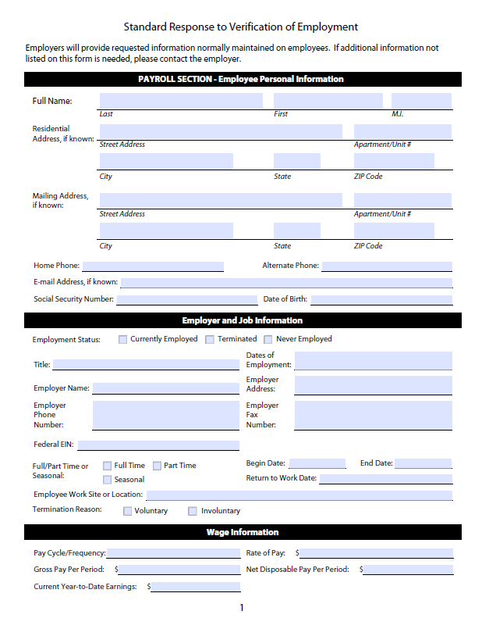

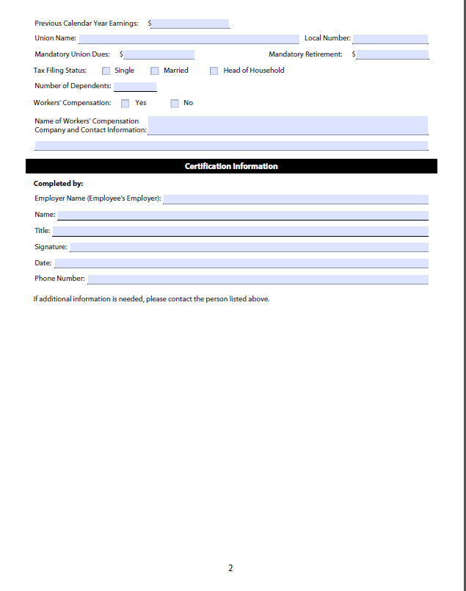

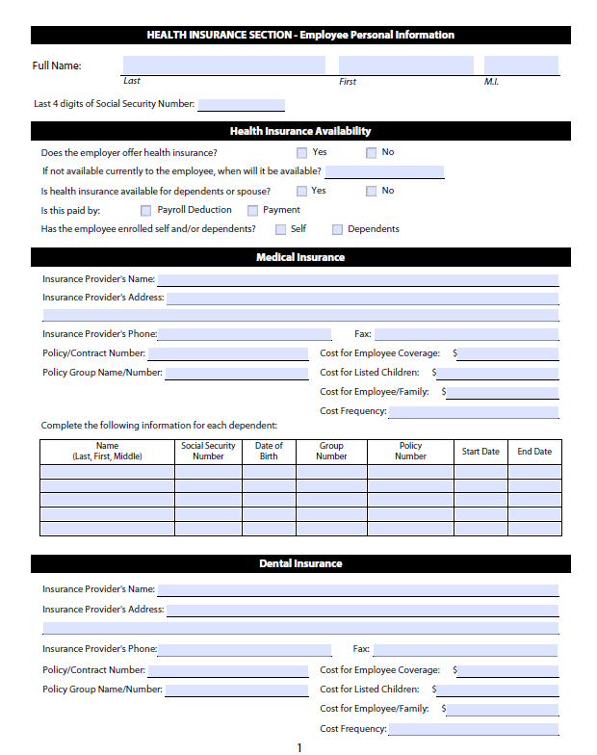

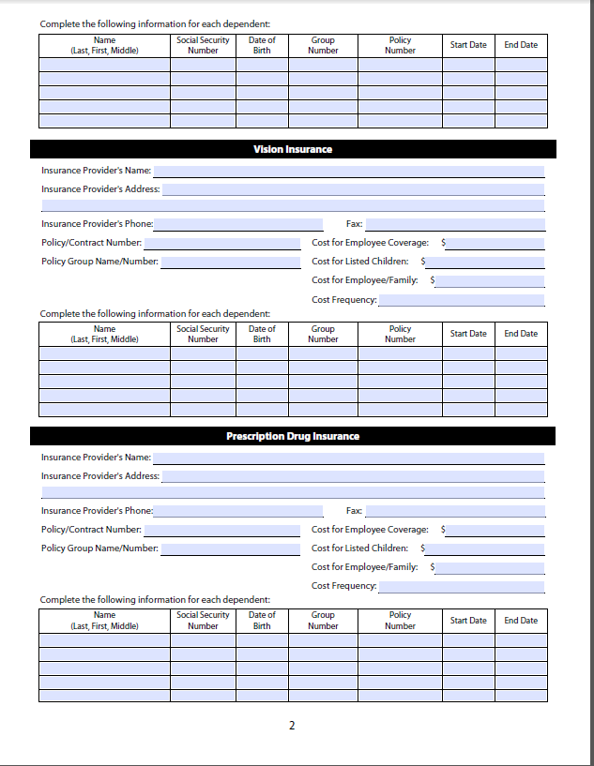

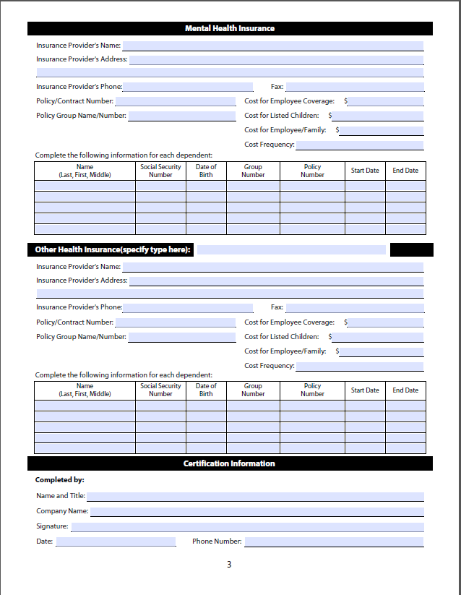

## A-4: OCSE Child Support Portal



## A-5:Daily Pay



# Appendix B - Participants

|  |  |  |  |  |
| --- | --- | --- | --- | --- |
| **CHILD SUPPORT AGENCIES** | | | | |
| **Last Name** | **First Name** | **Title** | | **Organization** |
| Adrian | Michael | Director of Policy & Program Development | | Michigan Office of Child Support |
| Aguirre | Teresa | Assistant Deputy Director | | Office of the Attorney General |
| Arneson | Kristie | IV-D Director/Senior Administrator, Economic Security Division | | Wyoming Department of Family Services |
| Arocha-De Leon | Christa | Manager | | Office of the Attorney General |
| Beecher | Carol | Director | | Department of Revenue - Child Support Division |
| Burshem | Craig | Deputy Commissioner For State Programs | | Virginia Department Of Social Services |
| Cason | Patricia | CSE Manager 3 | | Department of Children and Family Services-Child Support Enforcement |
| Cooper  Richardson | Kate | State IV-D Director | | Oregon Child Support Program - Department of Justice |
| Fleming | Jim | Director | | North Dakota Child Support |
| Fraser | Christy | Deputy Director | | Department of Revenue – Child Support Divison |
| Frisch | Erin | Director | | Michigan Office of Child Support |
| Gray | Tanguler | Director | | Department of Human Services |
| Hubbard | Bryan | Commissioner | | Child Support Enforcement - Department for Income Support |
| Johnson | Elaine | Executive Program Manager | | Georgia Judicial Council, Administrative Office of the Courts, Child Support Commission |
| Kilgore | David | Director | | CA Dept. of Child Support Services |
| McClenney | Lathesia | IV-D Director | | Alabama Department of Human Resources |
| McVey | Alan | Administrator | | State of Arkansas Office of Child Support Enforcement |
| **CHILD SUPPORT AGENCIES** | |  |  | |
| **Last Name** | **First Name** | **Title** | **Organization** | |
| Miller | Davida | Executive Assistant | Department of Social and Health Services/Division of Child Support | |
| Morris-  Williams | Barbara | General Counsel | State of Arkansas Office of Child Support Enforcement | |
| Parks | Richard |  | Michigan DHHS | |
| Proctor | Sondra |  | Michigan DHHS | |
| Reese | Carly | IT Chief | Department of Social and Health Services/Division of Child Support | |
| Risch | Patricia | IV-D Director | Department of Human Services/Division of Family Development/Office of Child Support Services | |
| Rogers | Selma Moreno | Deputy Director for Child Support | Office of the Attorney General | |
| Scales | Brittney | CSE Director | Department of Children and Family Services-Child Support Enforcement | |
| Sullo | Leah | Associate Deputy Attorney General | Massachusetts Child Support Enforcement | |
| Toulouse | Jeremy | Acting Director | New Mexico Human Services Department / Child Support Enforcement Division | |
| Townsend | Christopher | Departmental Analyst | Michigan Office of Child Support | |
| Ward | Montega | Support Enforcement Specialist - Wage Withholding Unit | Office of Attorney General, Child Support Services Division | |
| Williams | Matthew | Assistant Deputy Director | Missouri Dept. Social Service | |

|  |  |  |  |  |  |
| --- | --- | --- | --- | --- | --- |
| **EMPLOYERS & PAYROLL PROFESSIONALS** | | | | |  |
| **Last Name** | | **First Name** | | **Title** | **Organization** |
| Connor | | Tomeka | | Payroll Specialist | Charter Communications |
| Day | | Jill | | Payroll Tax Compliance Analyst II | Paychex, Inc. |
| Flores | | Corrinne | | Director Government Affairs | ADP, LLC |
| Frances | | Beth | | Benefits Support Specialist | Amazon |
| Galetka | | Kristin | | Product Owner - Payroll Taxation | Ceridian |
| Garbacik | | Kelly | | Payroll/ HRIS Specialist | Great Lakes Wine & Spirits |
| Hendricks | | Brooke | | Human Resource Manager | Ypsilanti Community Utilities Authority |
| Hutmacher | | Scott | | Supervisory Attorney | DFAS |
| Jackson | | Sherell | | Payroll Coordinator | Schoolcraft College |
| Jacobsohn | Alice | | Senior Manager, Government Relations | | American Payroll Association |
| Jitaru | Carmen | | Payroll Director | | Siemens Corp |
| Longo | Loretta | | Financial Systems Specialist | | DFAS |
| McAtee | Stephanie | | Director of Payroll | | McLane Company, Inc. |
| Milner | Tequila | | Lead HR Services Senior Business Analyst | | Home Depot |
| Owen | James | | Payroll Head of Americas | | Siemens |
| Payne | Traci | | HR Coordinator | | Texas Roadhouse |
| Sanders | Nicole | | Verification Specialist | | Precision Pipeline, LLC |
| Sanders | Brooke | | wage attachment specialist | | Texas Roadhouse |
| Sather | Susan | | Associate Controller/Director of Accounting Services | | Schoolcraft College |
| Schmidt | Linda | | Sr. Supervisor Payroll | | XPO Logistics |
| Schwager | Linda | | Payroll Assistant II | | Henry Ford Health System |
| Smith | Gloria | | Sr. Statutory Compliance Research Specialist | | ADP |
| Stevens | Gina | | Payroll Systems Manager | | Smithfield Foods |
| Vaughan | Catherine | | Payroll Manager | | Saginaw Valley State University |
| White | Stacy | | Income Withholding Manager | | Ford Motor Company |

|  |  |  |  |
| --- | --- | --- | --- |
| **Last Name** | **First Name** | **Title** | **Organization** |
| White | Larry | Director of Payroll Training | American Payroll Association |
| Williams | Connie | Senior Payroll Manager | Charter Communications |
| Woodring | Becky | Director Payroll | Henry Ford Health System |
| VENDORS | | | |
| Franklin | Maurice | Vice President Child Support | Maximus |
| French | George | President | Stellarware Corporation |
| Jackson | Josh | Product Marketing Director | DailyPay |
| Martin | Colleen | Director | Maximus |
| Root | Cathy | Senior Director | Maximus |
| Thomas | Trish | Sr Vice President - Human Services | Maximus |
| Sokolik | Katherine | Vice President, Child Support Practice | Center for the Support of Families, an SLI Company |
| Walker | Jamie | Director North America Child Support | Accenture |

|  |  |  |  |
| --- | --- | --- | --- |
| **OFFICE OF CHILD SUPPORT ENFORCEMENT (OCSE)** | | |  |
| Grigsby | Sherri | Manager, Employer Services | DHHS/ACF/OCSE |
| Holdren | Cynthia | OCSE Employer Services Team | DHHS/ACF/OCSE |
| Johnson | Melissa | Director, Division of Regional Operations | DHHS/ACF/OCSE |
| Large | Andrew | OCSE Employer Services Team | DHHS/ACF/OCSE |
| Large | Robyn | OCSE Employer Services Team | DHHS/ACF/OCSE |

# Appendix c - Poll Questions and Results

| TOPIC | VOTE | VOTING RESULTS |
| --- | --- | --- |
| New Hire Reporting | | |
| Include medical insurance availability and eligibility data in new hire reporting. | Accept & Pursue | 67% = Accept & Pursue  33% = Close Out |
| Determine the data elements required by most states and available from most employers within the timeframes for new hire reporting. | Close Out | 85% = Close Out  15% = Accept & Pursue |
| Determine if states need to filter for UI claims administrator addresses for local claims administrators. | Close Out | 85% = Close Out  15% = Accept & Pursue |
| Pursue national legislation to add e-mail address as a required data element for new hire reporting. | Accept & Pursue | 60% = Accept & Pursue  40% = Close Out |
| Pursue legislation to allow employer new hire reporting to OCSE (one stop for employers). | Accept & Pursue | 56% = Accept & Pursue  44% = Close Out |
|  | | |
| Verification of Employment | | |
| State agencies should use data already provided through automated sources to verify employment. | Accept & Pursue | 70% = Accept & Pursue  30% = Close Out |
| Use OCSE’s Portal to exchange information. | Accept & Pursue | 78% = Accept & Pursue  22% = Close Out |
| Develop VOEs for specific purposes and only request information for those purposes. For example, there could be a VOE to request only information needed for: establishing a support order; establishing paternity; modifying an existing order. | Accept & Pursue | 86% = Accept & Pursue 14% = Close Out |
| Standardize, centralize, and automate the VOE process using e-IWO as a model and pilot it with a few states and employers to increase large employer reporting. | Accept & Pursue | 69% = Accept & Pursue 31% = Close Out |
| Look at ways to limit the information needed, simplify requests for medical and other information, and consider privacy issues. | Accept & Pursue | 100% = Accept & Pursue |
|  |  |  |
| National Employer Database/Table | | |
| Establish a National Employer Database that is FEIN driven, and include any medical benefits the employer may provide. | Accept & Pursue | 94% = Accept & Pursue  6% = Close Out |
| Report new hires and quarterly wages using the same FEIN. | Accept & Pursue | 96% = Accept & Pursue  4% = Close Out |
| Follow Texas’ best practice of linking FEINs (parent and subsidiaries) in their employer tables or databases. | Accept & Pursue | 97% = Accept & Pursue 3% = Close Out |
|  |  |  |
| Forms & Automation | | |
| Standardize the IWO termination reporting process. OCSE will explore a change in regulations to require use of the IWO to terminate an existing IWO. | Accept & Pursue | 93%= Accept & Pursue 7% = Close Out |
| Determine how many states use the termination field (Y/N) on the electronic funds transfer-electronic data interchange (EFT-EDI) transaction to document terminations in their systems. There may be an opportunity to suggest a best practice for states to pull this data from the EFT record to automatically update their system about employee terminations. | Accept & Pursue | 90%= Accept & Pursue 10% = Close Out |
| Explore making e-IWO available to private attorneys and courts. | Accept & Pursue | 73% = Accept & Pursue 27% = Close Out |
| Ensure information received via e-IWO, such as employee terminations, is updated in their statewide system and disseminated to caseworkers. | Accept & Pursue | 100% = Accept & Pursue |
| Allow employers to respond to NMSNs on line. | Accept & Pursue | 94% = Accept & Pursue 6% = Close Out |
| Capture medical insurance availability from EFT payment files | Accept & Pursue | 60% = Accept & Pursue 40%= Close Out |
| Consider entering a cash medical support order if the NCP’s work hours fluctuate and there is not enough money for health insurance. | Close Out | 90% = Close Out  10% = Accept & Pursue |
|  |  |  |
| Lump Sum Reporting | | |
| Propose legislation that would standardize the process for reporting and withholding from lump sum payments. | Accept & Pursue | 86% = Accept & Pursue 14% = Close Out |
| Explore simplification of notice to an employer/income withholder to garnish a lump sum payment. | Accept & Pursue | 100% = Accept & Pursue |
|  |  |  |
| Gig Economy | | |
| Create a National Directory of New Hires for Independent Contractors. | Accept & Pursue | 95% = Accept & Pursue 5% = Close Out |

# 