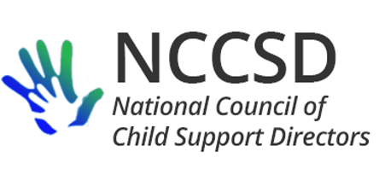

**Executive Committee Meeting**January 16, 2020

**AGENDA**

3:00–4:30 PM Eastern • 2:00–3:30 PM Central • 1:00–2:30 PM Mountain • 12:00–1:30 PM Pacific

**Conference Number: 701-328-0950** **• Access Code: 391545537**

[Join Skype Meeting](https://meet.lync.com/ndgov/jfleming/62Q9Z6Z0)

Members & Attendees

**NAME ROLE(S) NAME ROLE(S)**

Jim Fleming* President Jeremy Toulouse* Region 6

Erin Frisch* Past President Carol Eaton* Region 7

Michele Cristello* Vice President, Audit Chad Dexter* Region 8

Kate Cooper Richardson* Secretary, Region 10, Website Heather Noble* Region 9

Liesa Stockdale* Treasurer, Finance Carla West Systems & Data Sharing

Robin Arnell* Region 1, Systems & Data Sharing David Kilgore Public Relations

Terrence Joseph* Region 2 Eileen Stack Policy & Practice

Benidia Rice* Region 3 Karen Hebert Mentoring/Newbies

Lyndsy Landry Irwin* Region 4 Robert Patrick Collaborative Analytics

Jeff Aldridge* Region 5 Sharon Redmond Collaborative Analytics

**\*Voting member**

Welcome

Roll Call

Approval of Minutes

Treasurer’s Report

President’s Report

Committee Reports

* Audit Workgroup – Michele
* Child Support Employer Workgroup – Jim
* Collaborative Analytics – Sharon, Robert
* Finance Committee – Liesa
* Intergovernmental Committee – Jim
* Joint Committee on Public Relations – David
* Mentoring Committee – Karen
* Policy and Practice Committee – Eileen, Carol
* System Modernization and Data Sharing Workgroup – Carla, Robin
* Website Committee – Kate

Unfinished Business

* Old Ebbitt Grill as location for February 7 director dinner

New Business

* Approval of final 2019 Employer Symposium Report
* Letter of support regarding S.3025 (two-thirds majority vote required)
* Change in type of annual financial review: “The Treasurer shall have a review of the Council financial records conducted, and completed by January 15 each year.”

Next Meeting – February 20, 2020, at 2:00 PM Central