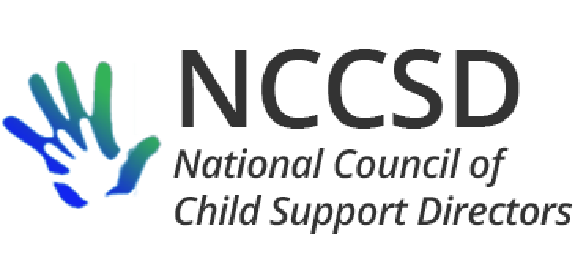

**TO:** NCCSD Executive Committee

**FROM:** Jim Fleming, NCCSD President

**DATE:** January 14, 2020

**RE:** Monthly President’s Report

Pending or Potential Legislation

In new business, the NCCSD Executive Committee will be asked to approve a letter of support for S.3025 on reporting of independent contractors, full faith and credit for bank levies, and in-state bank participation in the multi-state FIDM process. S.3154 regarding tribal access to federal offset and disclosure of FTI to contractors has been introduced. On December 18, Council members Cooper-Richardson and Fleming participated in a phone call with Senator Wyden’s staff to provide information on the proposal, and the Senator ultimately agreed to co-sponsor the legislation. NCCSD took action at a previous meeting to support the bill, including the improvements in authority to share FTI with contractors.

I have exchanged e-mail with Senate Finance Committee majority staff member Ryan Martin on S.3025. “We’re always really grateful to receive support letters as it helps us get support from other members and get bills moving. So if your organization is supportive and willing to have a sign-on letter or something expressing that we’d definitely be grateful.” This obviously poses issues with the prohibition on use of federal dollars for lobbing, but the door is open for NCCSD to express its position on S.3025.

Points of Contact

In addition to Meghan McCann taking on a new role as Senior Policy Analyst with the Education Commission of the States, Lauren Antelo has informed me that she is leaving ASPE and has accepted a new position as Associate Director for Strategic Initiatives in the Office of Regional Operations at the Administration for Children and Families. Lauren believes her new e-mail will be [lauren.antelo@acf.hhs.gov](mailto:lauren.antelo@acf.hhs.gov). Sofi Martinez will be replacing Lauren at ASPE. [Sofi.Martinez@hhs.gov](mailto:Sofi.Martinez@hhs.gov)

OCSE Leadership Meeting

The monthly meeting between NCCSD and OCSE leadership was held on January 13 with Michele and Jim participating on behalf of NCCSD. We submitted a number of agenda items aimed at learning new information from OCSE.

Work Number. OCSE was updated on the recent communication from Equifax to NCCSD.

Employer Symposium Report. OCSE was asked to disseminate the 2019 Employer Symposium Report after it is approved by NCCSD, as it has done in the past.

OCSE 157. With anticipation that the recent audits and “agreement to disagree” approach, OCSE advised that it will be nearly three years (October 2021) before the OCSE 157 form and instructions are open for comment again. This will give NCCSD time to prepare its position on any audit issues (and resulting changes in the OCSE-157) on which it wants to take a position.

Employer Portal. OCSE advised it may be another six months for design work to be finished on employer portal, because the project is connected to similar changes needed for other OCSE stakeholders.

Communication with Congress. In response to our question, OCSE advised that it does not communicate directly with Congress, but rather provides technical assistance upon request through the ACF Office of Legislation and Budget (OLAB).

Upcoming areas of rulemaking. OCSE claimed this was an era of deregulation and mentioned the technical rulemaking from December 2018, which prompted me to remind OCSE that the area of the technical rulemaking receiving the most public comment was something that was not deregulation. OCSE expressed hope that the technical corrections rulemaking would be concluded in the first quarter of 2020. OCSE noted there is a publicly available website on which executive branch agencies maintain a list of pending and upcoming rulemaking in the Fall of each year. <https://www.reginfo.gov/public/do/eAgendaMain>

The website includes a known [upcoming rulemaking](https://www.reginfo.gov/public/do/eAgendaViewRule?pubId=201910&RIN=0970-AC81&operation=OPERATION_PRINT_RULE) for OCSE titled “Optional Exceptions to the Prohibition Against Treating Incarceration as Voluntary Unemployment Under Child Support Guidelines.” The abstract for the upcoming rulemaking provides as follows:

This rulemaking would provide States the flexibility to incorporate in their State child support guidelines two optional exceptions to the prohibition against treating incarceration as voluntary unemployment. Under the proposal, States would have the option to exclude cases: 1) Where the individual is incarcerated due to intentional nonpayment of child support in accordance with guidelines established by the state under 303.6(c)(4); and/or 2) incarceration for any offense of which the individual’s dependent child or the child support recipient was a victim. The State would be able to apply such exception to the individual’s other child support cases.

OCSE expressed hope that this rulemaking would be proposed in the first quarter of 2020.

Medical Support. OCSE advises that it is working with CMS and its technical consultants, and also with Utah IV-D Director Liesa Stockdale on Medicaid referral best practices and state best practices regarding medical support. Six to ten states will be contacted for analysis at a deeper level.

Roles of regional representatives. A fact sheet on the roles and duties of OCSE regional representatives, as requested by NCCSD, is in the clearance process.

Next monthly meeting between OCSE and NCCSD is scheduled for February 10, 2020, at 3 PM Eastern.