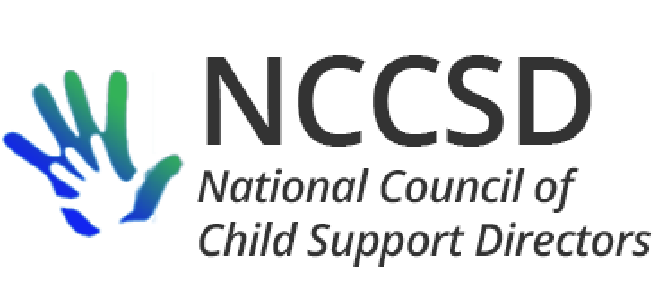

#### President

James C. Fleming, Director

Child Support Division

Department of Human Services

PO Box 7190

Bismarck, ND 58507-7190

701-328-7501

[jfleming@nd.gov](mailto:jfleming@nd.gov)

## **Vice President**

Michele Cristello, Director

Child Support Enforcement Division

Department of Revenue

PO Box 9561

Boston, MA 02114-9561

617-626-4042

[cristellom@dor.state.ma.us](mailto:cristellom@dor.state.ma.us)

### Secretary

Kate Cooper Richardson, Director

Oregon Child Support Program

Department of Justice

1162 Court Street NE

Salem, OR 97301

503-947-4388

[kate.richardson@doj.state.or.us](mailto:kate.richardson@doj.state.or.us)

**Treasurer**

Liesa Stockdale, Director

Office of Recovery Services

515 E 100 S, Suite 100

Salt Lake City, UT 84102

801-536-8901

[lcorbri2@utah.gov](mailto:lcorbri2@utah.gov)

[DATE]

«AddressBlock»

Dear [Name]:

The National Council of Child Support Directors consists of the directors of the state child support programs in the 54 states and territories in the United States. We write to express our support for the child support provisions in S.3025, the “Increasing Opportunities for Former Foster Youth Act.”

New hire reporting of employees is instrumental to establishing and enforcing child support for America’s families. With a growing number of parents participating in the “gig” economy, the extension of new hire reporting to independent contractors would build on successful child support processes today and give child support programs valuable information about the location and earnings of parents of children in our caseloads.

Providing for full faith and credit for account levies across state lines using a standard federal form would improve the efficiency of the child support program by reducing the number of cases where multiple states are enforcing the same obligation. We predict the provision will lead to increases in collections similar to the 1996 Welfare Reform legislation requiring full faith and credit for income withholding and property liens.

Child support programs depend on numerous public and private partnerships to help locate parents and obtain collections. Out of respect for these partnerships, we strive to make the assistance of our partners as simple and easy as possible, and support the option for in-state financial institutions to participate in the same processes as multi-state financial

Lastly, we appreciate the delayed effective date of the bill if needed for states to work with state legislatures on needed changes in state law to implement the improvements in the bill.

NCCSD is pleased to send this letter of support, and is available if you have any questions or need for information as this important legislation moves forward.

Sincerely,

[Author]

[Title]