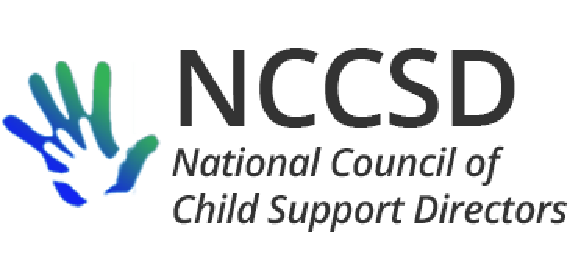

**TO:** NCCSD Executive Committee

**FROM:** Jim Fleming, NCCSD President

**DATE:** February 19, 2020

**RE:** Monthly President’s Report

OCSE Leadership Meeting

The monthly meeting between NCCSD and OCSE leadership was cancelled because it was scheduled only a few days after the NCSEA Policy Forum. Instead, I visited for 90 minutes with Deputy Commissioner Linda Boyer in person on Friday morning February 7 and later got to visit with Commissioner Lekan during the spring dinner.

Some concerns have arisen, and I have asked for a meeting with OCSE leadership which will hopefully be scheduled with the Commissioner and Deputy Commissioner late the week of February 24. Not to raise the alarm too early, but a state’s recent audit experience was challenging and led to the OCSE Office of Audits suggesting that the “agree to disagree” understanding is narrower than we originally understood, and described the relationship between NCCSD and auditors in a negative way (which I have subsequently clarified with the director of the Office of Audits). In addition, despite the Commissioner’s agreement would we be given a heads-up of policy areas being reviewed by OCSE for potential new written guidance, a number of such policy documents have been issued lately without any advance knowledge of NCCSD. This again raises the original concern (prior to our understanding with OCSE) that OCSE will inadvertently issue guidance that is contrary to our widespread understanding or is more substantive than OCSE realizes.

I received the long-awaited document regarding roles and responsibilities of regional representatives, but the description gave me more questions than answers on how active or reactive we can expect our regional representatives to be regarding our work. I posed those questions to OCSE and the division director for regional operations was not in the office. I still hope to hear from her and will disseminate the document once I’m sure it will be the final version.

Next monthly meeting between OCSE and NCCSD is scheduled for March 2, 2020, at 3 PM Eastern. In the meantime, I will update you after my call with OCSE next week.

Work Number.

As discussed during the January report of the Policy and Practice Committee to the Executive Committee, Equifax has given me sample contract documents to review at a high-level for any initial feedback. Mary Beth Parker from Equifax and I met during the Policy Forum and she reassured me that the contract documents for the free service are completely separate from the contract documents for the paid service, and likewise the platforms for using the two services are separate. This was a key concern last summer when NCCSD wrote a letter to Equifax.

Human Services Technology Association

Also at the Policy Forum, I was asked to meet with the Computing Technology Industry Association ([COMPTIA](https://www.comptia.org/)) Human Services IT Advisory Group (HSITAG). I had not previously heard of this group, but it is a nonprofit trade association. HSITAG described itself as a similar organization to APHSA and heavily involved in the ISM conference. HSITAG has prepared white papers on ways that technology can assist human service programs in data capture and analysis that helps deliver services. I provided samples of these white papers to the chairs of our Systems Modernization and Data Analysis Committee. HSITAG is interested in partnering with NCCSD to help us increase familiarity with available technology and its uses.

RFI on Employment Programs

This will be covered in the Policy Committee report, but all states are encouraged to respond to the RFI, especially states who already operate employment programs so they can share their experiences.

NCCSD Annual Meeting

Congratulations to Erin and her team on a financially successful 2019 annual meeting. I hope to submit a proposed 2020 budget by the time of the February 20 Executive Committee meeting. Local arrangements include free AV as part of the room rental from the Medora Community Center, which will save a lot of money. Also, the Medora Community Center authorizes groups to bring their own snacks and agreed to waive the provision prohibiting outside non-alcoholic beverages. As a result, depending on how actual revenue compares to budget, NCCSD can save a lot of money by supplying its own beverages and snacks for breaks. We also want to make sure that the surplus we earn on the event is not excessive, given that we obtain a large amount of money in sponsorships. Experience guides us in terms of places where we can add value to the attendee and vendor experience.

Respectfully Submitted,

Jim Fleming

NCCSD President 2019-2020