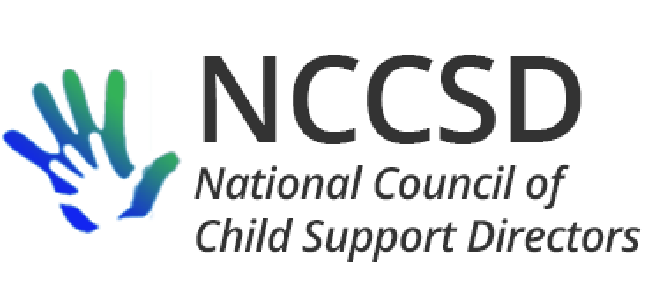

**TO:** NCCSD Executive Committee

**FROM:** Jim Fleming, NCCSD President

**DATE:** April 16, 2020

**RE:** Monthly President’s Report

Has it only been a month? In preparing my monthly report, I usually review e-mail that I have sent to the listserv and e-mail I have exchanged with OCSE in the preceding month. It usually takes about 15 minutes – this time took JUST a little longer.

COVID-19

Michele and I visited with OCSE on March 27 to convey our interest in avoiding the offset of stimulus payments, or at least giving states a choice. We received DCL-20-02 this week, which accepted as given fact that all eligible cases must be submitted by states to OCSE for offset, despite NCCSD’s arguments otherwise.

I anticipate us receiving another set of guidance, possibly not a DCL or IM, on operational issues related to offsets of stimulus payments. OCSE was hoping for the clearance process to be completed any day as of April 14. Also, OCSE still plans on a set of its own Q&A on stimulus payments. At times, it is hard to tell whether OCSE envisions these as two separate things, or one combined item. Lastly, we are looking forward to something from ACF on Stafford Act waivers.

OCSE Leadership Meeting

The monthly meeting between NCCSD and OCSE leadership was held on Monday, April 6. The call consisted of discussion of the recent ACF IM on grants and stimulus payments

Regarding the application of recent IM-ACF-OA-2020-01 – application to mandatory programs

* + #5 - Charging salary and benefits – payable if in line with agency policies for those who are not telework enabled and need to be on administrative leave
  + #6 – allowabilty of costs – cancellation of events and travel, can still be allowed
  + #9 – extension of performance reporting – guidance still in works with HHS because it affects timeframes for drawdown and incentives
  + Extension of currently approved indirect costs; tribes are annual, not so much for states
  + #12 – single audit submission delay – have extension of time

I previously e-mailed the notes of the discussion on stimulus payments. Next monthly meeting between OCSE and NCCSD is scheduled for May 4, 2020, at 3 PM Eastern.

Waiver possibilities

Those mentioned so far, and provided to OCSE as suggestions, are:

1. The most immediate deadline is for the annual self-assessment at the end of March (subsequently extended to May 29, per OCSE on March 17)
2. Two-day distribution will be a difficult timeframe for many states and their contractors to meet
3. Quarterly financial reports, including the OCSE 396 and OCSE 34, will be harder to prepare and submit within usual timeframes
4. Audit response timeframes
5. Establishment and enforcement timeframes
6. Depending on the length of time that the delivery of child support services is disrupted, states may face PEP penalties
7. Clarification or expansion of authority to share information between Child Support and Public Health
8. 157 change implementation
9. IM 2020-01 applied to AAPDU timeframes?
10. Delay for state quadrennial guidelines review?

Miscellaneous

After a concerning experience for one state, OCSE confirmed for NCCSD that SSA will still honor income withholding orders as usual. Also, the Treasury FAQs were quickly and successfully changed to be clear that there is no financial hardship exception for parents who owe child support and want to keep their economic stimulus payments.

I gave a courtesy call to the human service lead staff person at Senate Finance Committee on April 2 to discuss child support distribution and stimulus payments.

At the request of my Department Executive Director, I participated in a meeting coordinated by the Aspen Institute and reviewed a letter Aspen plans to send to Governors asking them to promote opportunities for parents to request child support modifications that will be effective when the request is made, even if courts were not open at that time. Aspen wants states to take the state’s portion of assigned collections from offsets of stimulus payments and send the money to the parent.

Respectfully Submitted,

Jim Fleming

NCCSD President 2019-2020