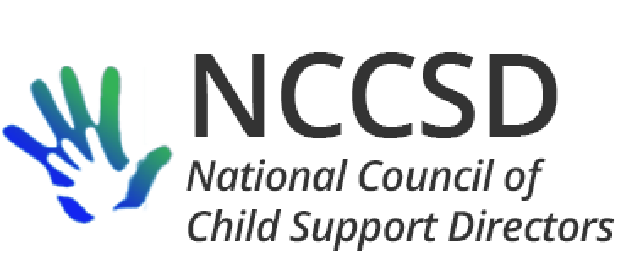

**TO:** NCCSD Executive Committee

**FROM:** Jim Fleming, NCCSD President

**DATE:** May 20, 2020

**RE:** Monthly President’s Report

OCSE Leadership Meeting

Three sets of FAQs were released by OCSE in the last month. As of this writing, OCSE has just responded to a request to revisit the FAQ on FMAP increase, and this issue is included on the Executive Committee’s May meeting agenda under New Business. A multitude of questions are pending with OCSE.

The monthly NCCSD and OCSE leadership meeting was held on Monday, May 4. The call opened with a request for OCSE to increase the frequency with which it provides information or updates to state directors. Directors can judge for themselves whether this has been true in the last 16 days. We also covered stimulus payments and issues related to joint returns (this was prior to issues surfacing regarding deceased and incarcerated recipients). It was noted, briefly, that states will not be able to submit the OCSE-157 using the new form even if they are ready (implementation of the new form was originally scheduled for 2020 but has been pushed back until 2021). It was also emphasized that any delayed federal reports for second quarter of FY 2020 need to be submitted prior to submitting the reports for third quarter.

Annual NCCSD Meeting

Article VIII of our bylaws requires NCCSD to hold an annual business meeting. With the indefinite postponement of our meeting in Medora until at least 2021, we need to schedule an alternate meeting before the end of the Federal fiscal year. Not surprisingly, our bylaws do not anticipate holding a virtual meeting in the middle of a pandemic. However, since many of us have travel restrictions from time to time. Article IX Paragraph A of the bylaws provide: “At a duly called meeting to the Council, the presence of 34% of the members, in attendance in person and via conference call, shall constitute a quorum.” The bylaws do not establish a minimum number of directors who need to attend a meeting in person, so it is my recommendation that we set a time for all directors to participate in a virtual annual business meeting.

At the last meeting of the Executive Meeting, there was discussion about having the 2021 annual meeting in Medora North Dakota. I have asked the Foundation to hold the week of July 18, 2021. They agreed, and have asked if we could confirm by August 1, 2020.

Respectfully Submitted,

Jim Fleming

NCCSD President 2019-2020