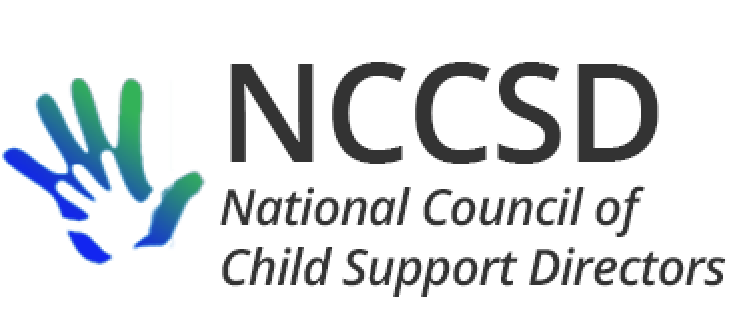

**TO:** NCCSD Executive Committee

**FROM:** Jim Fleming, NCCSD President

**DATE:** June 17, 2020

**RE:** Monthly President’s Report

The last month has continued a trend where communication among directors has remained very active, which not only shares ideas and best practices but also support and encouragement as we face common challenges and sources of stress. I continue to receive thanks from ERICSA and WICSEC for the survey responses that are periodically shared with their presidents when updates occur.

ACF Meeting

I have forwarded e-mail to all directors on follow-up to the meeting, including the list for a written description of remaining issues or concerns. This item is included in the agenda for discussion by the Executive Committee on June 18 to determine how to respond.

OCSE

The monthly meeting was not held in light of the Executive Committee action to refrain from organized interaction with OCSE until a meeting could be scheduled with ACF. A number of policy changes have been issued in the last month, including:

* Additional COVID-19 [FAQs](https://www.acf.hhs.gov/css/resource/delayed-implementation-of-revised-ocse-157-data-report-2021-10-01)
* [AT-20-07](https://www.acf.hhs.gov/css/resource/final-rule-child-support-technical-corrections) Final technical corrections rule (concurrent benefits)
* [DCL-20-04](https://www.acf.hhs.gov/css/resource/flexibilities-for-state-and-tribal-child-support-agencies-during-covid-19) Stafford Act waiver guidance
* [AT-20-06](https://www.acf.hhs.gov/css/resource/delayed-implementation-of-revised-ocse-157-data-report-2021-10-01) Delay in implementation of OCSE 157 changes

Most recently, we have been advised that a DCL is being finalized which will confirm OCSE’s decision not to impose PEP penalties for 2020 and 2021. NCCSD was also advised that OCSE will be recommending to the Senate regarding HR 6800 (Heroes Act) that 2020 and 2021 incentives be disbursed based on 2019 incentive percentages and 2019 audited data.

The continuity spreadsheet was changed to add a column so states can report waiver request beyond those listed in DCL-20-04.

Annual NCCSD Meeting

The annual meeting has been divided into a business meeting and a virtual webinar. The business meeting has been scheduled in two parts for July 28 and 29 (if needed). The seminar portion of our annual meeting will be replaced with webinars developed by a planning committee chaired by Lyndsy Landry Irwin (MS) and Adam Norman (IN).

Cost Avoidance Studies

During a “Time for You” call, it was mentioned that it would be nice to have more up-to-date information about cost avoidance in Child Support. Jerry Joy in Vermont provided the following description for cost avoidance estimates he received from Laura Wheaton at Urban Institute:

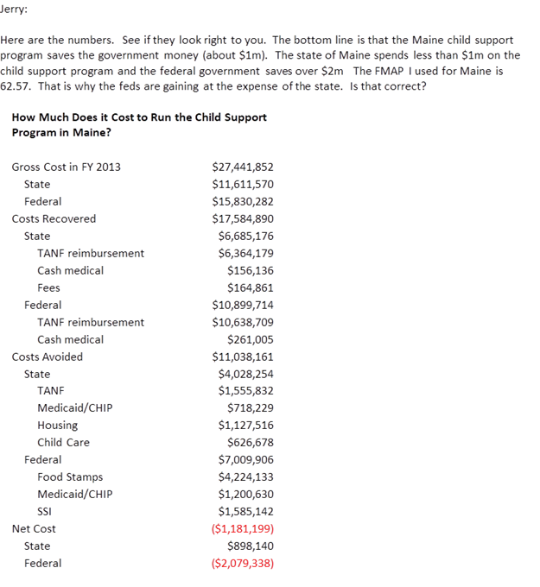

It would be good to discuss whether to commit roughly $30,000 to obtain a national and state level update to these figures.

Respectfully Submitted,

Jim Fleming

NCCSD President 2019-2020