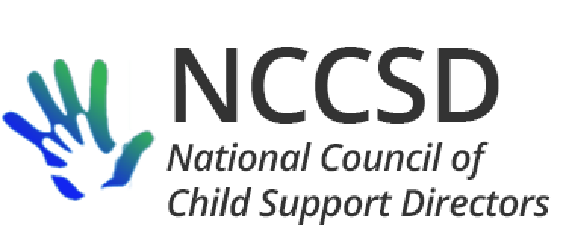

**TO:** NCCSD Executive Committee

**FROM:** Jim Fleming, NCCSD President

**DATE:** July 15, 2020

**RE:** Monthly President’s Report

Another quiet month (not!) as the members of our association continue to communicate frequently to support each other and share helpful information.

The agenda for this meeting includes suggested action on two important pieces of unfinished business – a letter to ACF detailing our concerns and a COVID impact statement. Highlights of the last month:

* Delayed incentive payments from OCSE, based apparently on internal confusion or disagreement on the appropriate inflation rate
* Child Support Director Association of California interested in partnering on the cost avoidance study
* Still waiting for something in writing from Treasury on their intentions regarding economic impact payments made erroneously to incarcerated and deceased individuals
* Directors have shared Stafford Act waiver requests and OCSE responses; OCSE provided summary of waiver requests that have been approved and, at request of many directors, have started to identify the states submitting the request if the state has consented to the release. One of the notable waivers approved so far is skipping the annual self-assessment process. OCSE has clarified some timing aspects of the waivers.
* On July 1, OCSE announced a national workgroup on the pandemic, apparently with the intent of co-sponsoring with NCCSD, without telling NCCSD
* ACF no longer believes it has authority to waive PEP performance penalties without a change in federal law, but has suggested it is working on a different approach
* OCSE advised that ASPE is sponsoring a 6-state survey of remote delivery of services under many HHS programs

Respectfully Submitted,

Jim Fleming

NCCSD President 2019-2020