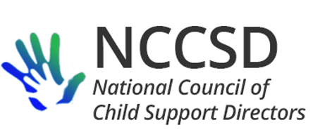

**Executive Committee Meeting**[Day, Date]

**AGENDA**

3:00–4:30 PM Eastern • 2:00–3:30 PM Central • 1:00–2:30 PM Mountain • 12:00–1:30 PM Pacific

[Join Microsoft Teams Meeting](https://teams.microsoft.com/l/meetup-join/19%3ameeting_ZTEwOGM3YTktN2Y2Zi00OTk2LThiZTctZTc2NjQ2MDlkNmEy%40thread.v2/0?context=%7b%22Tid%22%3a%222dea0464-da51-4a88-bae2-b3db94bc0c54%22%2c%22Oid%22%3a%2279e46aac-8322-4659-b288-33c805214023%22%7d)

[+1 701-328-0950](tel:+1%20701-328-0950,,531932899# )   United States, Fargo (Toll)

Conference ID: 531 932 899#

**NAME ROLE(S) NAME ROLE(S)**

Jim Fleming* President, Employer Collaboration Carla West* Region 4, Systems & Data

Erin Frisch* Past President, Region 5, Policy Jeremy Toulouse* Region 6

Michele Cristello* Vice President, Audit Cindy Wiesen* Region 7

Kate Cooper Richardson* Secretary, Website Chad Dexter* Region 8

Liesa Stockdale* Treasurer, Finance Heather Noble* Region 9

Karen Hebert* Region 1, Mentoring Sharon Redmond* Region 10

Eileen Stack* Region 2, Policy & Practice Robin Arnell Systems & Data Sharing

Ted Mermigos* Region 3 David Kilgore Public Relations

*\*Voting member*

Welcome

* Guests – Annual Conference Program Committee co-chairs

Roll Call

Approval of Minutes

Treasurer’s Report

President’s Report

Committee & Workgroup Reports

* Audit Workgroup – Michele
* Child Support-Employer Collaboration Workgroup – Jim
* Finance Committee – Liesa
* Joint Committee on Public Relations – David
* Mentoring Committee – Karen
* Policy & Practice Committee – Eileen, Erin
* System Modernization & Data Sharing Workgroup – Carla, Robin
* Website Committee – Kate
* Annual Conference Program – Sharon and Adam

Unfinished Business

* Reversals of offsets of EIP for joint filers
  + Waiver extensions – any remaining anticipated reversals? OCSE scheduling a meeting with BFS and IRS
  + Will IRS reconcile Recovery Rebate Credits with eligibility for payments and later reverse excess amounts claimed by the taxpayer?
* Annual meeting and conference budget

New Business

* Letter from American Payroll Association regarding e-NMSN

Next Meeting – April 15, 2021, at 2:00 Central