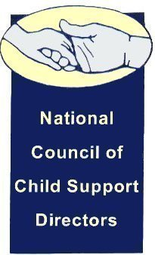

|  |  |  |
| --- | --- | --- |
|  |  | **F:\2016 NCCSD Slide Decks\Logo.png** |
|  |  |

Dear child support family,

Thank you all for participating in our 2017 annual NCCSD conference. I trust you’re all safely back home and figuring out how to integrate the things you heard into your work.

The many hands and minds and hearts that toiled and united to make this conference happen also made it a huge success. Great, thought-provoking, masterfully presented sessions, broad participation, tremendous networking, and huge support from our community and sponsors filled my notepads with ideas and inspiration to bring back to my teammates.

Attached, please find the slide decks and handouts for many of the sessions. And please take a few minutes to complete the [brief survey](https://www.surveymonkey.com/r/VL9RXC2) so next year’s conference can be even better.

It was my honor to host you in our Emerald City. I hope to see you next year in Virginia hosted by our charming President-elect, Craig Burshem.

Wally McClure, President

### President

Wally McClure, Director

Division of Child Support

Dept. of Social and Health Services

712 Pear Street SE

Olympia, WA 98507-9162

(360)664-5225; (360)586-3274 (fax)

[mccluwj@dshs.wa.gov](mailto:mccluwj@dshs.wa.gov)

#### Vice-President

Craig Burshem, Director

Div. of Child Support Enforcement

Department of Social Services

801 E. Main St. 12th Floor

Richmond, VA 23219-2901

(804)726-7405; (804)726-7476 (fax)

[craig.burshem@dss.virginia.gov](mailto:craig.burshem@dss.virginia.gov)

## **Secretary**

Erin Frisch, Director

Office of Child Support

Dept. of Health and Human Services

201 N. Washington Ave. Suite 401

Lansing, MI 48909-8078

(517)241-7460; (517)373-4980 (fax)

[FrischE@michigan.gov](mailto:FrischE@michigan.gov)

**Treasurer**

James C. Fleming, Director

Child Support Enforcement Program

Department of Human Services

P.O. Box 7190

Bismarck, ND 58507-7190

(701)328-7501; (701)328-6575 (fax)

[jfleming@nd.gov](mailto:jfleming@nd.gov)