**DRAFT - NOT FOR DISTRIBUTION**

**ACTION TRANSMITTAL**

**OCSE-AT-16-XX**

**DATE: TBD**

**TO**:  State Agencies Administering Child Support Plans under Title IV-D of the Social Security Act and Other Interested Individuals

**SUBJECT:**  Interstate Child Support Payment Processing

**STATUTORY REFERENCE:** 42 U.S.C. 654, 42 U.S.C. 654A, 42 U.S.C. 654B, 42 U.S.C. 666.

**PURPOSE:** Several state child support agencies have requested guidance from the federal Office of Child Support Enforcement (OCSE) on the issue of payment processing when parties live in different states, especially as related to state enactment of the Uniform Interstate Family Support Act (UIFSA) last amended by the Uniform Law Commission (ULC) on September 30, 2008. This Action Transmittal (AT) addresses basic interstate responsibilities and payment processing principles and many of the inquiries and concerns received by OCSE on interstate payment processing, but it is not intended to be exhaustive or to capture the complexity of all possible interstate scenarios.

**BACKGROUND:** In the United States, over $1.5 billion in child support is collected by one state and forwarded to another state each year.[1] Cooperation among the states in interstate child support enforcement is critical to the success of the Title IV-D program and mandatory as a condition of receiving federal financial participation (FFP).

Federal requirements for interstate cases help ensure that all children receive support, regardless of where their parents reside. When a parent owing support lives in another state, a state child support agency must consider using one-state remedies, including direct income withholding, to enforce the support obligation in accordance with 45 CFR 303.7(c)(3). If one-state remedies are not appropriate, an interstate IV-D case must be initiated (45 CFR 303.7(c)(4)(ii)), and the responding state will collect support using the same procedures as in intrastate IV-D cases (45 CFR 303.7(d)(6)). If the parent owed support applies for services in a state that did not issue the child support order, section 454B(b)(1) of the Social Security Act (Act) allows for payment forwarding between states to facilitate the proper distribution of support.

Against this backdrop of federal law and regulations is UIFSA, state law first adopted in 1992 by the ULC that governs interstate child support establishment, modification, and enforcement. In 2001, the ULC added sections 307(e) and 319(b) to UIFSA as a new state law option for payment redirection for child support agencies when neither the parents nor child reside in the order-issuing state. In that circumstance, either the support enforcement agency of the state that issued the order or another state can request redirection of payments, and UIFSA section 319(b) imposes a limited duty on the order-issuing state to (1) direct support payments to the state child support agency providing services to the parent owed support and (2) issue and send to the employer of the parent owing support an income withholding order or administrative notice of change of payee reflecting the new payment location. These provisions were retained in UIFSA 2008, which all states were required to enact in accordance with the Preventing Sex Trafficking and Strengthening Families Act (P.L. 113-183).

UIFSA redirection requests are discretionary, not mandatory. Instead of making a UIFSA redirection request, state child support agencies may find it more efficient to use traditional enforcement options. This AT provides guidance on these options, which include one-state remedies, requests for payment forwarding from the order-issuing state’s SDU to another state’s SDU, and interstate IV-D case referrals, as well as the new option for payment redirection under UIFSA sections 307(e) and 319(b).

*Scenarios and Diagrams*

This AT contains scenarios that provide examples of different interstate enforcement fact patterns and the corresponding payment path. In every scenario, State A is the order-issuing state and responsible for maintaining a record that accounts for payments made by the parent owing support. State B is the state where one or both of the parents now reside. In the scenarios involving three states, one parent resides in State C. In all of the scenarios, the child resides with the parent owed support. This AT also includes diagrams that illustrate the payment path for several of the scenarios.

**ONE-STATE REMEDIES**

*Definition*

**One-state remedies**: As defined in 45 CFR 301.1, “’One-state remedies’ means the exercise of a State’s jurisdiction over a non-resident parent or direct establishment, enforcement, or other action by a State against a non-resident parent in accordance with the long-arm provision of UIFSA or other State law.”

*Introduction*

When the parent owing support resides in another state, the IV-D agency must determine in accordance with 45 CFR 303.7(c)(3), “whether it is appropriate to use its one-state remedies to . . . enforce a support order, including . . . income withholding.” 45 CFR 303.100(a)(1) provides: “The State must ensure that in the case of each noncustodial parent against whom a support order is or has been issued or modified in the State, and is being enforced under the State plan, so much of his or her income…must be withheld…as is necessary to comply with the order.”

Section 501 of UIFSA allows a state child support agency to send an income withholding order to an employer in a different state. In accordance with section 502(b), “[t]he employer shall treat an income-withholding order issued in another state which appears regular on its face as if it had been issued by a tribunal of this state.” This enforcement tool is commonly referred to as “direct income withholding.”

*Scenario: The parent owing support leaves the order-issuing state*

**QUESTION 1:** A IV-D child support order is entered in State A, designating State A’s SDU as the payment location. The parent owing support moves to State B. May State A enforce its support order directly by sending an income withholding order to the parent’s employer in State B? If so, where should the employer send the payments?

**RESPONSE 1:** Yes. This is the simplest example of “direct income withholding,” where the order-issuing state continues to enforce its own order. 45 CFR 303.7(c)(3) requires State A to determine whether direct enforcement of its order through income withholding is appropriate in this case. UIFSA section 501 authorizes a state child support agency to send an income withholding order issued in one state directly to an employer located in another state, and UIFSA section 502 requires the employer to treat the order, if regular on its face, as if it had been issued by a local tribunal. The income withholding order sent to the employer in State B (on the OMB-approved Income Withholding for Support form) should identify State A as the “appropriate SDU” and direct that payments be sent from the employer in State B directly to State A’s SDU, which then will distribute the collection in accordance with section 457 of the Act as shown in **Diagram 1**.

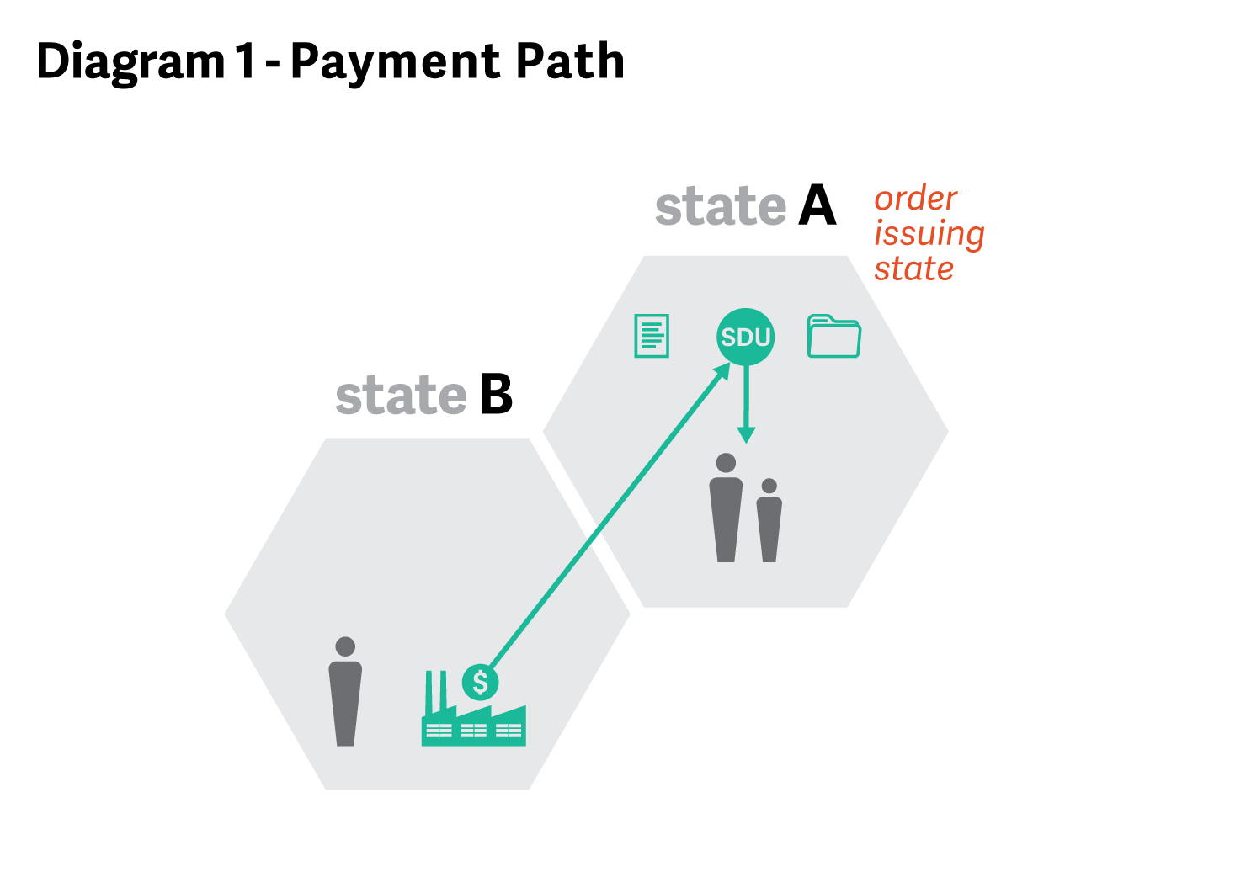

*Scenario: The parent owed support leaves the order-issuing state*

**QUESTION 2:** A IV-D child support order is entered in State A, designating State A’s SDU as the payment location. The parent owed support moves to State B and applies for child support services. The parent owing support continues to live and work in State A. May State B directly enforce State A’s support order by sending an income withholding order to the parent’s employer in State A?

**RESPONSE 2:**  Yes, but 45 CFR 303.7(c)(3) requires State B to first determine whether direct enforcement of State A’s order through income withholding is appropriate in this case. Within no more than 20 calendar days of receiving the parent’s application for services, in accordance with 45 CFR 303.2(b)(1), State B must open a case and “[s]olicit necessary and relevant information from the custodial parent and other relevant sources and initiate verification of information, if appropriate.”

If State B determines that State A has an open and active IV-D case with an effective income withholding order in place for current support, it is unnecessary and inappropriate for State B to issue another income withholding order as it would be confusing to the employer, and could subject the parent owing support to double collection. If there is an effective income withholding order in place, State B should request that State A forward payments to State B’s SDU to facilitate disbursement and monitor future compliance with the order. Section 454B of the Act requires that every SDU use automated procedures for the collection of payments from other states and the disbursement of payments to the agencies of other states in these types of cases, and FFP is available for services provided by both states in accordance with 45 CFR 304.20(b)(4) to facilitate the forwarding of payments.

If State B determines that there is no current income withholding order in place, direct enforcement of State A’s order may be appropriate and section 501 of UIFSA authorizes State B to send an income withholding order directly to the employer in State A. However, the income withholding order sent by State B to the employer must specify State A’s SDU. As explained in PIQ-01-01 in response to a question regarding the payment designation when using direct income withholding under UIFSA section 501 to enforce another state’s order (Response to Question 2):

[I]f a support order or income withholding order issued by one State designates the person or agency to receive payments and the address to which payments are to be forwarded, an individual or entity in another State may not change the designation when sending a [direct] Order/Notice to Withhold Child Support.

UIFSA section 502(c)(2) requires an employer to forward funds as directed by the terms of the withholding order. In the official comment to section 502(c)(2), the ULC explained that: “the destination of the payments must correspond to the destination originally designated or subsequently authorized by the issuing tribunal, such as by the redirection of payments pursuant to Section 319.”

OCSE recognizes, however, that State B is providing IV-D services to the parent owed support and is responsible for distribution and disbursement of payments. In order to route payments from State A’s SDU to State B’s SDU for disbursement to the parent, as demonstrated in **Diagram 2** below, State B should request that State A forward the payments to State B’s SDU.

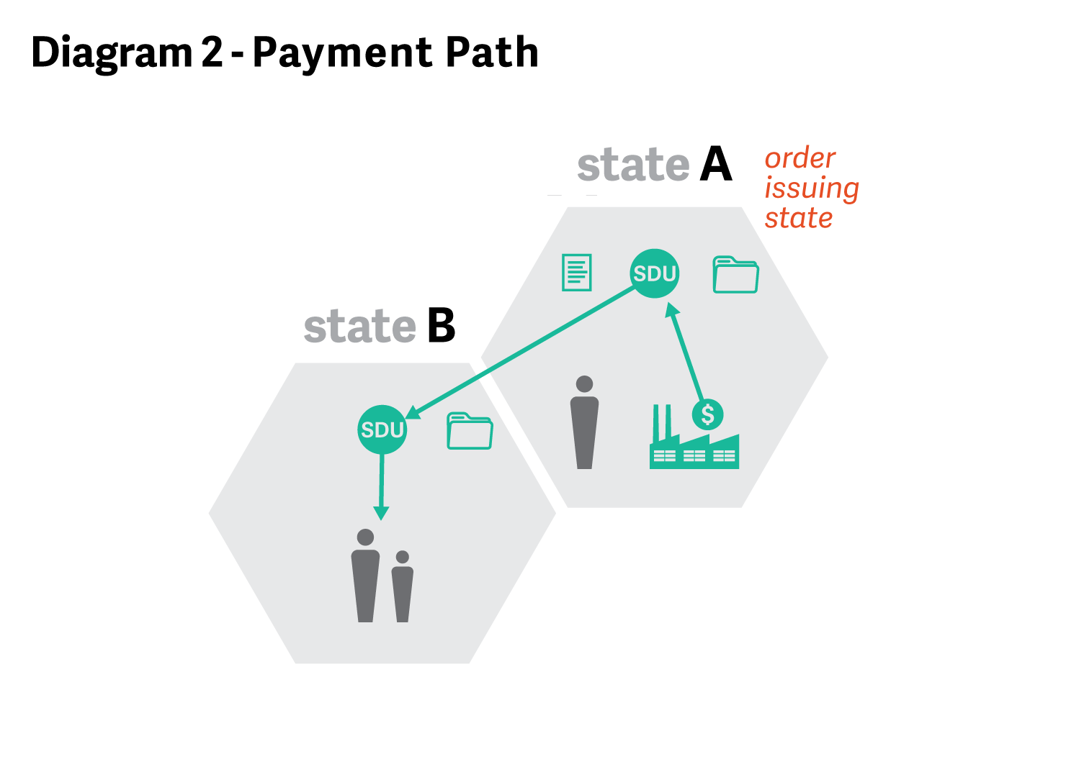

**QUESTION 3:** Using the scenario presented by Question 2, assume the case originally had been a non-IV-D case in State A and State A has no record of the non-IV-D order on its state case registry. May State A reject State B’s request to forward the payments to State B’s SDU?

**RESPONSE 3:** No. Section 454A(e)(1) of the Act requires each state to have a state case registry that contains records with respect to every case in which IV-D services are provided and “each support order established or modified in the State on or after October 1, 1998.” Therefore, the state case registry in State A must contain a record for both IV-D cases and non-IV-D orders. If State A has no record of the non-IV-D order, it must update its state case registry. As explained in PIQ-10-01, FFP is available for state child support agencies to enter data elements on non-IV-D orders listed in 45 CFR 307.11(e)(3) into the state case registry.

*Scenario: Both parents leave the order-issuing state and now reside in different states (3 state involvement)*

**QUESTION 4:** A IV-D child support order is entered in State A, designating State A’s SDU as the payment location. The parent owed support moves to State B and applies for services. The parent owing support moves to State C. May State B directly enforce the child support order by sending an income withholding order to the parent’s employer in State C?

**RESPONSE 4:** Yes, but first State B should determine whether State A or State C already has an income withholding order in effect. Because multiple states are involved in this case, states must work together to avoid duplicative and potentially confusing collection efforts.

If it is necessary and appropriate for State B to do direct income withholding in this case, as in Response 2, the income withholding order must specify State A’s SDU as the appropriate payment location. After State B requests that State A forward the payments to State B for distribution and disbursement, payments will flow from the employer in State C through State A’s SDU to State B’s SDU, as demonstrated by **Diagram 3**.

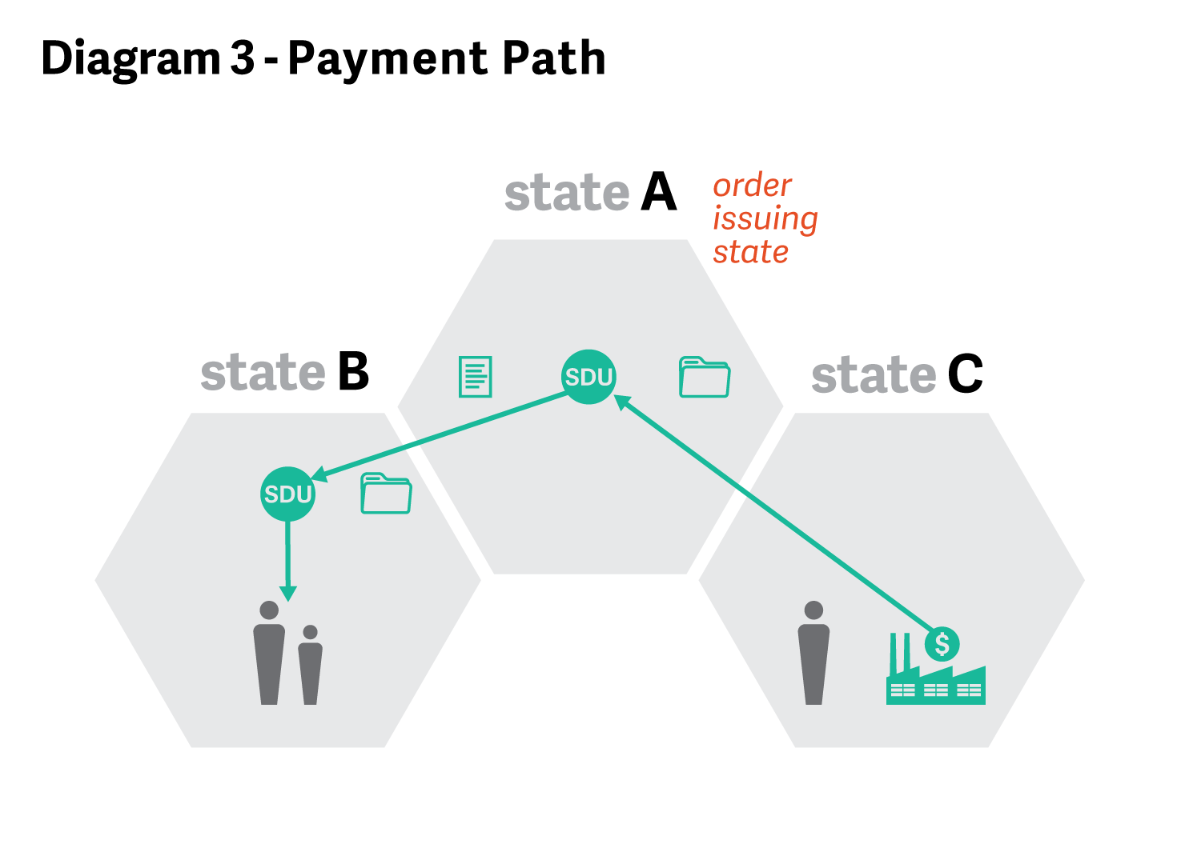

*Conclusion*

One-state remedies are an integral part of interstate child support collection, and direct income withholding provides an expedient way for programs to get support for a family. One-state remedies, however, are not always the most efficient or appropriate means to provide services in a particular case. Since direct income withholding involves one state’s interstate enforcement of support against a non-resident parent, as opposed to a state’s intrastate enforcement of support against a resident parent, the payment location reflected on the direct income withholding notice must reflect the payment location specified in the controlling order. In addition, when multiple states are involved, the risk of duplicative direct enforcement is a concern that states must work together to address and avoid.

**INTERSTATE IV-D CASE REFERRAL**

*Definition*

**Interstate IV-D case**: As defined in 45 CFR 301.1, “Interstate IV-D case means a IV-D case in which the noncustodial parent lives and/or works in a different State than the custodial parent and child(ren) that has been referred by an initiating State to a responding State for services. An interstate IV-D case also may include cases in which a State is seeking only to collect support arrearages, whether owed to the family or assigned to the State.”

*Introduction*

Section 454(9) of the Act requires that each state “cooperate with any other State . . . in securing compliance by a noncustodial parent residing in such State (whether or not permanently) with an order issued by a court of competent jurisdiction against such parent for the support. . . of the child.” Section 466(b)(9) of the Act provides that a state “must extend its withholding system under this subsection so that such system will include withholding from income derived within such State in cases where the applicable support orders were issued in other States.” In addition, section 454B(b)(1) of the Act requires efficient payment processing for disbursements to the agencies of other states and section 454(9)(D) mandates cooperation with other states in carrying out child support functions under the Act.

In the Child Support Enforcement Amendments of 1984 (Pub. L. 98-378), Congress added provisions to improve interstate enforcement including a new provision in section 458 of the Act, which requires child support collected in interstate IV-D cases to be credited in full to both the initiating and responding state agencies for purposes of computing incentive payments.

The need to integrate interstate IV-D cases into a state’s intrastate child support enforcement system to effectuate the new Congressional mandate was explained by an advisory group comprised of representatives of the American Bar Association and the National Conference of State Legislatures as follows:

It was beneficial to create a simple procedure for interstate withholding which merely ties into the State’s intrastate system and borrows heavily from its procedures. The chief advantages of this nexus between the interstate and intrastate withholding laws are that it encourages placing responsibility for the interstate and intrastate withholding in the same agency and facilitates use of the State’s regular income withholding procedures. (AT-86-20, Responding State IV-D Agency Responsibilities).

In the final rule published in 1988, OCSE substantially revised 45 CFR 303.7 to delineate the duties of the responding agency in an interstate IV-D case. As the federal regulations today require, the responding state agency must “[p]rovide any necessary services as it would in an intrastate IV-D case” (45 CFR 303.7(d)(6)), including “processing and enforcing orders referred by an initiating agency, whether pursuant to UIFSA or other legal processes, using appropriate remedies applied in its own cases” (45 CFR 303.7(d)(6)(iv)). Further, section 603(b) of UIFSA provides that: “A registered support order issued in another state or a foreign country is enforceable in the same manner and is subject to the same procedures as an order issued by a tribunal of this state.” As in all intrastate IV-D cases, the responding agency’s duties will include, as appropriate or necessary:

* monitoring compliance with the child support order (45 CFR 303.6(a))
* identifying any delinquency (45 CFR 303.6(b))
* initiating income withholding (45 CFR 303.6(c)(1); 45 CFR 303.100)
* taking other appropriate enforcement action when a delinquency occurs (45 CFR 303.6(c)(2)), including submitting the case for a state tax refund intercept (45 CFR 303.6(c)(3); 45 CFR 303.102).

The responding agency also is responsible for “[c]ollecting and monitoring any support payments from the noncustodial parent and forwarding payments to the location specified by the initiating agency” (45 CFR 303.7(d)(6)(v)). Consistent with the UIFSA 603(b) provision for enforcement using intrastate remedies, this rule authorizes the responding state to route collections and payments through its own SDU. Federal regulations further provide that “[i]n interstate IV-D cases, amounts collected by the responding State on behalf of the initiating State must be forwarded to the initiating State within 2 business days of the date of receipt by the SDU in the responding State” (45 CFR 302.32(b)(1)). In accordance with these regulations and section 458(c) of the Act, both states receive credit for those collections.

OCSE recognizes that this intrastate withholding process, which allows enforcement of an out-of-state order against a resident parent as if it had been issued by the responding state, results in collections flowing through the responding state’s SDU. In contrast, as explained in Response 2, when a state uses direct income withholding to collect support from a non-resident parent based upon another state’s order, the payment location must reflect the designation in the controlling order. In both, the order-issuing state remains responsible for maintaining an accurate payment record.

In an interstate IV-D case, the initiating state (if not the order-issuing state) needs to keep the order-issuing state apprised of any payments received to allow for accurate record keeping. As OCSE advised in AT-98-30 (Response to Question 73):

For consistency with UIFSA’s premise that the issuing State is responsible for the accounting of payments under its order, when the issuing State is neither the responding nor initiating State in a IV-D case, the initiating State, upon receipt and distribution of collections in an interstate case, should notify the issuing State of payments under its order to ensure accurate accounting by the issuing State.

*Scenario: The parent owed support leaves the order-issuing state*

**QUESTION 5:** A IV-D child support order is entered in State A, designating State A’s SDU as the payment location. The parent owed support moves to State B and applies for child support services. The parent owing support continues to live and work in State A. State A has an open IV-D case and an effective wage withholding order in place. May State B initiate an interstate IV-D case to State A?

**RESPONSE 5:** Yes, federal law allows State B to refer an interstate IV-D case to State A. However, as in Response 2, State A already has an open IV-D case and an effective wage withholding order in place. Therefore, State B may simply request that State A forward payments to State B’s SDU, without the need for a full interstate IV-D case referral.

*Scenario: The parent owing support leaves the order-issuing state*

**QUESTION 6:** A IV-D child support order is entered in State A, designating State A’s SDU as the payment location. The parent owing support moves to State B. If the parent owing support stops making payments, may State A refer an interstate IV-D case to State B?

**RESPONSE 6:** Yes, but it usually will be more efficient and preferable for State A to initiate direct income withholding if the parent owing support is employed in State B. If State A determines direct income withholding would not be effective or additional services are needed, State A may initiate an interstate case to State B and send the documents required for registering and enforcing the State A order to State B. Section 507(b) of UIFSA requires State B to “consider and, if appropriate, use any administrative procedure authorized by the law of this state to enforce a support order.” If State B determines that administrative enforcement under section 507(b) is not appropriate, State B will register and enforce the State A order under section 603(b) of UIFSA. In both instances, State B will enforce the order as an intrastate case by collecting and monitoring incoming support payments through State B’s SDU and forwarding those payments to the SDU of the initiating state, State A, for distribution in accordance with 45 CFR 303.7(d)(6)(v), as demonstrated in **Diagram 4**.

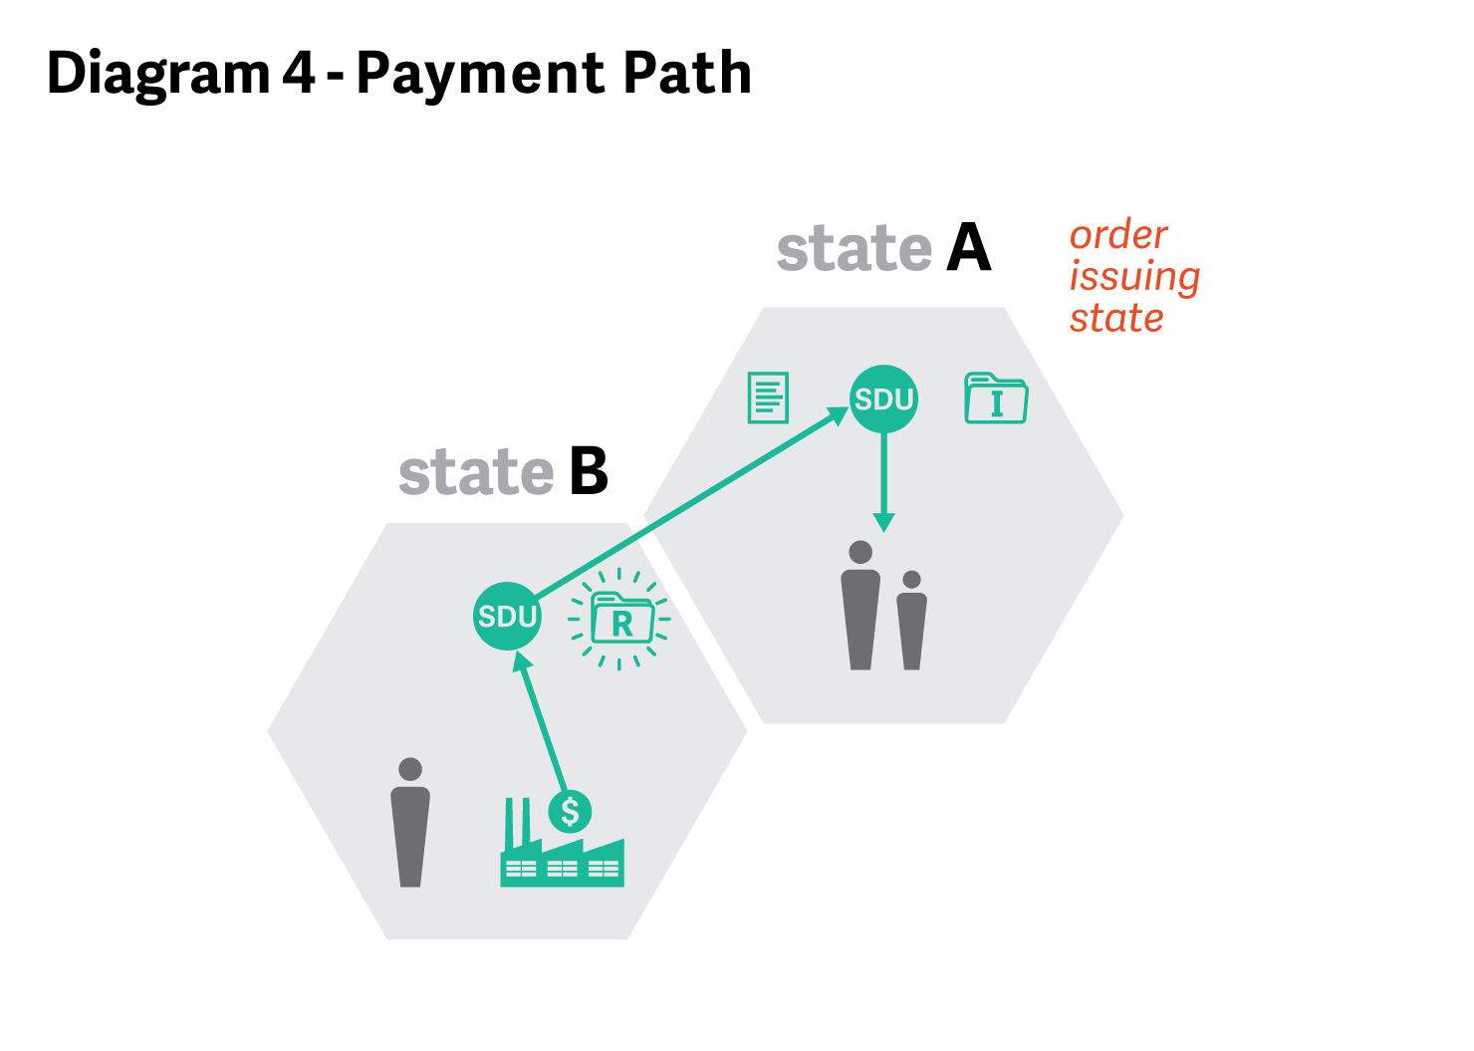

**QUESTION 7:** Using the scenario presented in Question 6, what if State B disagrees with State A’s decision to send an interstate IV-D case as opposed to directly enforcing the order using one-state remedies?

**RESPONSE 7:** It is the initiating state’s responsibility to decide the appropriateness of one-state remedies, as required under 45 CFR 303.7(c)(3). As OCSE explained in AT-98-30 (Response to Question 26):

[T]he decision whether to pursue enforcement of a support order via a direct income withholding action or via a traditional two-state process rests with the initiating State. If a State believes that direct withholding is the most appropriate service for a particular case, then that State should pursue the direct income withholding remedy. If, however, enforcement actions other than income withholding are desired, then it would be necessary for the initiating State to formally request the assistance of the IV-D program in the obligor’s State of residence. In short, the responding State cannot dictate what enforcement actions the initiating State must pursue.

Whereas direct income withholding is usually the preferred enforcement method, other services such as state tax refund offset, lien registry, or license revocation may be warranted under certain circumstances. States should communicate and determine whether one-state or interstate remedies are required, or a combination of both.

*Scenario: Both parents leave the order-issuing state and now reside in different states (3 state involvement)*

**QUESTION 8:** A IV-D child support order is entered in State A, designating State A’s SDU as the payment location. The parent owed support moves to State B and applies for child support services. The parent owing support moves to State C and stops making payments. Can State B refer an interstate IV-D case for registration and enforcement to State C?

**RESPONSE 8:** Yes, State B may initiate an interstate IV-D case to State C. As the responding agency, State C may use administrative procedures or else register State A’s order for enforcement against the resident parent. State C would then use appropriate intrastate remedies as applied in its own cases, including identifying an employer in the state for the paying parent and sending an income withholding order. In contrast to direct income withholding against a non-resident parent, as contemplated in the Responses to Questions 2 and 3, where payments must flow through the order-issuing state, the intrastate income withholding order will direct that payments should be made through State C’s SDU, and then be forwarded to the initiating state, State B, within two business days for distribution to the parent owed support. In accordance with 45 CFR 303.7(d)(6)(v) and 45 CFR 302.32(b)(1), State C must collect and monitor support payments made through its SDU, but State A remains the order-issuing state and should be notified by the initiating state of any payments received. This payment path is demonstrated in **Diagram 5**.

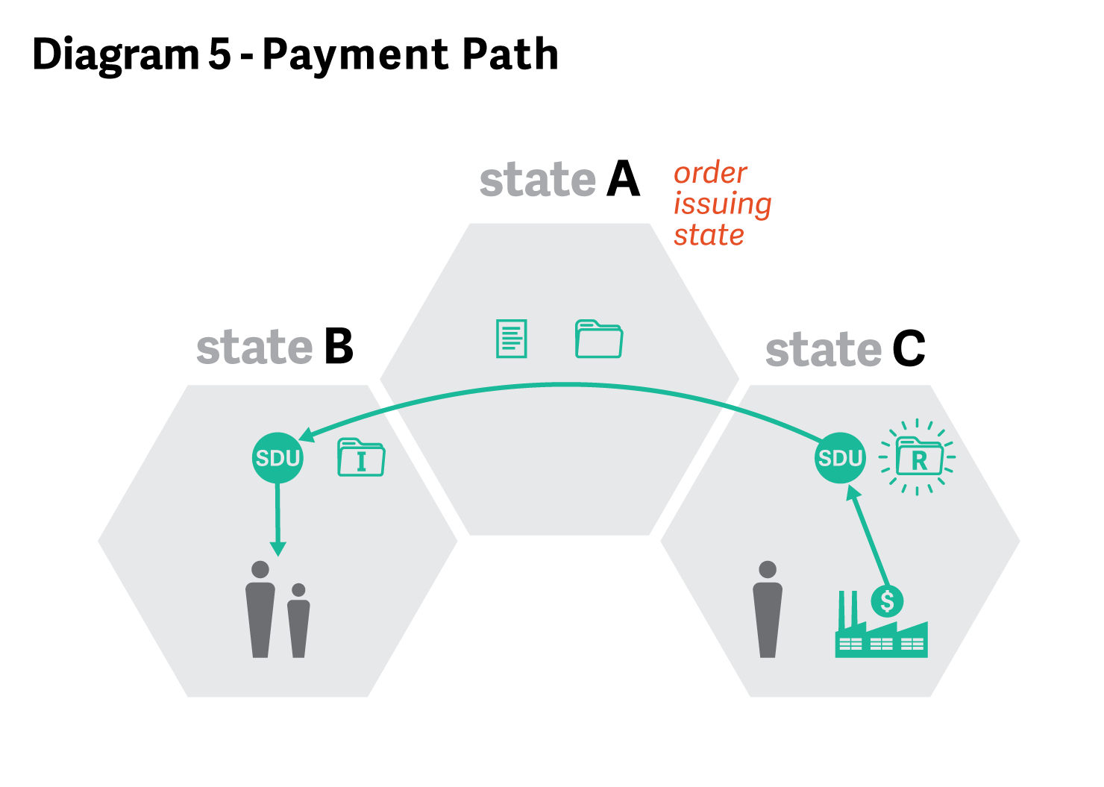

**QUESTION 9:** Using the scenario presented by Question 8, what obligation does each state have for maintaining payment records?

**RESPONSE 9:** In accordance with section 454(10) of the Act, each state child support agency must maintain a record of all support collected and disbursed.

As the order-issuing state, State A ultimately is responsible for the accounting of all payments made under its order. Therefore, State B, as the initiating state, should regularly inform State A of any payments collected and disbursed.

**QUESTION 10:** Using the scenario presented by Question 8, which state is responsible for distributing the support?

**ANSWER 10:** The initiating state, State B, is responsible for distribution in accordance with 303.7(c)(10).

*Scenario: Case closure when both parents leave the order-issuing state*

**QUESTION 11:** In the scenario presented in Question 8 where all parties have left State A, under what circumstances may State A close its IV-D case?

**RESPONSE 11:**  State A must continue to provide services in a IV-D case unless and until the case meets one of the closure criteria under 45 CFR 303.11(b). State A may close its case at the request of the non-IV-A recipient of services, under case closure criterion 45 CFR 303.11(b)(8), as long as there is no assignment to the state of medical support or arrearages. Case closure also is appropriate if the child support agency in State A is unable to contact the IV-D parent despite good faith efforts and the case meets all other requirements under 45 CFR 303.11(b)(4).

*Conclusion*

Designed almost 30 years ago, the interstate IV-D case referral process has been instrumental in ensuring that states are responsive and ensure that all children receive the support they deserve, regardless of where their parents reside. Congress recognized that states working together as partners in interstate IV-D cases must both receive credit for payments flowing from the responding state’s SDU to the initiating state’s SDU. And by requiring a responding agency to treat these cases as intrastate cases, through income withholding and other enforcement mechanisms, interstate IV-D case processing is cost-effective and expedient to the benefit of millions of children each year.

OCSE recognizes, however, that accurate record keeping continues to be a challenge in interstate IV-D cases when neither parent resides in the order-issuing state. Because the order-issuing state ultimately remains responsible for the accuracy of the payment record, the initiating state needs to keep the order-issuing state informed of payments collected by the responding state and forwarded to the initiating state.

**PAYMENT PROCESSING WHEN BOTH PARENTS LEAVE THE ORDER-ISSUING STATE AND RESIDE IN THE SAME STATE**

*Scenario: Both parents leave the order-issuing state and now reside in the same state.*

It is common for both parents to reside in the same state after leaving the order-issuing state. This scenario covers an option available to the new state where both parents reside if the parent owed support applies for IV-D services there.

**QUESTION 12:** A IV-D child support order is entered in State A, designating State A’s SDU as the payment location. The parent owed support moves to State B, and applies for IV-D services in State B. The parent owing support also now lives and works in State B. State B determines that there is no current income withholding order in place and State A has closed its case according to the criteria in 45 CFR 303.11(b). What should State B do?

**RESPONSE 12:** State B should review State A’s order and, if appropriate, register it for enforcement. Since the parent owing support lives and works in State B, State B does not need to rely on direct income withholding in accordance with UIFSA sections 501 and 502, which apply when income withholding orders are sent to employers located in other states.

Instead, section 603(b) of UIFSA provides that the registered order “is enforceable in the same manner and is subject to the same procedures as an order issued by a tribunal [of State B].” Here, state B may use its intrastate remedies and issue its own income withholding order directing the intrastate employer to send payments to State B’s SDU. State B also may use other enforcement actions against the parent residing in the state to collect any past due support including tax refund intercepts and liens. Because State A remains the order-issuing state, however, State B should notify State A of any payments received as a result of its intrastate enforcement actions. The payment flow for this scenario is shown below in **Diagram 6**.

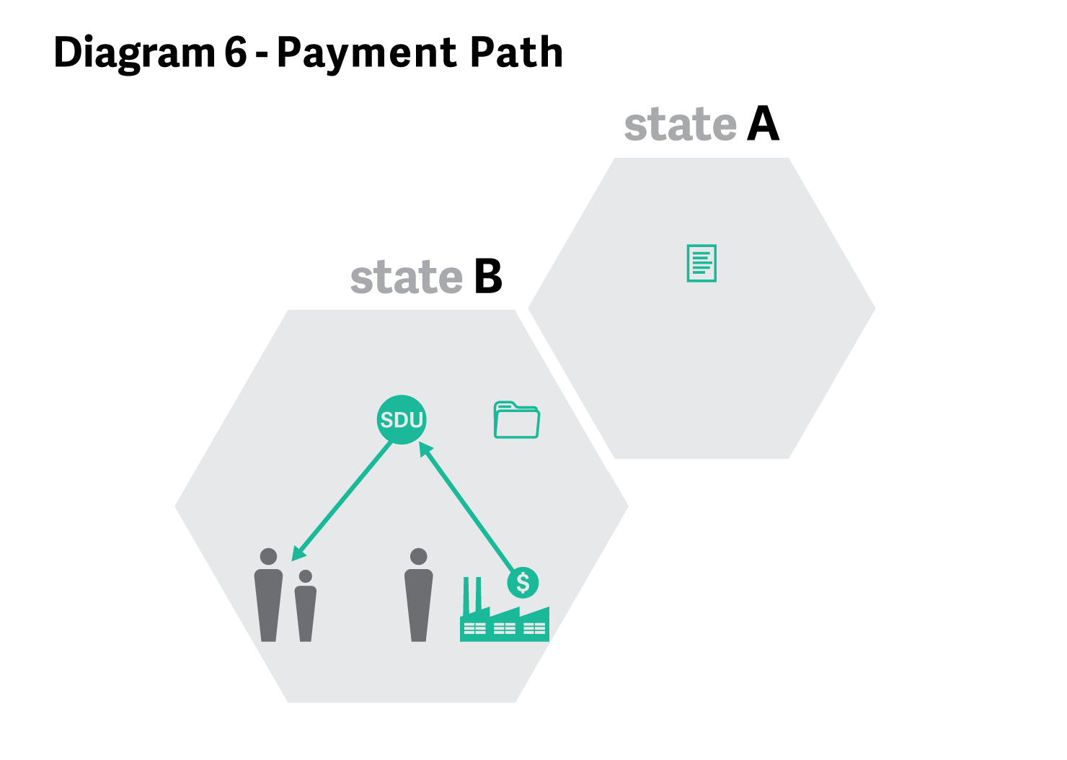

**REDIRECTION OF PAYMENTS PURSUANT TO UIFSA SECTION 319**

*Definition*

**Redirection**: A change to the payment location by the order-issuing state in accordance with sections 307 and 319 of UIFSA.

*Introduction and History*

In UIFSA 2001, the ULC added two provisions that were intended to “provide clearer guidance to state support agencies with regard to the redirection of support payments to an obligee’s current state of residence” (ULC Summary, Amendments to the Uniform Interstate Family Support Act). Section 307(e) states:

A support enforcement agency of this state shall [issue or] request a tribunal of this state to issue a child-support order and an income-withholding order that redirect payment of current support, arrears, and interest if requested to do so by a support enforcement agency of another state pursuant to Section 319.

In the official comment to 307(e), the ULC explained that this provision is to be read in conjunction with 319 in order to “facilitate redirection of the stream of child support in order that payments be more efficiently received by the obligee.”

UIFSA Section 319, in turn, imposes a limited duty on the order-issuing state, upon request from a state child support agency when neither party resides in the state, to change the payment location on its order. It provides:

Section 319. Receipt and Disbursement of Payments.

* * *

(b) If neither the obligor, nor the obligee who is an individual, nor the child resides in this state, upon request from the support enforcement agency of this state or another state, [the support enforcement agency of this state or] a tribunal of this state shall:

(1) direct that the support payment be made to the support enforcement agency in the state in which the obligee is receiving services; and

(2) issue and send to the obligor’s employer a conforming income-withholding order or an administrative notice of change of payee, reflecting the redirected payments.

(c) The support enforcement agency of this state receiving redirected payments from another state pursuant to a law similar to subsection (b) shall furnish to a requesting party or tribunal of the other state a certified statement by the custodian of the record of the amount and dates of all payments received.

In the unofficial annotations to UIFSA 2001, section 319 (reprinted in note 61 of the 36 Family Law Quarterly 407 (Fall 2002)), the ULC explained that:

Creating this redirection process was one of the challenges facing the UIFSA 2001 Drafting Committee. There was some sentiment for allowing an agency providing services to an obligee to redirect payments in all situations. This was soundly rejected in the case where the obligor continued to reside in the order issuing state; the issue is moot if the obligee remains. Another challenge was to do no violence to the provision of § 611 that provides the party seeking a modification has to “play away.” There was a consensus that allowing a tribunal that did not issue the order to redirect payments was, per force, a modification.

The result of the discussions was a process that is legally sustainable and compatible with the other tenets of UIFSA. States have moved from orders providing that payments are to go directly to the obligee or to a county registry towards having the collections sent to the federally mandated “central disbursement unit.” Redirection of those payments has become common-place. This new section simply provides that an additional option available to the issuing tribunal is to redirect the payments to the support enforcement agency in the state that is providing services to the obligee. The effect of such an order is to redirect the payments from one state disbursement unit to another.

While this process may assure somewhat swifter receipt of money by the obligee, there is still the need for the issuing state to be involved. Unless and until all states become capable of keeping accurate arrears and payment records, including interest, the role of the issuing tribunal remains to assure that there is an “official” accounting of payments.

* * *

While redirection was part of UIFSA 2001, many states have only recently changed their laws from UIFSA 1996 to UIFSA 2008.

*Concerns about Redirection Raised by NCCSD*

Several state child support agencies through representatives of the National Council of Child Support Directors (NCCSD) have expressed concerns to OCSE about the redirection option under UIFSA section 319. NCCSD explains that the use of redirection when the order-issuing state has an open and active IV-D case is of particular concern. Unless one of the case closure criteria set forth in 45 CFR 303.11(b) is met, the order-issuing state must continue to provide appropriate and necessary IV-D services after redirection in accordance with federal law and regulation that may include: enforcing its order (45 CFR 303.6; 45 CFR 303.100); using automatic enforcement procedures if payments are not timely (45 CFR 307.11(c)(3)); and maintaining accurate payment records (Section 454(10) of the Act; 45 CFR 307.11(e)(5)). NCCSD maintains that after a UIFSA redirection request, the order-issuing state may have difficulty in providing these services because payments no longer flow through its SDU.

Further, NCCSD points out that the payments received by the order-issuing state before redirection count as current collections for Federal Financial Participation (FFP) and federal incentive payments (45 CFR 304.20(b)(4); 45 CFR 305.2(a)(3); 45 CFR 305.34). After redirection, however, the order-issuing state is no longer eligible for incentive credits once the payments are diverted to the requesting state.

Finally, NCCSD raises the problem with the order-issuing state continuing to maintain an accurate payment record after redirection. Section 319(c) of UIFSA requires that the state receiving redirected payments to furnish a certified statement of the amount and dates of all payments received—but it is incumbent on the order-issuing state to request that statement.

In considering the appropriate use of UIFSA section 319 in IV-D cases, there is no federal or state requirement that a child support agency make a UIFSA redirection request, even if a case meets the criteria under section 319, and that it may frequently be unnecessary and unwarranted. The traditional federally authorized interstate options described in this AT are available for states to use instead of UIFSA redirection, and must be considered in assessing the appropriate services to provide in each particular case scenario. NCCSD is in the process of fostering communication among the states on the appropriate use of redirection that may further alleviate concerns about the unnecessary or even improper use of section 319. OCSE is available to help facilitate this collaborative effort.

*Scenario: Both parents leave the order-issuing state and now reside in different states (3 state involvement)*

**QUESTION 13:**  A IV-D child support order is entered in State A, designating State A’s SDU as the payment location. The parent owed support resides in State B and applies for services. The parent owing support resides and works in State C. State A has an income withholding order in effect. May State B request UIFSA redirection from State A?

**RESPONSE 13:** As with one-state remedies and interstate IV-D case referrals, State B must consider what services are appropriate in each case. While redirection is one option because neither the parents nor child reside in State A, State B must consider the fact that State A has an effective income withholding order in place. Instead of redirection under UIFSA section 319, State B may simply request payment forwarding from State A’s SDU to State B’s SDU. This will allow State A to continue to monitor payments, an important consideration given that State A is responsible for maintaining an accurate payment record. As explained in Response 2, both States A and B are eligible to receive FFP for facilitating the forwarding of payments.

If IV-D enforcement action, in addition to income withholding, is warranted, State B may also choose to initiate an interstate IV-D case to State C, as described in Response 8. For example, if the parent owing support has assets, State C might be able to use its administrative remedies to satisfy any delinquencies such as establishing a lien on property or garnishing a bank account.

If State B determines that redirection is the most appropriate option given the facts of the case, sections 307(e) and 319(b) of UIFSA allow State B to request redirection from State A. If State B pursues this option, State A will be required to change the payment location on the controlling order to State B’s SDU and send a new income withholding order to the employer in State C.

No other provision of the order, however, is changed with payment redirection under UIFSA section 319. State B must apply State A’s terms of the order including State A’s interest rate as State B does not become the new controlling order state. Because State A remains the order-issuing state and is responsible for the payment record, UIFSA section 319(c) requires State B to provide State A, upon request, with a certified statement of the amount and dates of all payments received.

**Diagram 7** shows the payment path following redirection, with payments flowing from the employer to State B’s SDU to then be disbursed to the parent owed support.

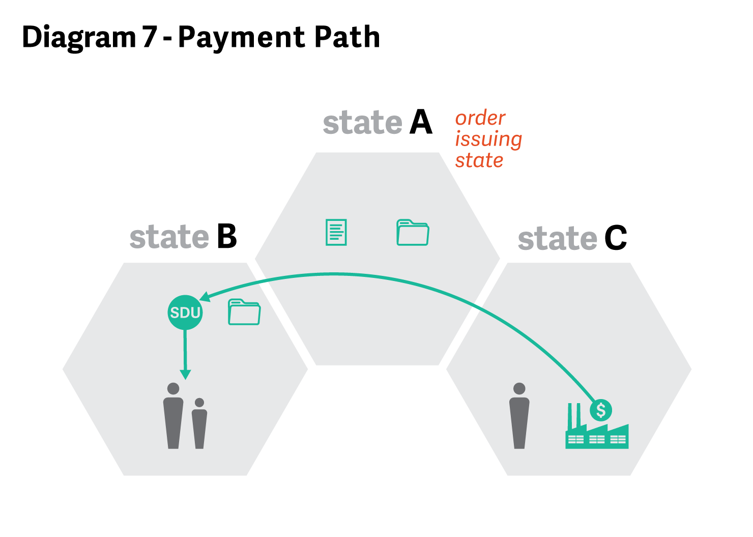

*Scenario: Arrears-only when both parents leave the order-issuing state and now reside in different states (3 state involvement)*

**QUESTION 14:** In the scenario presented in Question 13, assume State A is owed assigned arrears. Further assume State B has requested that State A change the payment location to State B’s SDU pursuant to section 319(b) of UIFSA. May State A refuse State B’s request? If not, may State A send an income withholding order to the employer in State C requiring a portion of the collected support to be sent to State A’s SDU?

**RESPONSE 14:** No. If State B determines that redirection is the most appropriate option in this case, State A may not refuse State B’s request to change the payment location and State A may not send an income withholding order that requires the employer to send payments to two different SDUs. Instead, the UIFSA redirection provisions require State A to issue a conforming income withholding order or an administrative notice of change of payee that designates State B’s SDU as the payment location. The order should detail current support, arrears owed to State A and/or arrears owed to the custodial parent, and interest, if appropriate. After State A issues the new income withholding order, State A should communicate with State B on the most effective way for State A to collect its assigned arrears.

*Conclusion*

Communication is key in interstate cases and section 454(9) of the Act requires states to cooperate in serving families across state lines. Before making a UIFSA redirection request, states should consult each other in individual cases to determine whether redirection or another interstate enforcement option is most appropriate given the specific facts of the case.

1. OCSE FY14 Preliminary Report, Table P-33.

   