**How to Add/Delete Committee Members**

* To add a member to or delete a member from a committee, go to the Dashboard > Users > All Users.

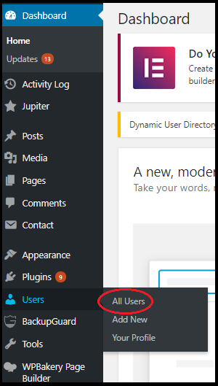

* Find the user you want to add to or delete from a committee and click Edit.   
    
  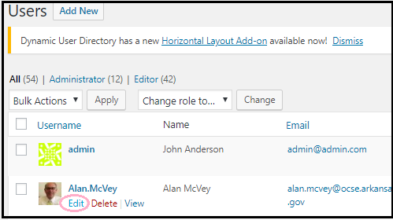
* Scroll to down to Committees and click or un-select the desired committee.   
  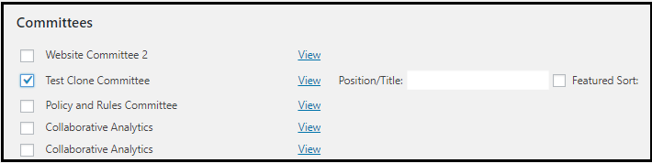

Hover over the area to the right of Position/Title. A box will appear. Type in the appropriate position. Most people will be members.

* Click Update User to save your changes.

