How to add Help Documents

1. Create your help document in Microsoft Word or PowerPoint
2. Upload the document into the Document Manager <http://www.nccsd.net/documents/>

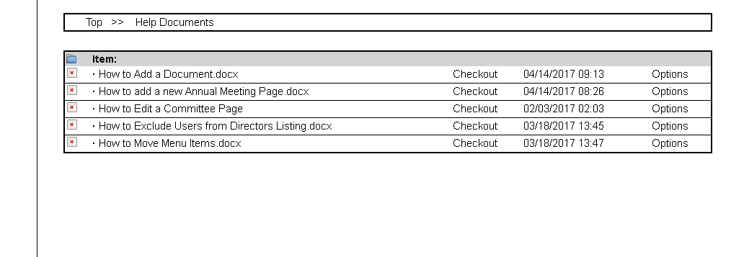

1. Click on your document now listed to open the document in the document viewer.
2. Copy the document url from your browser to the clipboard.

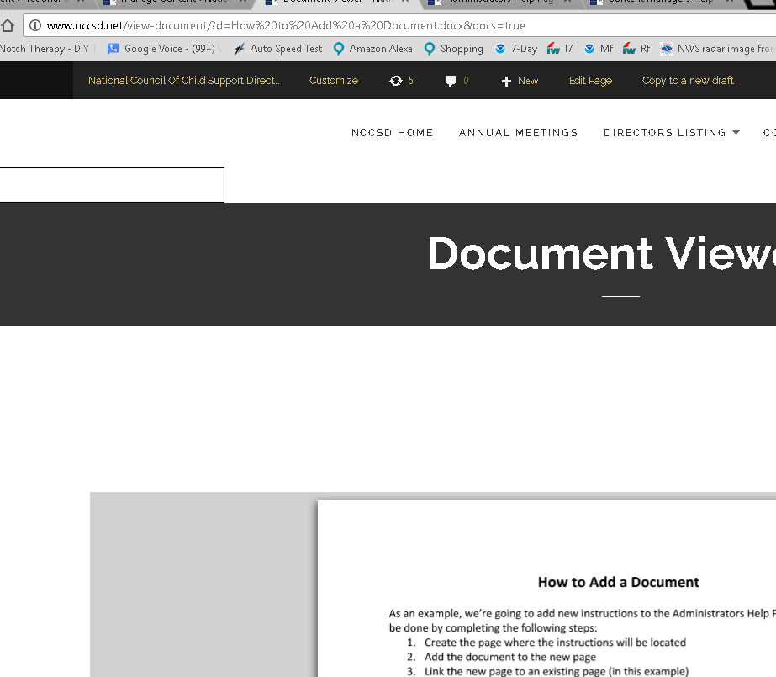

1. Open one of the 3 the associated help pages such as <http://www.nccsd.net/content-managers-help-page/> in edit mode.
2. Paste the url from your clipboard into the page and save.
3. The link will now open the help document that is located in the Document Management system.