**How to Add New Users**

When a new director is to be added as a user, the NCCSD secretary will notify the web committee and will provide the director’s name and email address.

* Go to the Dashboard.  
    
  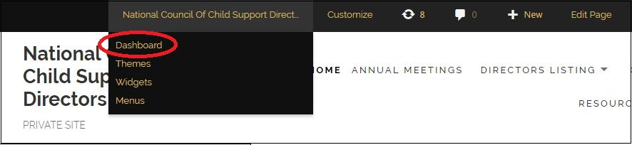
* Hover over Users and click Add New.  
    
  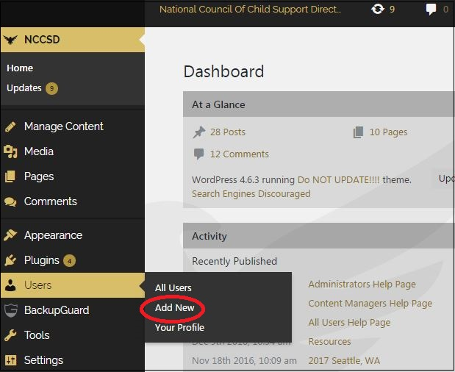
* The Add New User screen will pop up.

The Username will be in the format of FirstName.LastName. If someone hyphenates their last name or has two last names, enter the last name as the user prefers. Hyphens or spaces are fine. For example: Paula.Phillips-Smith or Paula.Phillips Smith.  
  
  
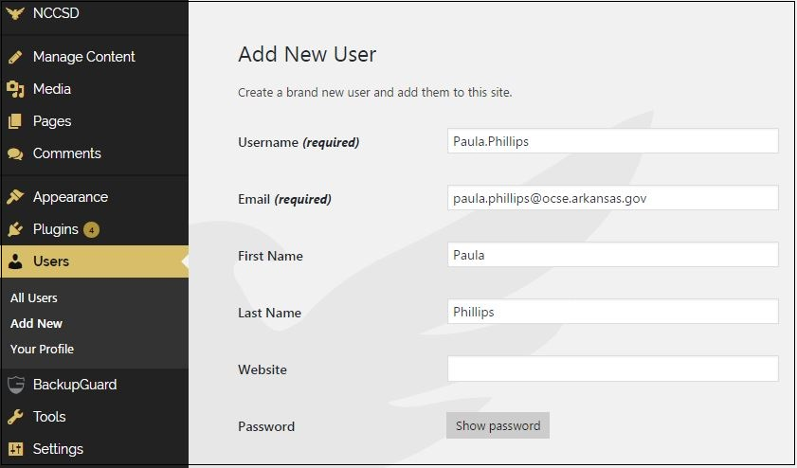

* Assign a password by clicking Show password.  
    
  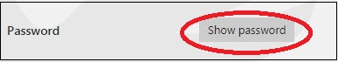
* A box will pop up with a suggested password. Enter a new password in the format of “nccsd” plus the capitalized state abbreviation. For example: nccsdAR.  
    
  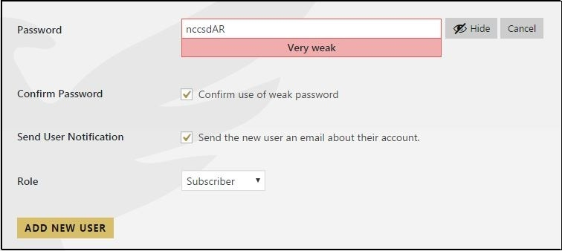
* A weak password is not a concern with this site. Click the “Confirm use of weak password” box.
* Make sure the next box is checked: “Send the new user an email about their account.” The new user will receive an email about how to access the site.
* To save, click Add New User.