**How to Edit a Committee Page**

The only changes to make on the committee page are in the committee charge section.

Document changes are made by going to Documents.

* Open the desired committee page. To edit, click Edit with WPBakery Page Builder.

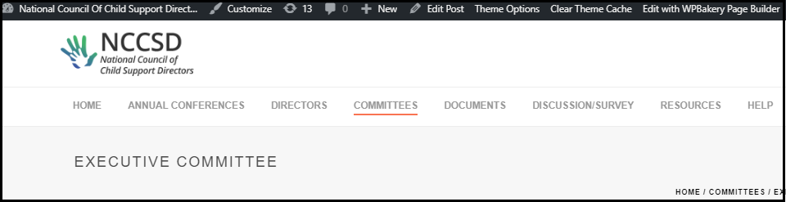

* Make whatever changes you want and click Update.

