**How to Update a Document**

* Locate the document you wish to update. Click to download the document to your computer.   
  *This example is a document on the IRS Audit Committee page.*

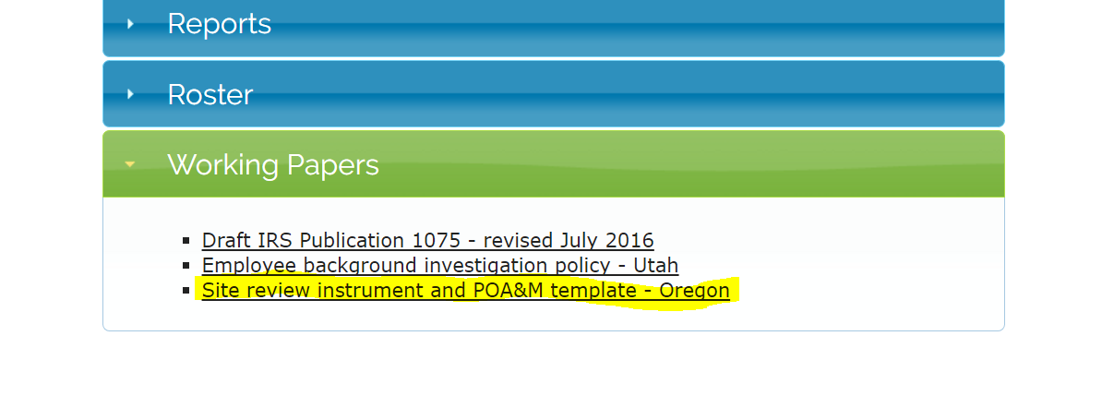

* If necessary, click to download the document to be updated to your computer.
* To check out the document while updating, click on Documents from the banner at the top of the website.

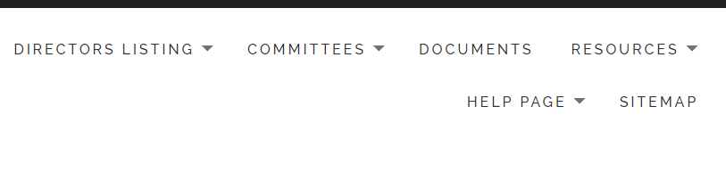

* The Document Manager page will appear. The pathway box is here – if not already at Top,   
  click on Top to start the pathway.
* Navigate by clicking through the relevant folders to locate your document.   
  *(Here, start with Committees, then IRS Audit Committee, etc.)*

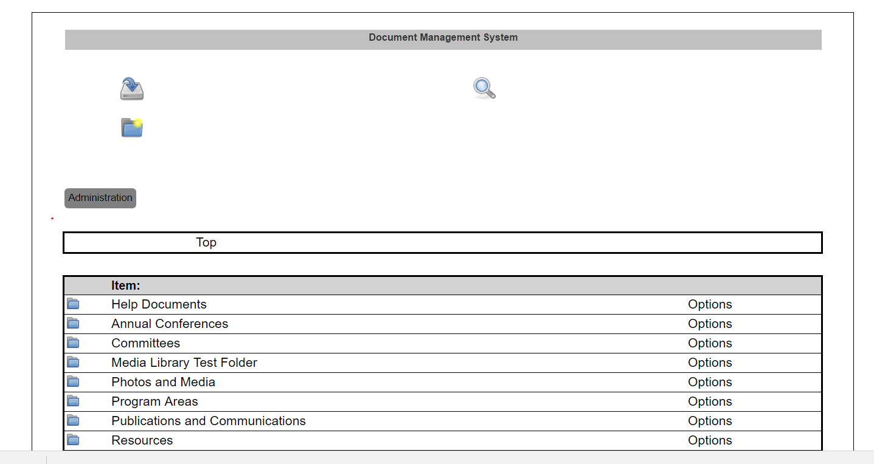

* Once you’ve located your document through the pathway, click on Checkout.

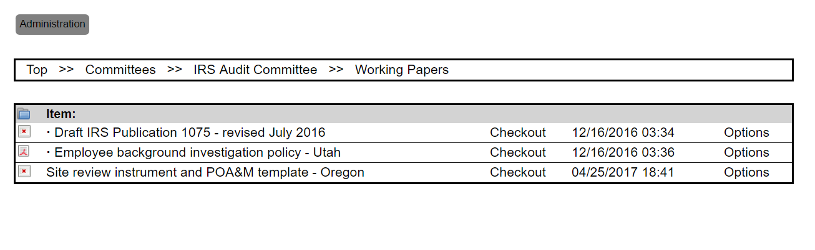

* Confirm checkout of the document by clicking the checkout button.

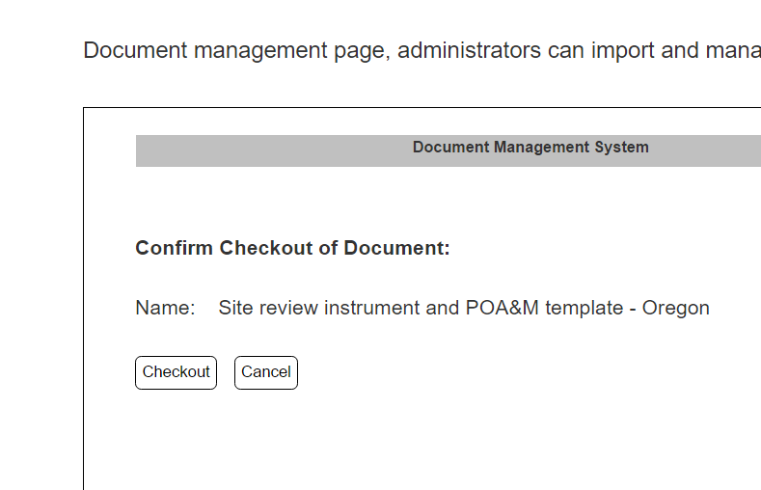

* Make changes to the downloaded document as needed.
* Save your changes to the document on your computer.
* To update the document and check in your changes, return to the location and click on Check-in.

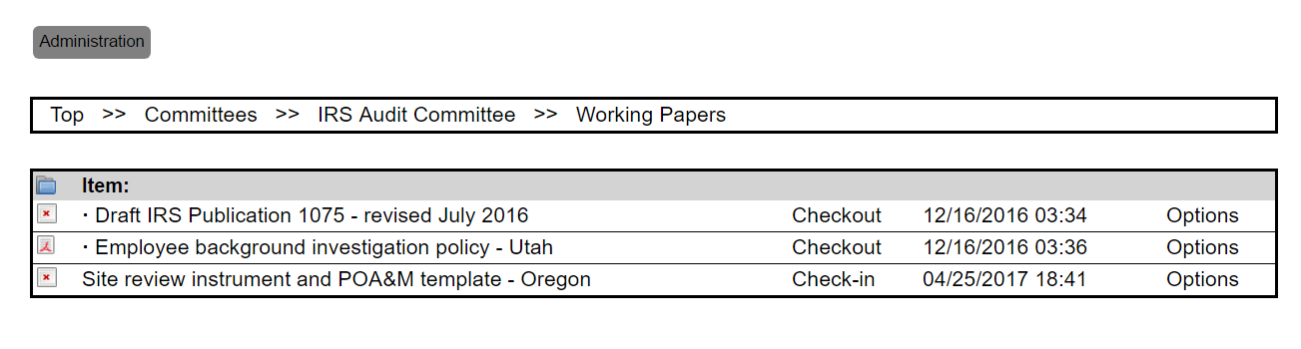

* Select version, then browse to choose file. Click on Check-in button.

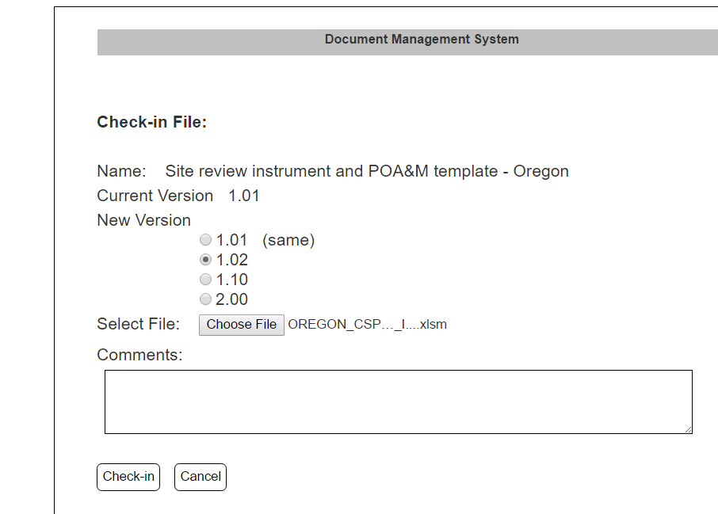

* Allow document to upload. Done!