Listserv Management

# Credentials

Listserv Moderators will login as [list@nccsd.net](mailto:list@nccsd.net) with the moderator password

# Add a new Member

1 Go to [**Listserv Add Member**](http://nccsd.net/mailman/listinfo/listserv_nccsd.net)

2 Enter the email of the new Member and subscribe

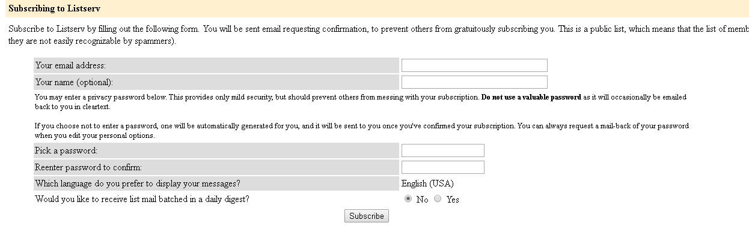

# Changing Existing Member Email Address or Removing Existing Member

1 Go to [**Listserv Change or Remove Member from List**](http://nccsd.net/mailman/roster/listserv_nccsd.net)

2 Select the member to change or remove

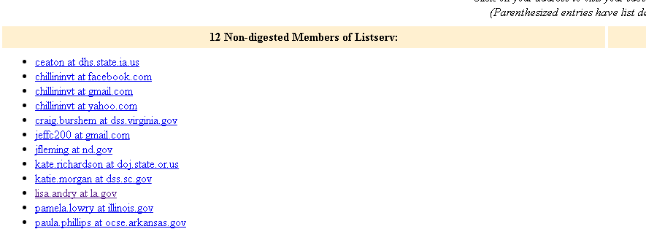

3 You will then be on a page to manage this member.

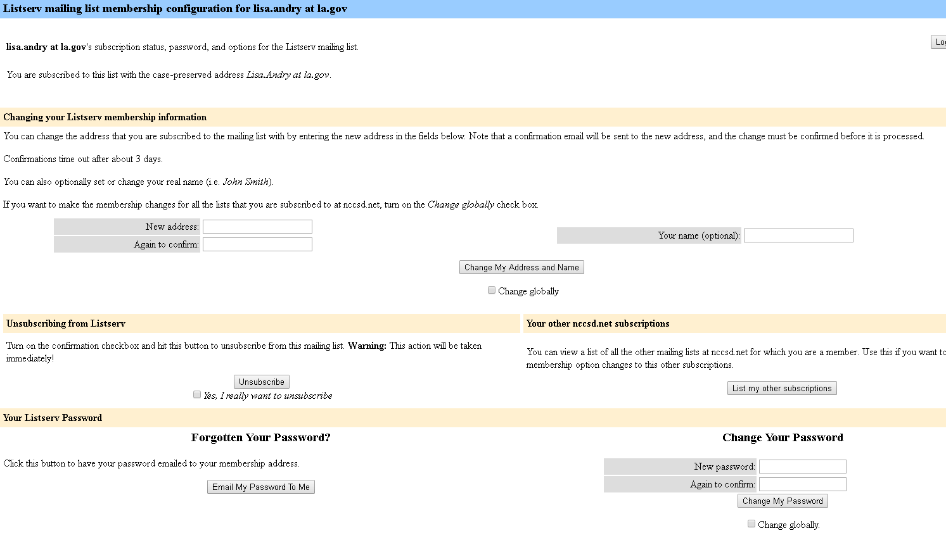

Remove member here

Check Globally and Confirm here

Change and address here

Make sure you have the right person

Make sure you have the right person

[**Listserv Member Management**](http://nccsd.net/mailman/admin/listserv_nccsd.net/members)

[**Listserv Management**](http://www.nccsd.net/nccsd-admin/admin.php?page=manage-listarchives)

[**Listserv Administrative Interface 1**](http://nccsd.net/mailman/admin/listserv_nccsd.net/nondigest)

[**Listserv administrative interface**](http://nccsd.net/mailman/admin/listserv_nccsd.net)