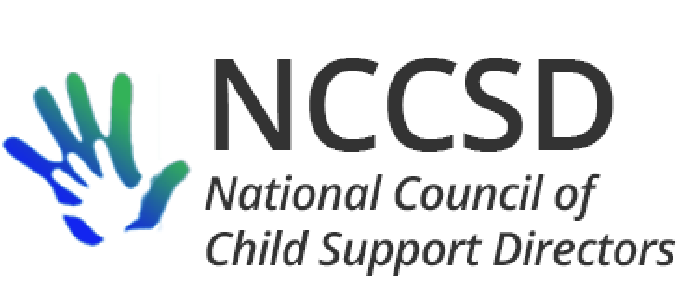

#### President

James C. Fleming, Director

Child Support Division

Department of Human Services

PO Box 7190

Bismarck, ND 58507-7190

701-328-7501

[jfleming@nd.gov](mailto:jfleming@nd.gov)

## **Vice President**

Michele Cristello, Director

Child Support Enforcement Division

Department of Revenue

PO Box 9561

Boston, MA 02114-9561

617-626-4042

[cristellom@dor.state.ma.us](mailto:cristellom@dor.state.ma.us)

### Secretary

Kate Cooper Richardson, Director

Oregon Child Support Program

Department of Justice

1162 Court Street NE

Salem, OR 97301

503-947-4388

[kate.richardson@doj.state.or.us](mailto:kate.richardson@doj.state.or.us)

**Treasurer**

Liesa Stockdale, Director

Office of Recovery Services

515 E 100 S, Suite 100

Salt Lake City, UT 84102

801-536-8901

[lcorbri2@utah.gov](mailto:lcorbri2@utah.gov)

July 26, 2020

«AddressBlock»

Dear [Name]:

Sincerely,

[Author]

[Title]