NCCSD Systems/Data Workgroup Vendor Webinars – October 18, 25 and November 1

COVER PAGE for Answers by Vendors

Attached please find the answers provided by IBM, who was invited by the Systems Workgroup of the National Council of Child Support Directors (NCCSD) to present educational webinars on two of the newest approaches to modernizing state child support systems. These two topics are “replatforming/refactoring” and “low code/COTS”. Note that some vendors are responding to both topics, and some are responding to only one.

IMPORTANT: Even though these are educational sessions, the vendors may be providing some proprietary information in their answers. Therefore by opening these documents you are agreeing to treat the information as confidential.

NCCSD Systems Workgroup Vendor Forums – Q&A related to “Low Code/COTS”

Vendor Name: IBM and Grays Peak Strategies
Please enter your responses into this document, but feel free to send any other attachments as well.

Table of Contents
1. Since there is not yet a consistent term or definition for this approach, please give your company's description, including your terminology and definitions. How is this approach different from a "custom" build of a child support system? If you choose to do a quick demo or screen shots that would be welcome. 2
2. With reference to the "core" functionality required by the OCSE Systems Certification Guide (Case Initiation, Locate, Establishment, Case Management, Enforcement, and Financial Management), how does this approach handle each area? In particular, since Child Support requires complicated financial processing, e.g. distribution rules and arrears calculations, please address how these are handled with this approach. 6
3. What COTS or other products are used in conjunction with this approach to give a state a fully functional system? 30
4. Under what circumstances does it make the best sense for a state child support agency to consider this new approach versus other possible means of modernizing its child support system? Are there any characteristics of either a state’s IT system or its business processes that lend themselves more to this approach? 31
5. Generally speaking, what should a state expect on the following: project timeframe, project cost, time to rollout statewide? 33
6. The states don’t want to again face the major system build and cost challenges once they have modernized. If they choose this approach, what is the continuous improvement model for the platform? Will the states benefit from the vendor efforts without major costs? 35
7. What are the most important things that a state should do to prepare for this approach? 39
8. How does this type of child support system fit with states who need to have an enterprise approach? Many of the platforms seem to be creating the same old silos on a new platform. Is it possible to have one casefile for each person/family across the systems (child support, SNAP, TANF, family services, etc.)? 40
9. What haven’t we asked that we should have? 41

Questions:

Since there is not yet a consistent term or definition for this approach, please give your company's description, including your terminology and definitions. How is this approach different from a "custom" build of a child support system? If you choose to do a quick demo or screen shots that would be welcome.

Microsoft Dynamics 365 is a highly configurable solution that provides simple web-based tools for configuration of data model, forms, views, reports, workflow & security. With a COTS product like Microsoft Dynamics 365, users have access to “out-of-the-box” (or “native”) functionality, including entities, forms, views, business process flows, etc. Users also have access to native configuration tools, allowing them to build custom functionality without custom code. Here is some terminology that might be helpful:
- “Configuration” definition: A means to change/update system functionality using tools native to the system. Sophisticated COTS systems like Microsoft Dynamics 365, have intuitive user interfaces (UI’s) that put the power of custom coding into the hands of non-developers.
  - Figure 1a below: Dynamics 365/PowerApps: Form Editor – “No Code”
  - Figure 1b below: Dynamics 365/PowerApps: Business Process Flow Editor – “No Code”
  - Figure 1c below: Dynamics 365/PowerApps: Canvas App Editor - “Low Code”
- “Customization” definition: A feature, extension, or modification that requires custom coding and developer skill sets.
- “Native” functionality: Also referred to as “out-of-the-box” functionality, includes everything that your Microsoft Dynamics 365 user license provides you upon first login. Case, for example, is a native entity in Microsoft Dynamics 365 Customer Service applications.
- “Custom” functionality: With COTS products like Microsoft Dynamics 365, users can leverage native tools to create custom* entities, forms, views, business process flows, etc. In our Child Support Services demo/accelerator, “Support Order” is a custom entity that we created with native configuration tools. *Note: Custom functionality does NOT mean “custom code.”

Dynamics 365/PowerApps: Form Editor – “No Code” (Figure 1a)
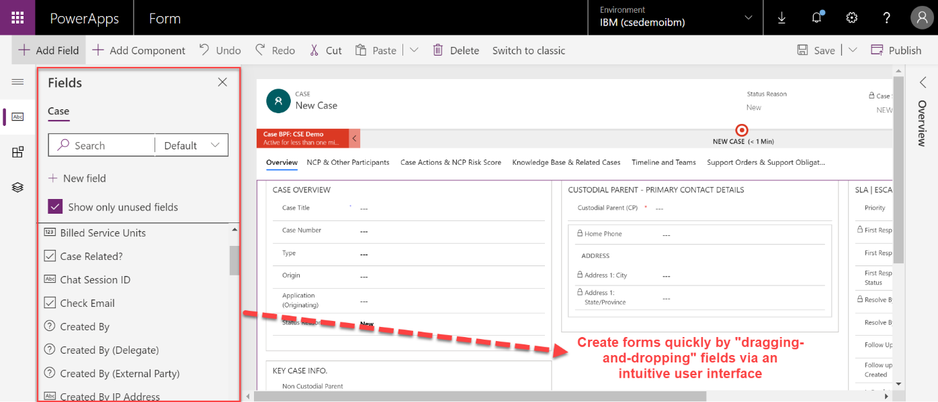

Dynamics 365/PowerApps: Business Process Flow Editor – “No Code” (Figure 1b)
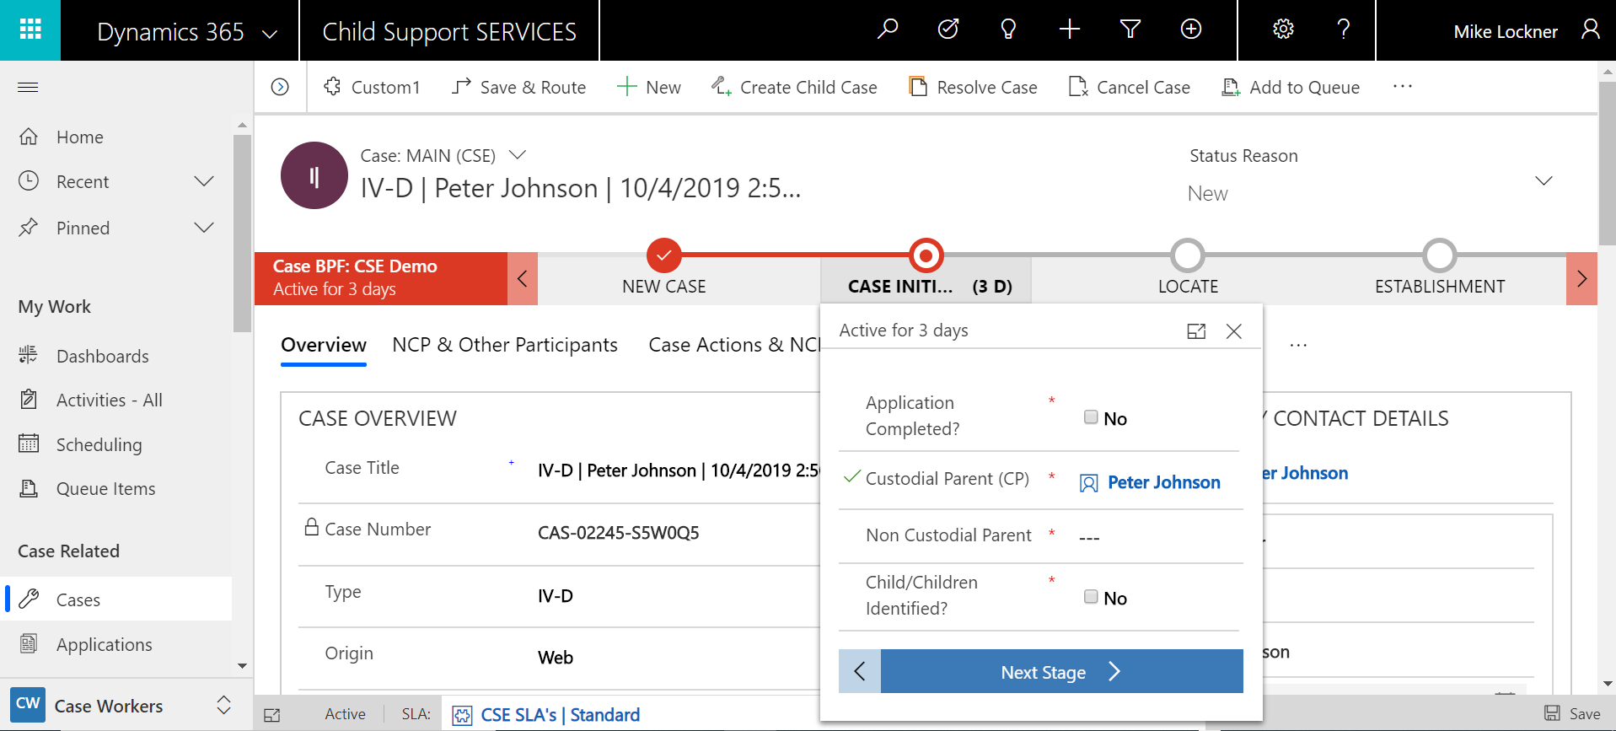
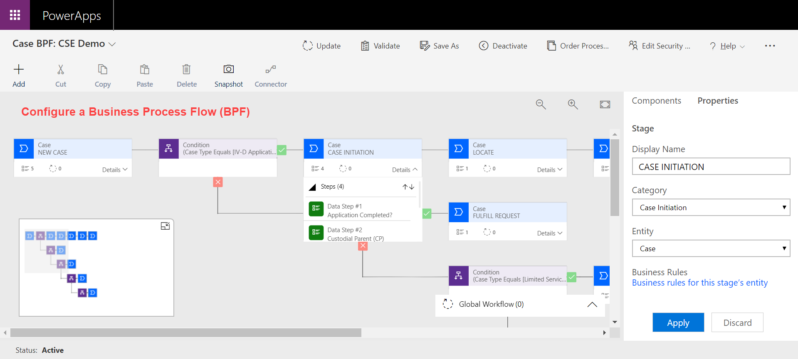

Dynamics 365/PowerApps: Canvas App Editor - “Low Code” (Figure 1c)
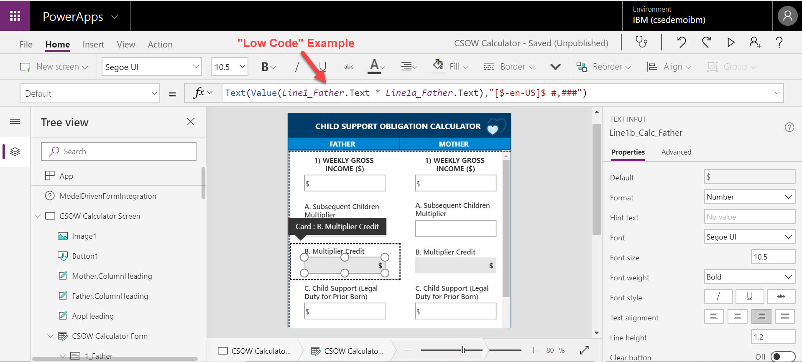

Microsoft Dynamics 365 can be extended mostly by configuration and with custom code in some cases. The balance between configuration and code really depends on the specific customer scenario and requirements. However, it is not uncommon for customers to achieve 80% of their requirements by simple web-based configuration, needing custom code only for the remaining 20% (see Figure 2 below). Our solution utilizes configuration to meet system requirements whenever possible. That said, most integration requirements will necessitate customization.

Building Dynamics Applications: 80% Configuration / 20% Customization (Figure 2)
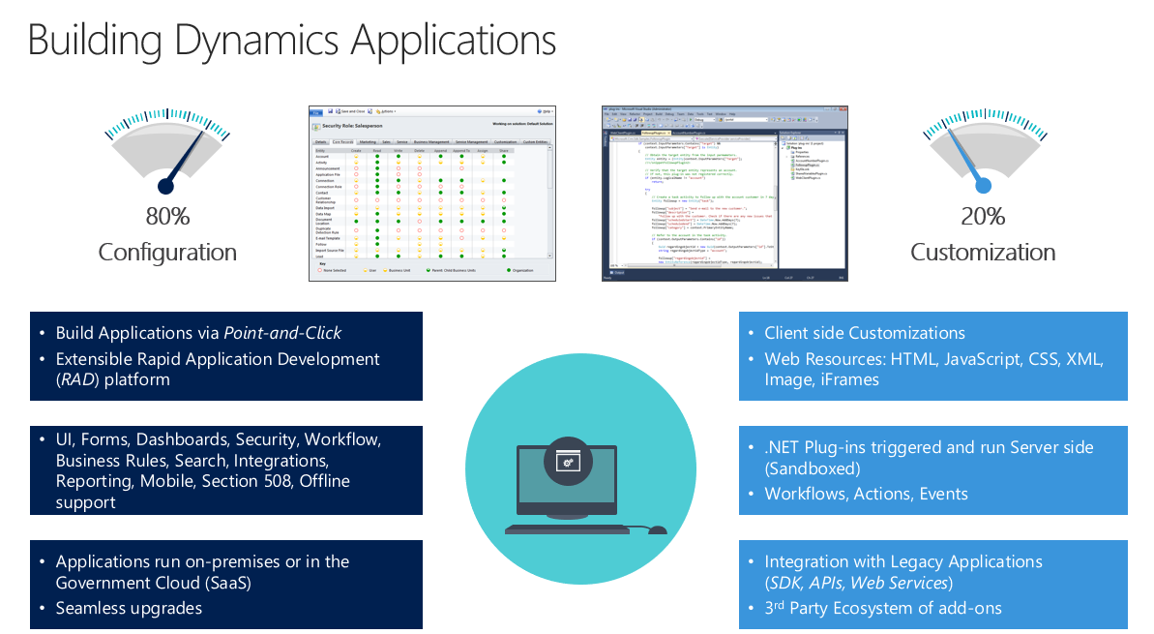

In addition, “low code/COTS” applications can be developed via any project methodology; however, Microsoft Dynamics 365’s intuitive and UI-friendly configuration lends itself well to Agile-like methodologies that focus on system demonstrations early and often. This allows the project team to gather feedback from key stakeholders throughout the project lifecycle, which has an undeniably positive impact on eventual user adoption.

Figure 3 below shows the “Dynamics Core Features” next to proposed application lifecycles phases.

Building Dynamics Applications: Core Features and Application Lifecycle Phases (Figure 3)
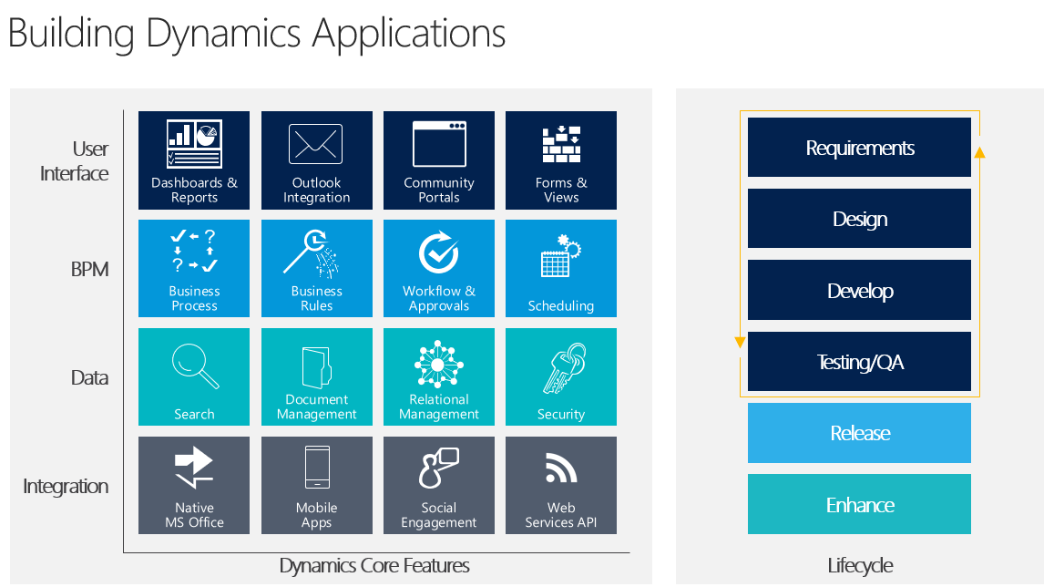

With reference to the "core" functionality required by the OCSE Systems Certification Guide (Case Initiation, Locate, Establishment, Case Management, Enforcement, and Financial Management), how does this approach handle each area? In particular, since Child Support requires complicated financial processing, e.g. distribution rules and arrears calculations, please address how these are handled with this approach.

Case Initiation
Our solution provides the ability to create a IV-D Application from an externally facing Portal. If Custodial Parents submit via the Portal, a Case is automatically created in Microsoft Dynamics 365.

In this section, you will see screenshots of our system related to the following:
- PowerApps Portal – submit a IV-D Application; submit a request for an Application; submit a Question.
- Microsoft Dynamics 365
  - Case Worker Dashboard
  - Case Form – Business Process Flow
Custodial Parents can log into an externally facing Portal, which was built using Microsoft’s PowerApps Portal. | 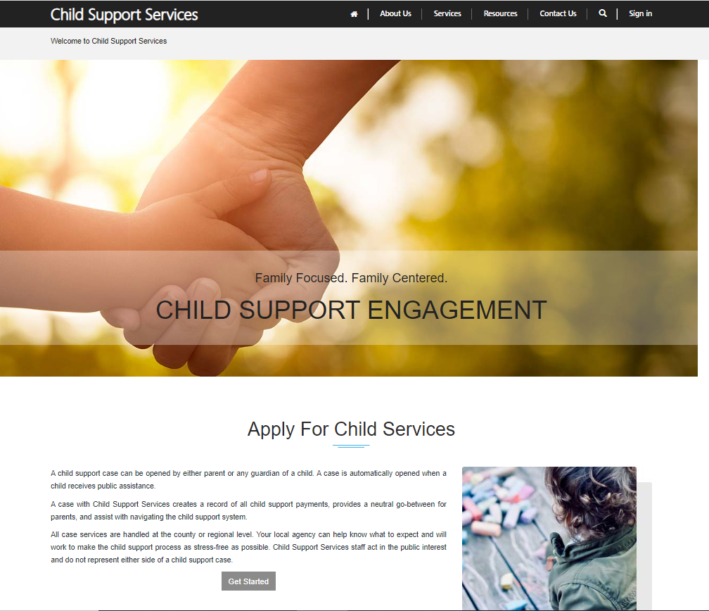
Portal users have the following actions* to choose from:  *All of these are easy to change/add.  - My Profiles  - My Cases  - Application Request  - Questions  - Applications  - Help  - Contact Us | 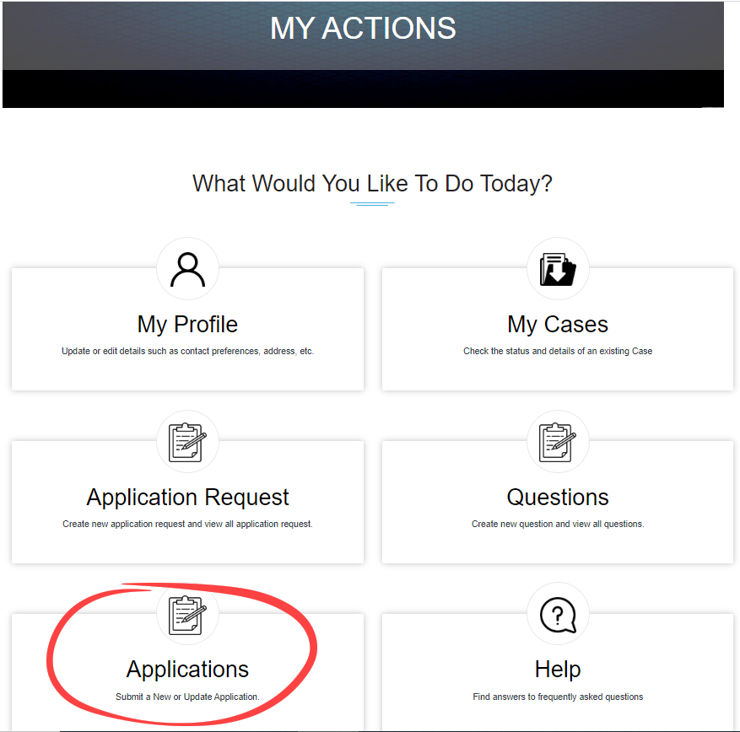
Portal Users can create IV-D Applications from the Portal. | 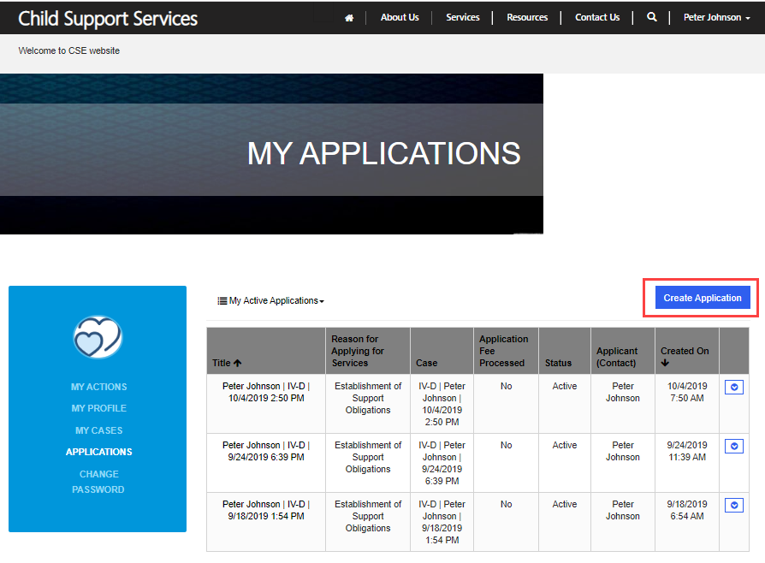
IV-D Application example.  Upon Application submit, the following records are auto-created in Microsoft Dynamics 365:  - Application record  - Case record | 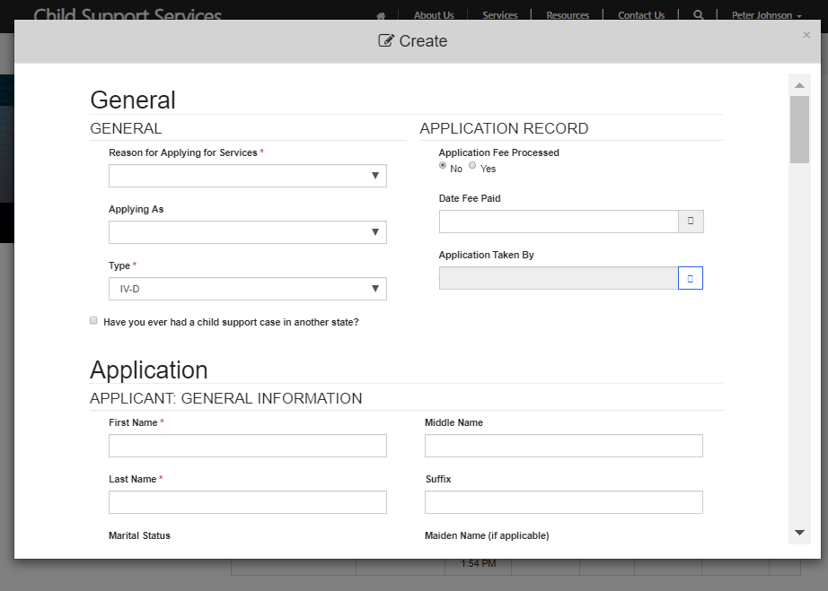
Microsoft Dynamics 365 – Customer Engagement  Case Workers and Case Managers will see a Dashboard when logging into D365.  Cases can be opened from a User’s Dashboard.  *Note: All Dashboards are highly configurable and easy to create and update. | 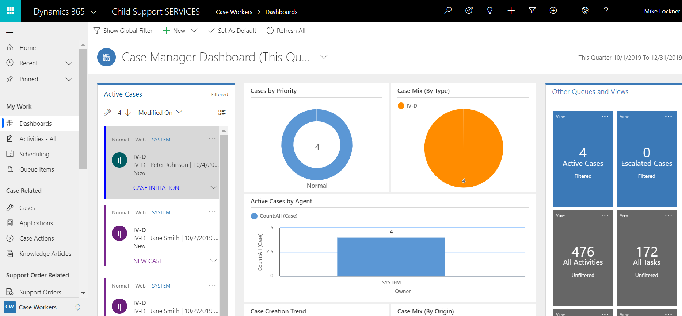
This is a IV-D Application “Case Form” in D365. At the top of the screen is a Business Process Flow (BPF) that contains all the stages called out in this question.  The Business Process Flows are also highly configurable and easy to create/update.  Users can check off tasks and move a Case to the next stage from the BPF. | 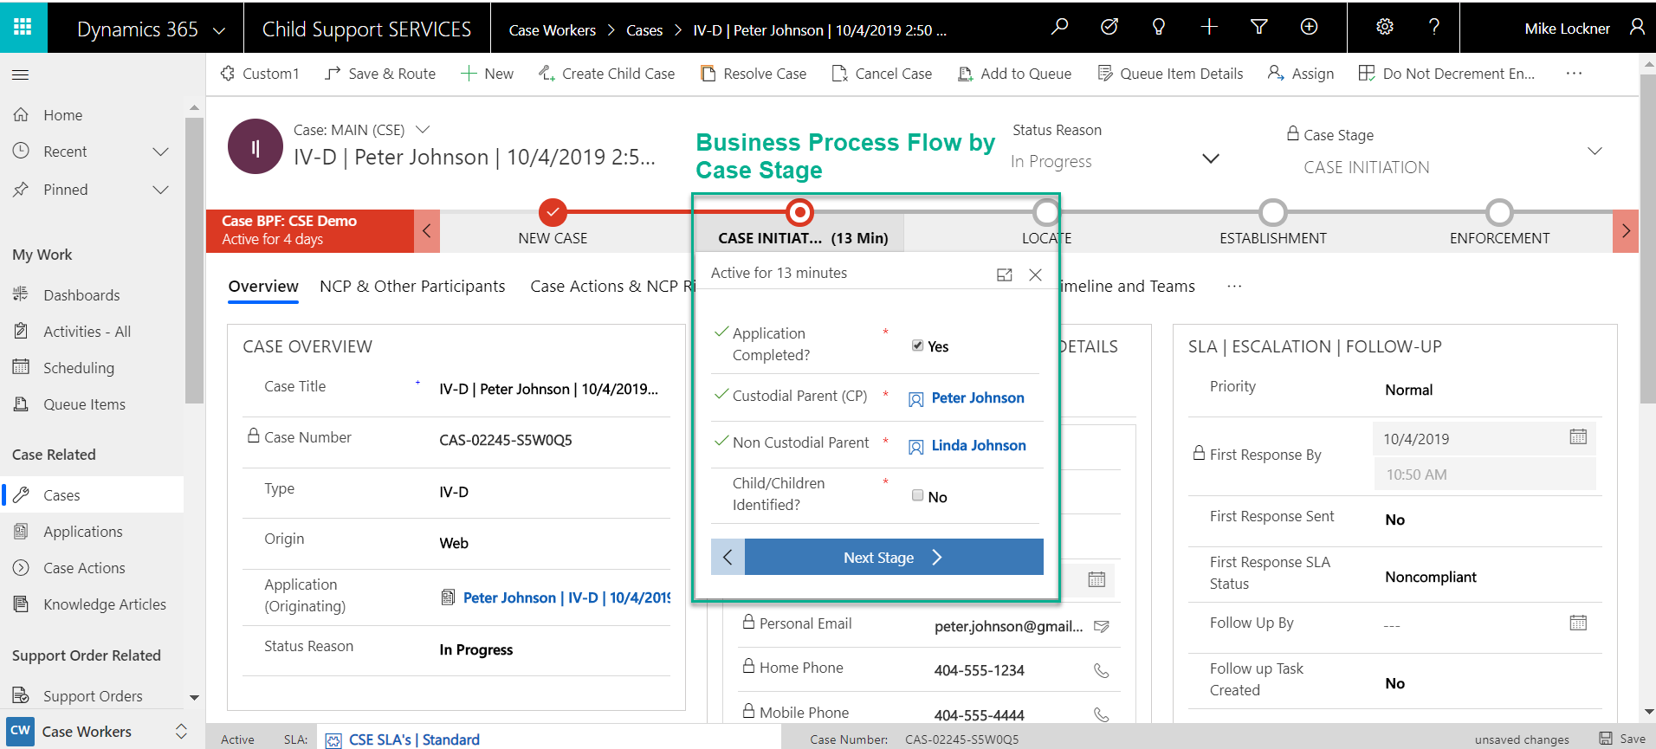
During Case Initiation, Case Workers will confirm NCP details and ensure all related Contacts, like Children, are linked to the Case.  Some of this association will automatically be handled by automation upon Application submission. | 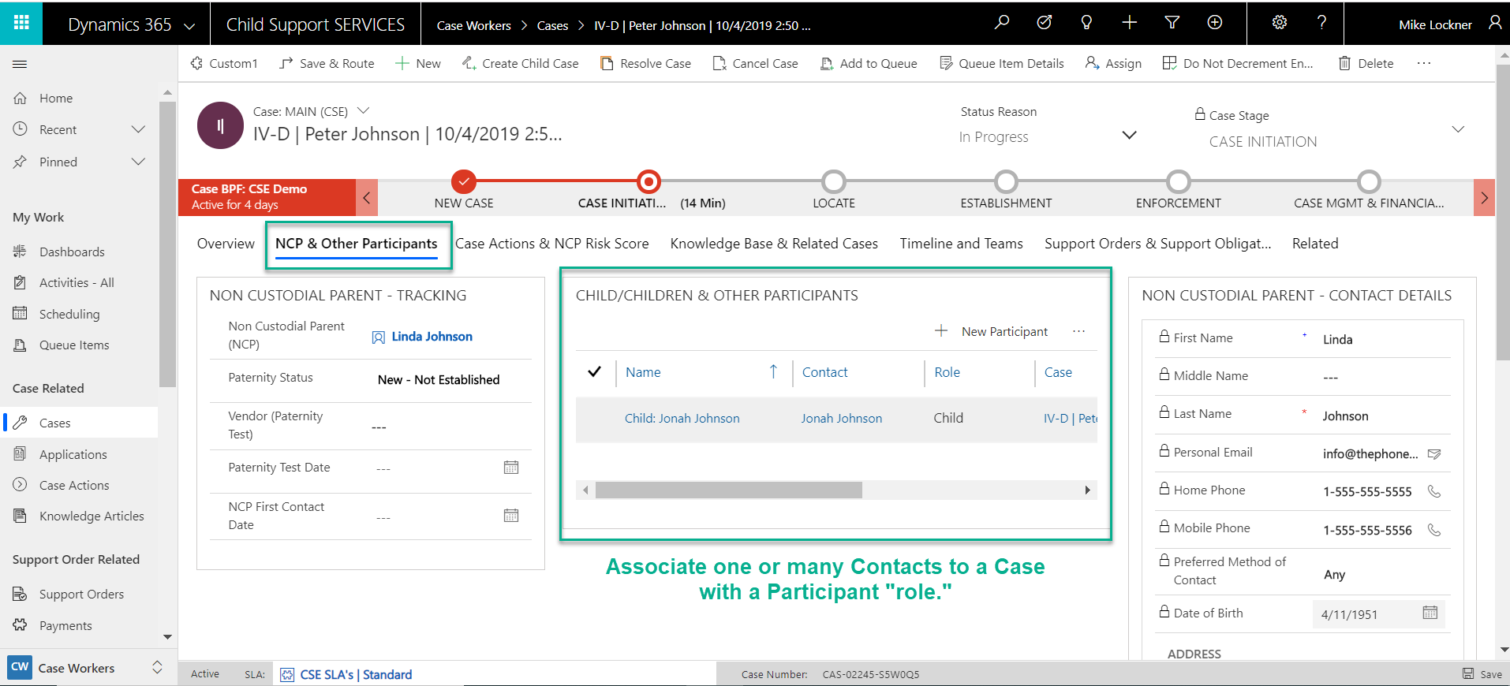

Locate
Our solution provides the ability to track many details about all Case Participants, but especially the Non-Custodial Parents.  This screenshot shows the Locate phase Business Process Flow steps and some details about the NCP. | 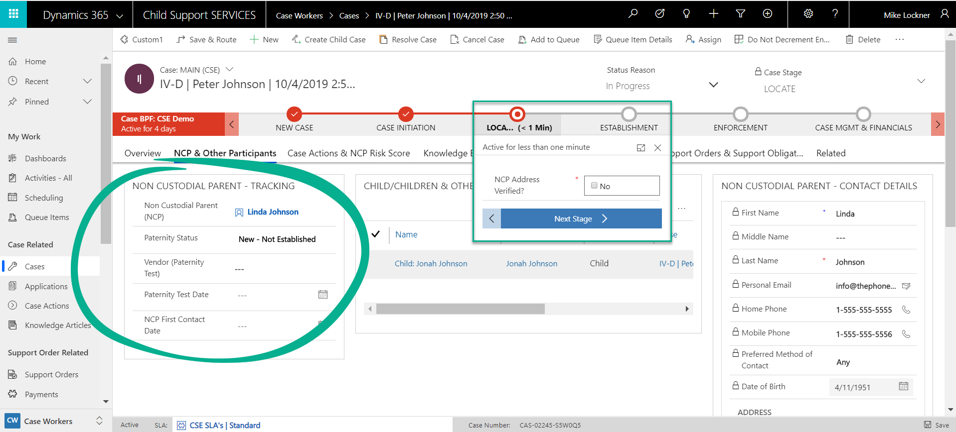
All CP’s and NCP’s will be tracked as “Contacts” in D365. This screenshot shows the Contact form. | 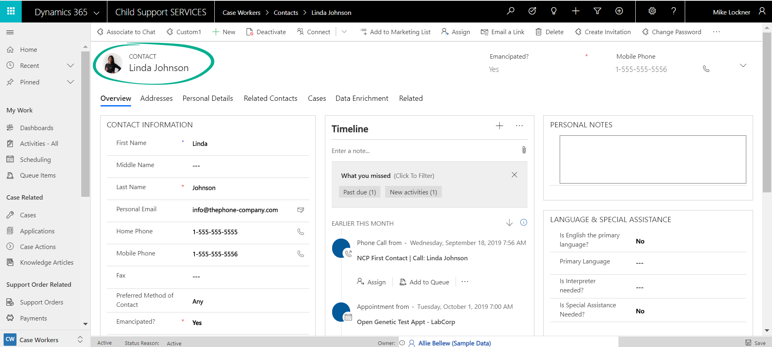
Our solution also provides native address validation capabilities. This Address Suggestion pop-up will also generate a latitude and longitude for each Contact. | 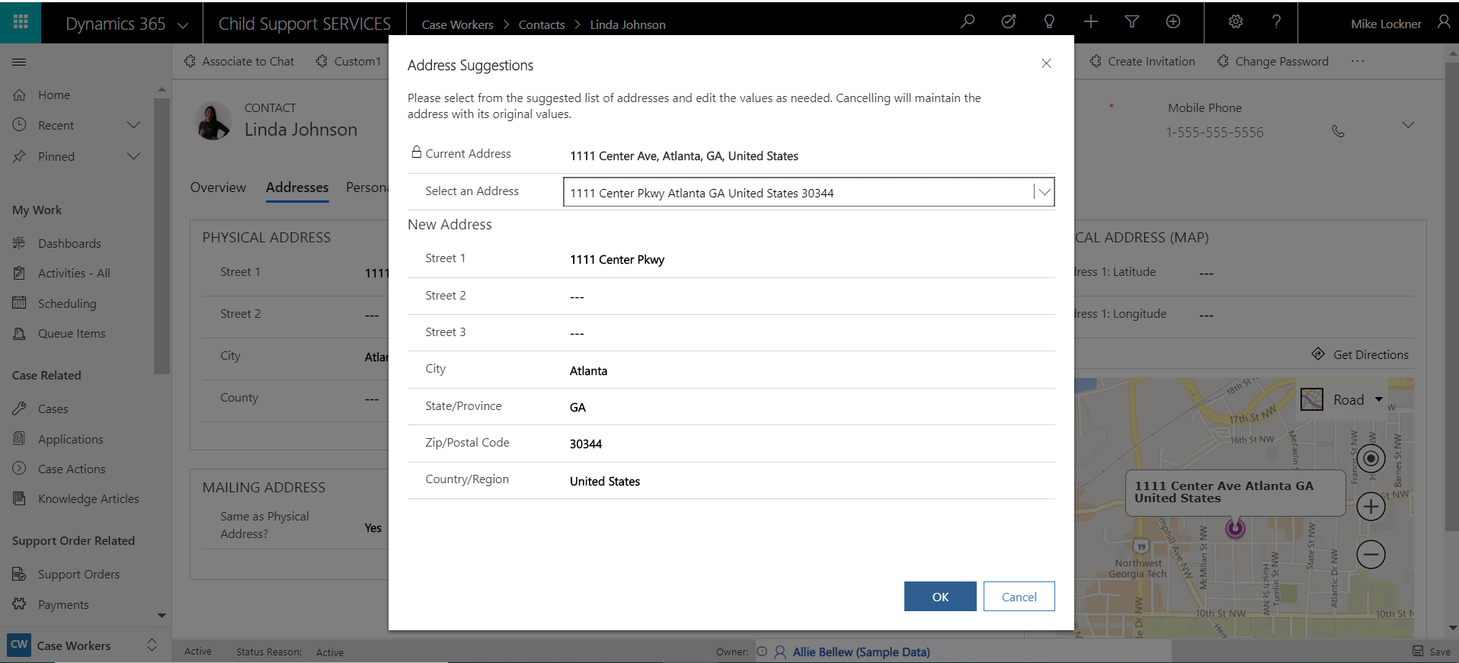
Our solution also provides the ability to connect Contacts to one another via a “Related Contacts” custom entity. | 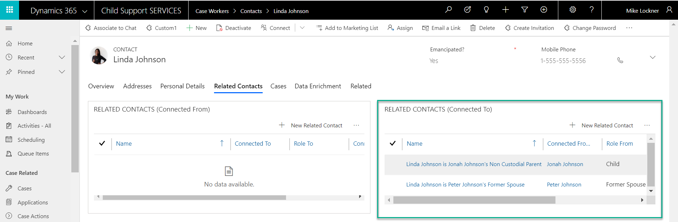
From the Contact form, you can also view all Cases related to that Contact, assuming they are listed as the CP or NCP on the Case. | 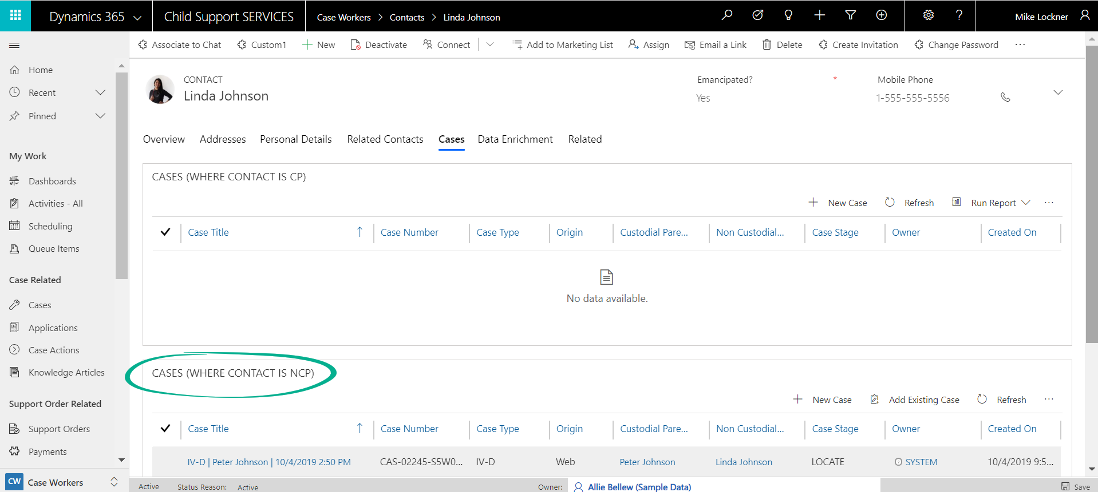
Because our solution is a demo/accelerator, our “integrations” are currently not live. However, we have developed an Azure Logic App that enriches Contact data via an integration with an Excel spreadsheet.  That said, Microsoft Dynamics 365 can integrate with any internet-facing system via API’s. | 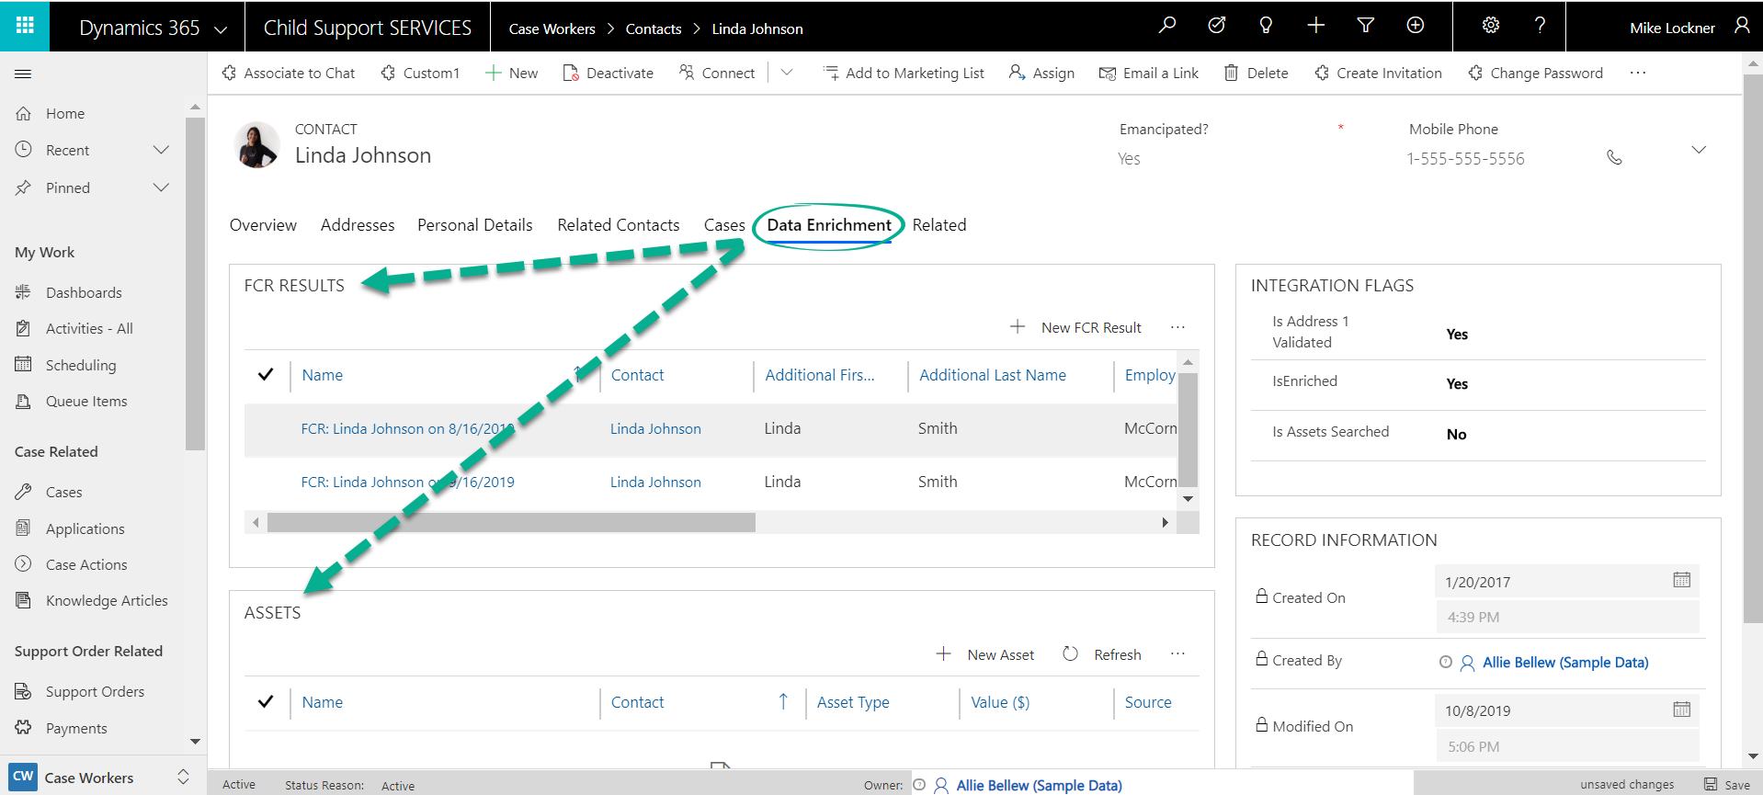

Establishment
This screenshot shows the Establishment Business Process Flow steps. | 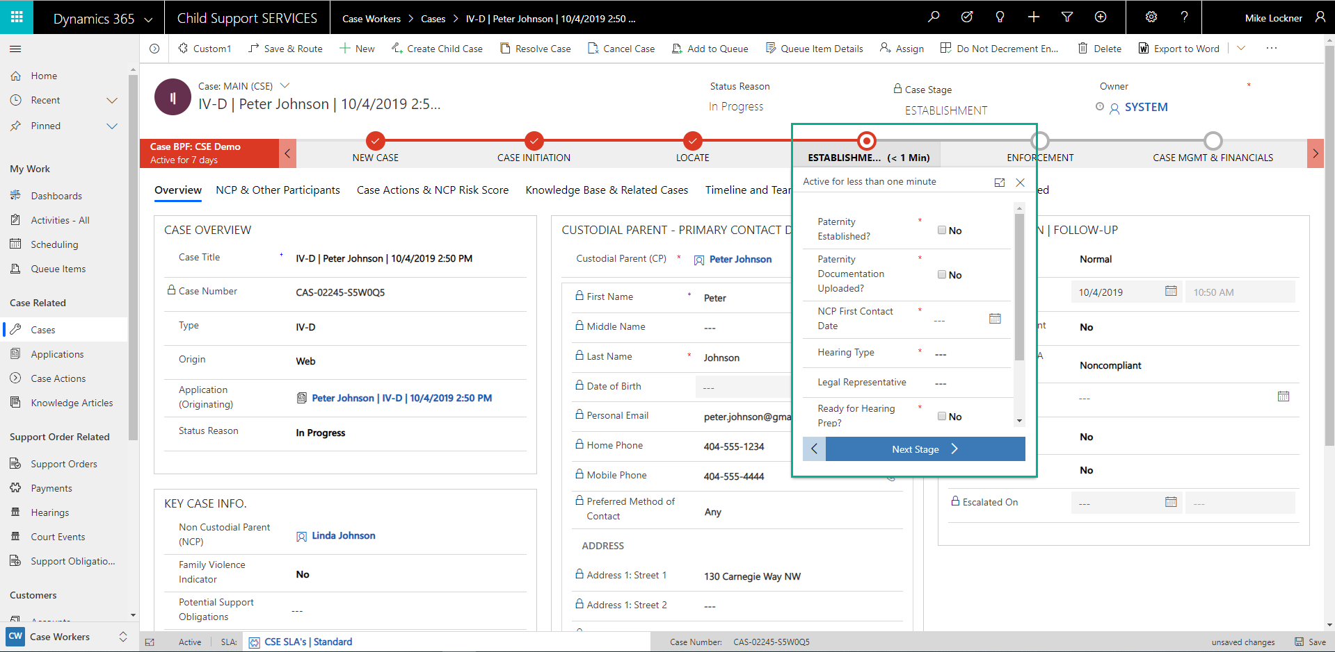
Our solution provides the ability to track paternity establishment. | 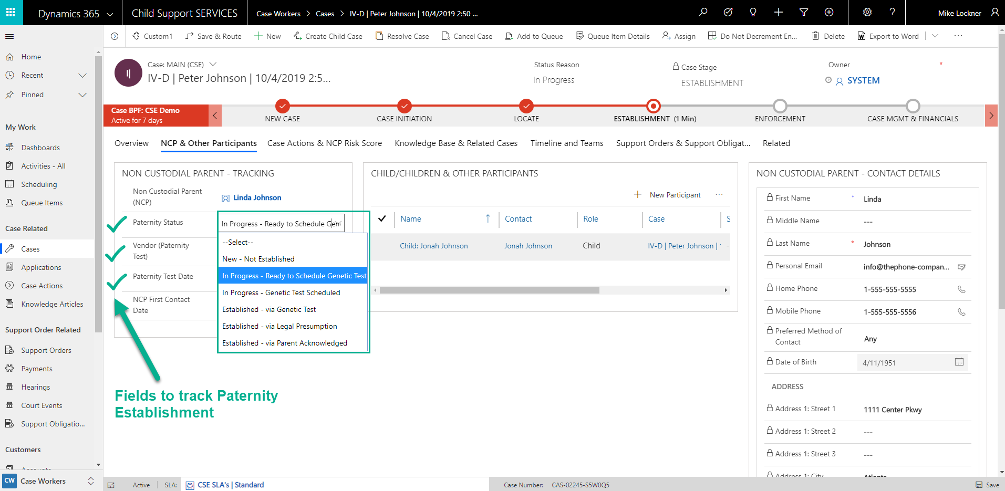
Our solution provides the ability to schedule Paternity Tests.  *Note: A State’s real-world implementation will likely involve integrations with external labs and/or a portal for scheduling purposes. | 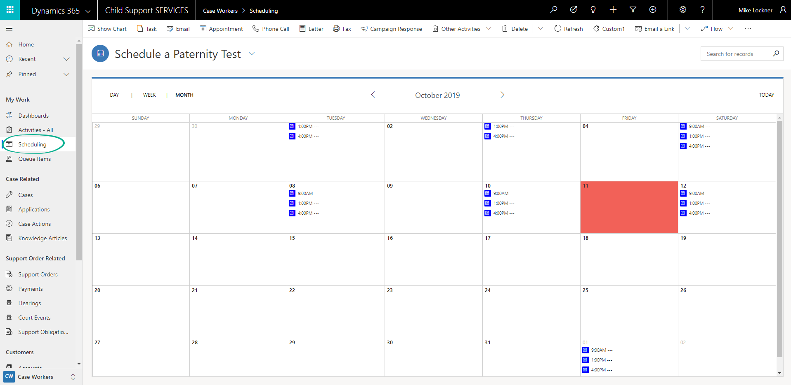
Our solution provides the ability to create documents are emails from D365 records/data. | 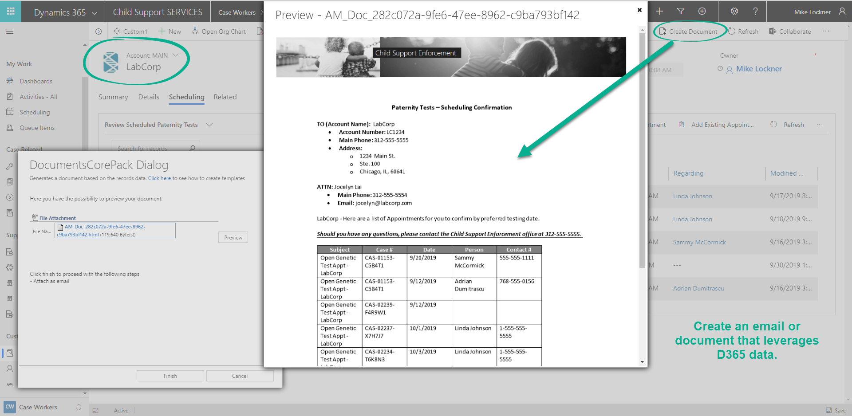
After paternity has been established, a workflow auto-creates an “NCP 1st Contact” Phone Call. The purpose of this phone call is for states to establish working relationships with NCP’s from the beginning.  This screenshot shows the 1st Contact (NCP) | Early Intervention (IV-D) Queue. | 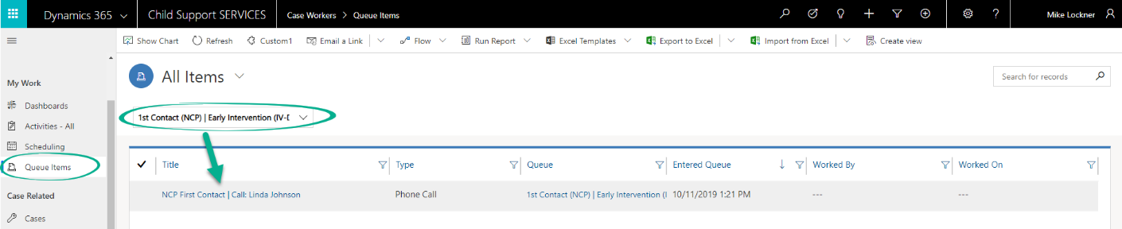
Case workers can open the Phone Call record from the Queue.  Updates from the Phone Call record are reflected on the Case record after the Case worker marks the Phone Call as “Complete.” | 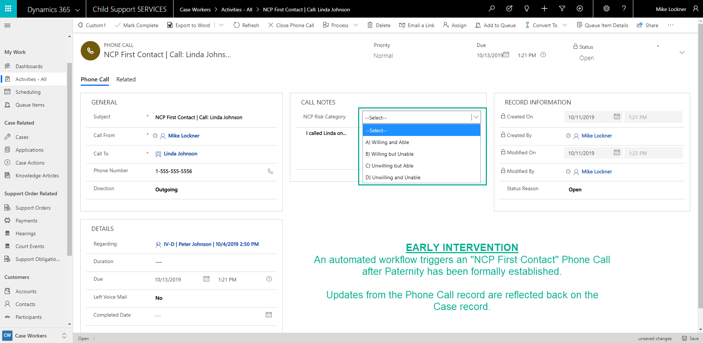
Native "AI Builder" is used to identify High Risk NCP's.  The AI Builder model can be based upon any fields on the Case and is dependent upon historical data. | 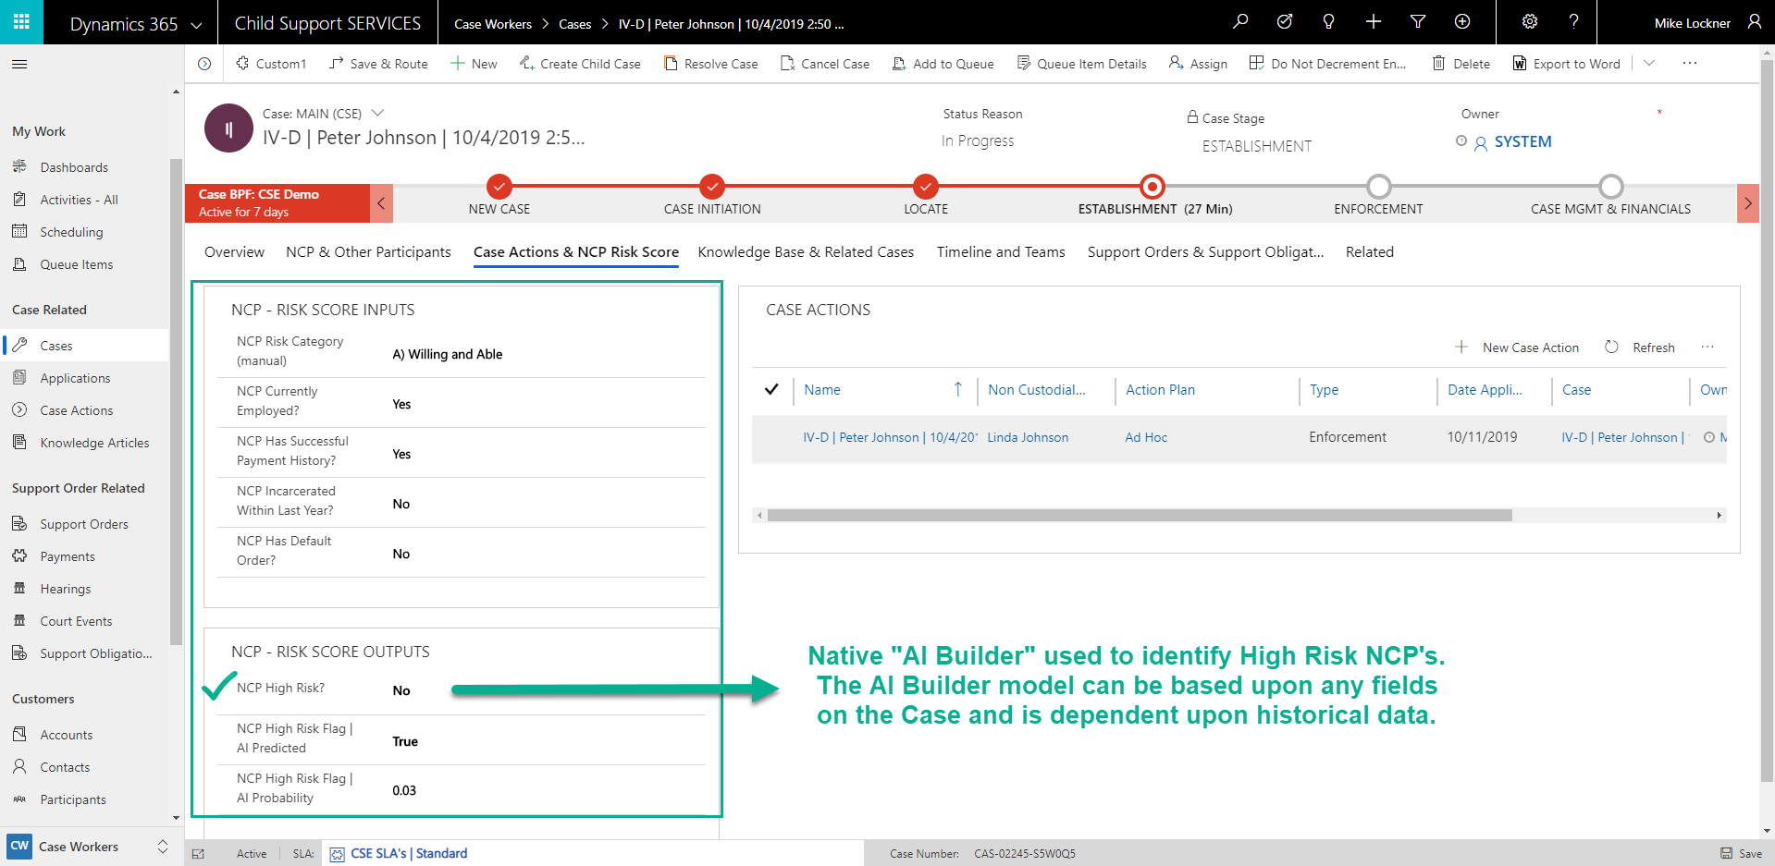
Example of scheduling a Hearing.  Our solution supports both Court Hearings and Administrative Hearings.  *Note: A State’s real-world implementation will likely involve integrations with external courts or hearing locations for scheduling purposes. | 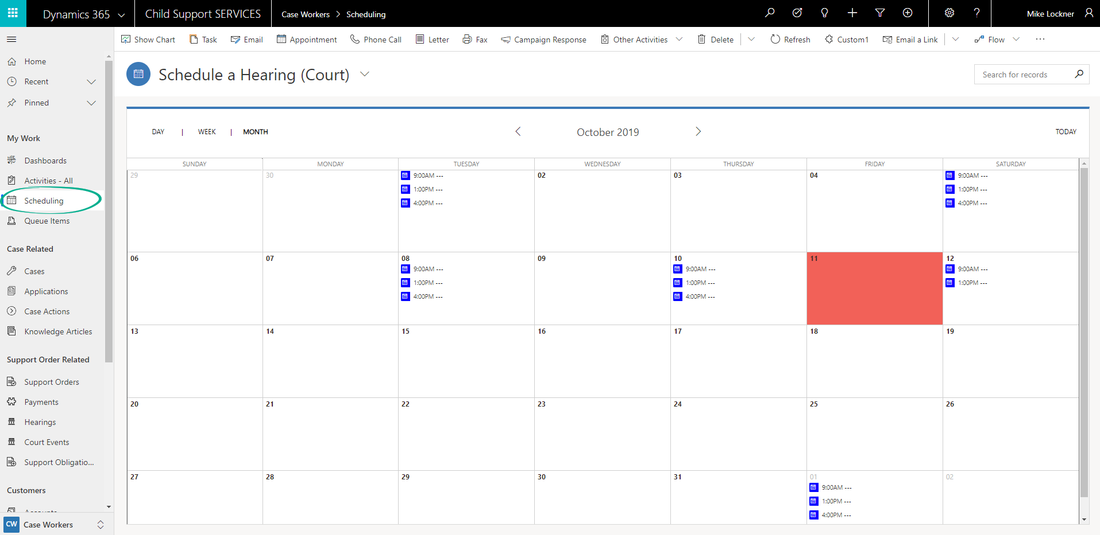
After a Hearing Appointment has been scheduled, automated workflows will auto-create the “Court Event” or “Hearing” record. | 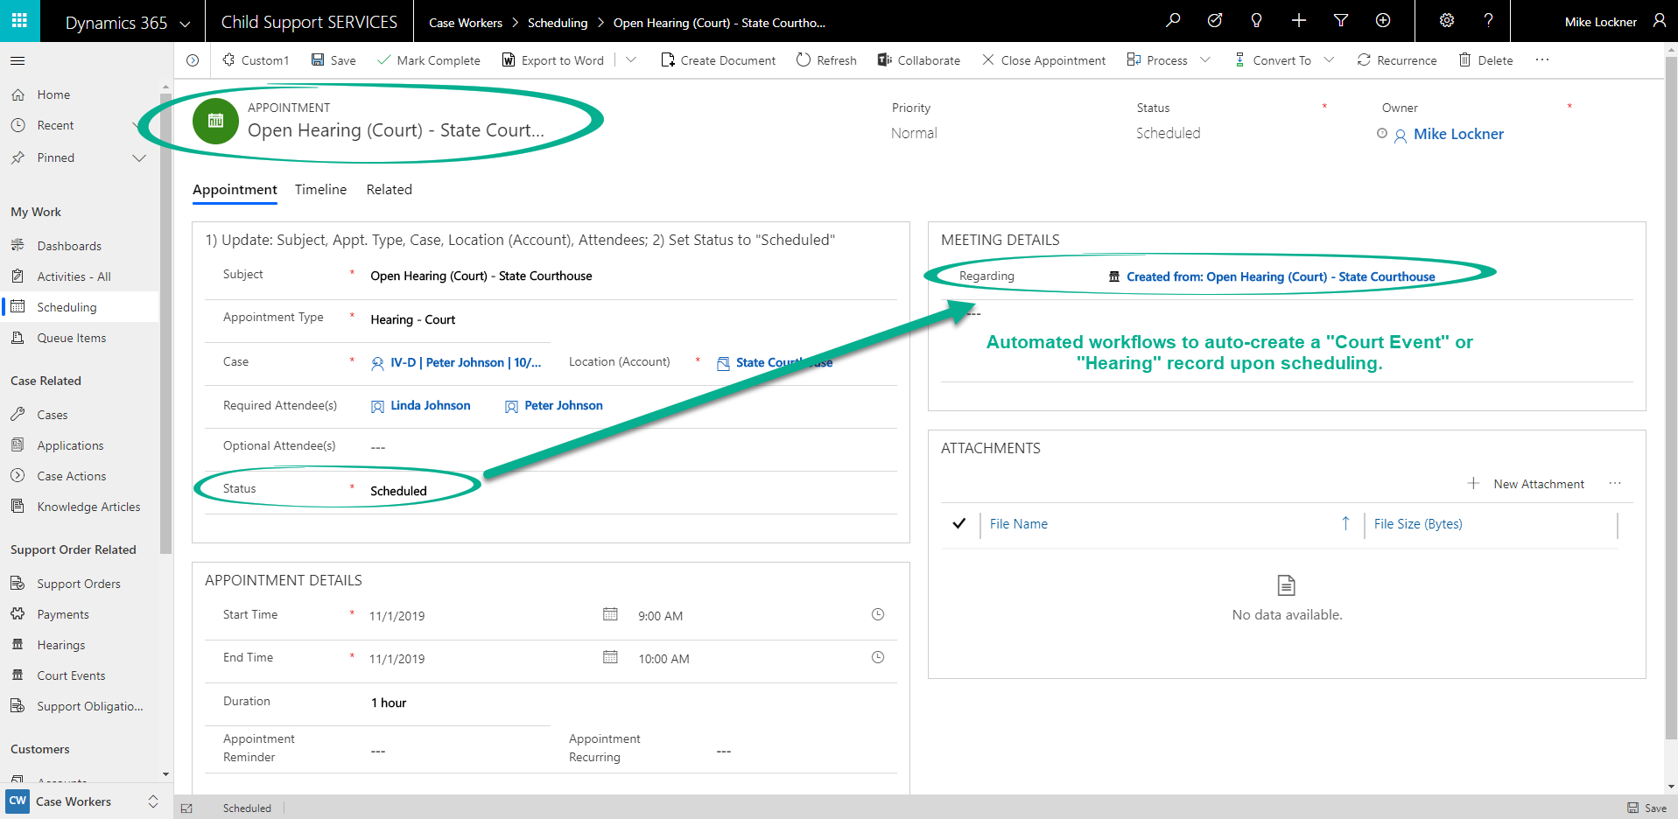
This screenshot shows our Court Event record. When Court Events or Hearing records are created, data is auto-populated from the related Case record. | 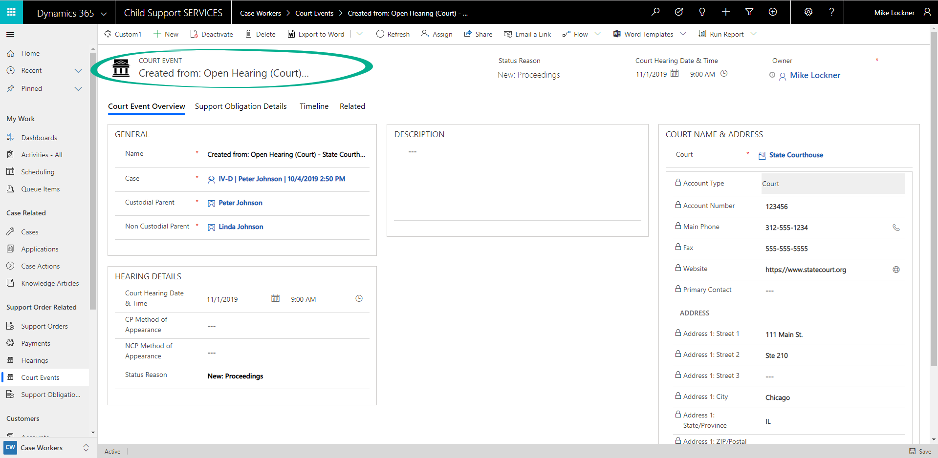
Users will have the ability to create Support Obligation records against Court Events and Hearings.  Our solution also contains an embedded “Canvas App” for support obligation calculations. This calculator is built upon Microsoft’s PowerApps framework. | 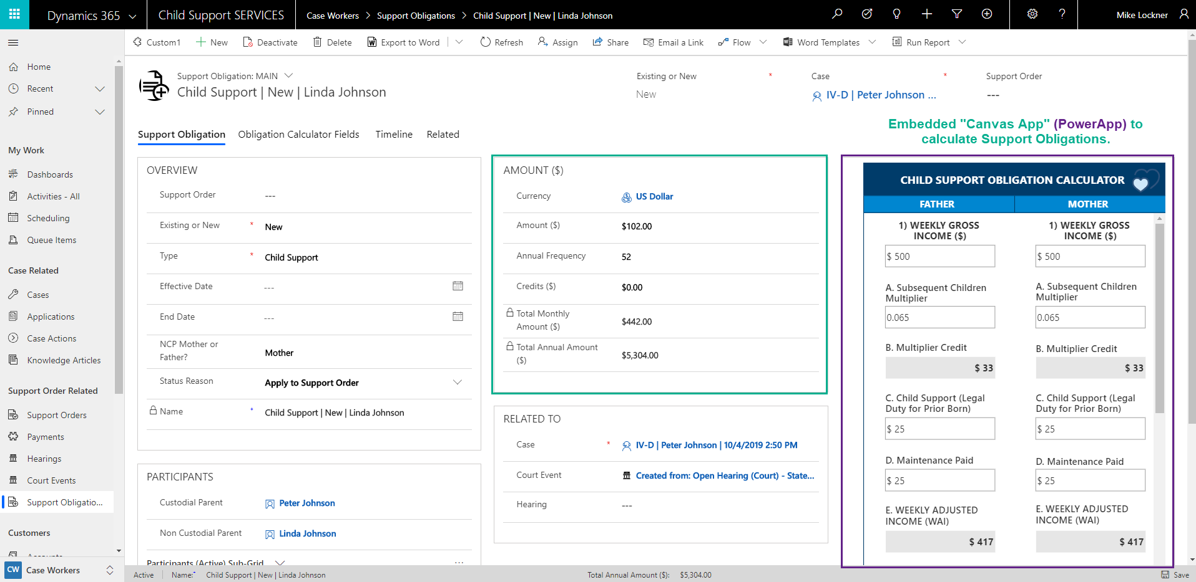
After one or many Support Obligations are created against a Court Event or Hearing, Microsoft Flow will auto-create the related Support Order record and link all Support Obligations from the Court Event or Hearing.  Status changes on the Court Event or Hearing record trigger the creation of the Support Order. | 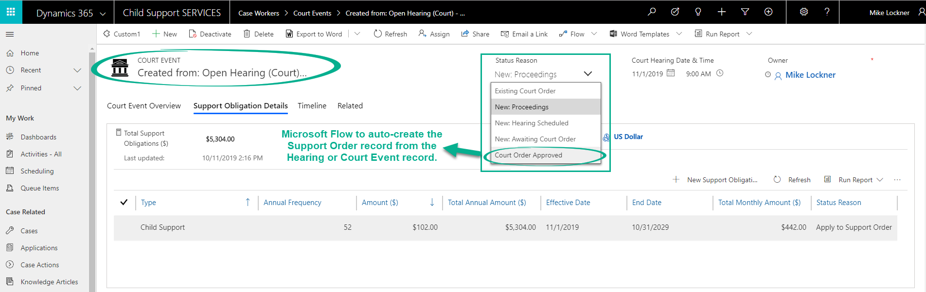

Case Management
In addition to the Case Management functionality already identified, Case workers can also view related Support Orders and Support Obligations from the Case record. | 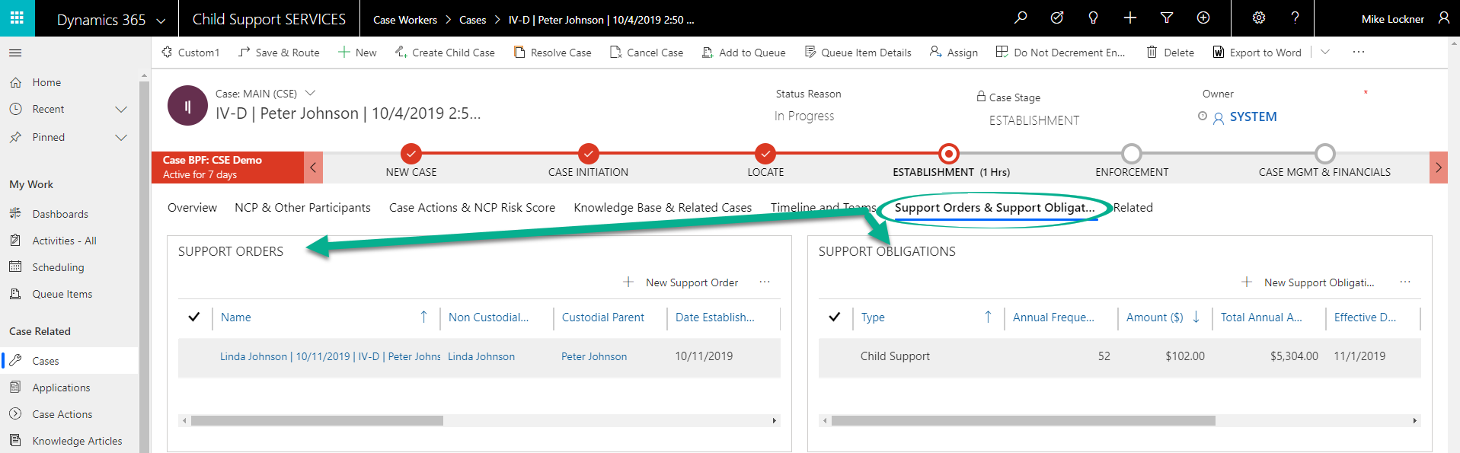
A Case worker can open a Support Order from a Case record.  This screenshot depicts our Support Order form. From the “Obligations & Payments” tab, Case workers can view the Support Obligation details and related Payments made. | 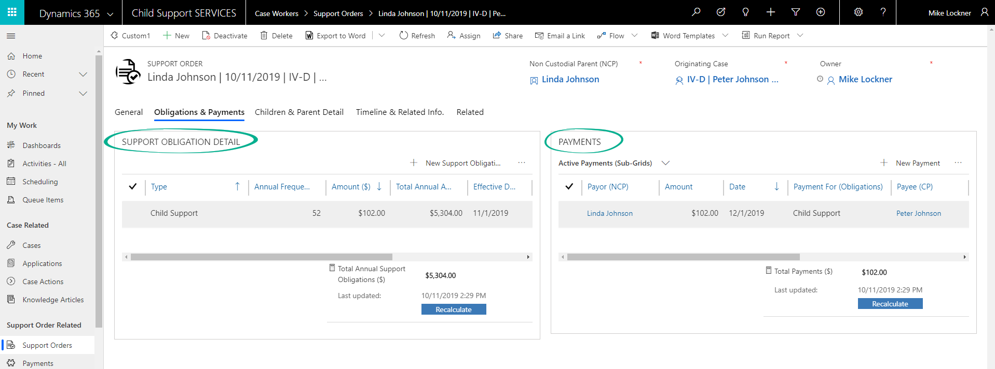
The Support Order also displays details about the parents and children. This allows a Case worker to view pertinent information without having to link to multiple records. | 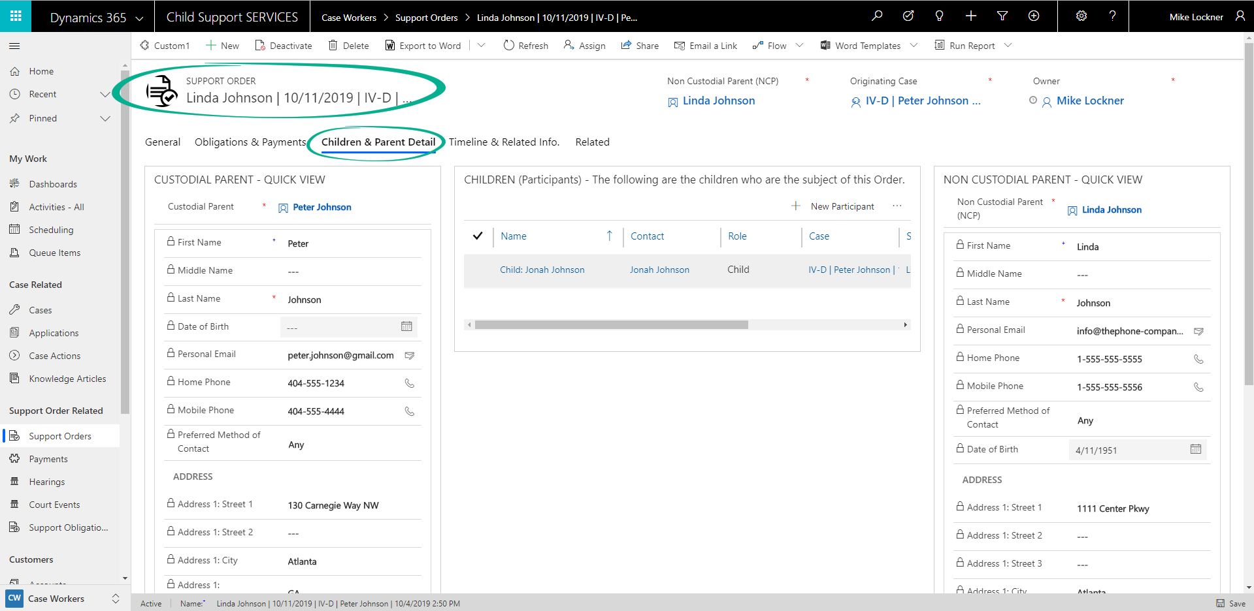
Case workers can also link Knowledge Base articles to Cases and view similar Cases that are automatically linked via “Case Similarity Rules.” These rules are easy to set up and to change. | 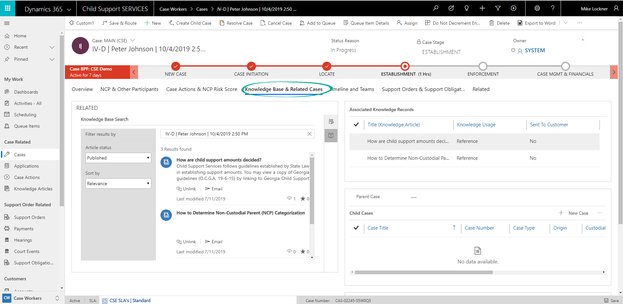
Our solution also contains an integration with Microsoft Teams, which is a software used for collaboration purposes.  Case workers can initiate Teams conversations from within a Case record. This could help new Case workers get up-to-speed more quickly and enhance interoffice collaboration.  This “Teams – Start a Conversation” Canvas App is also built upon Microsoft’s PowerApps framework. | 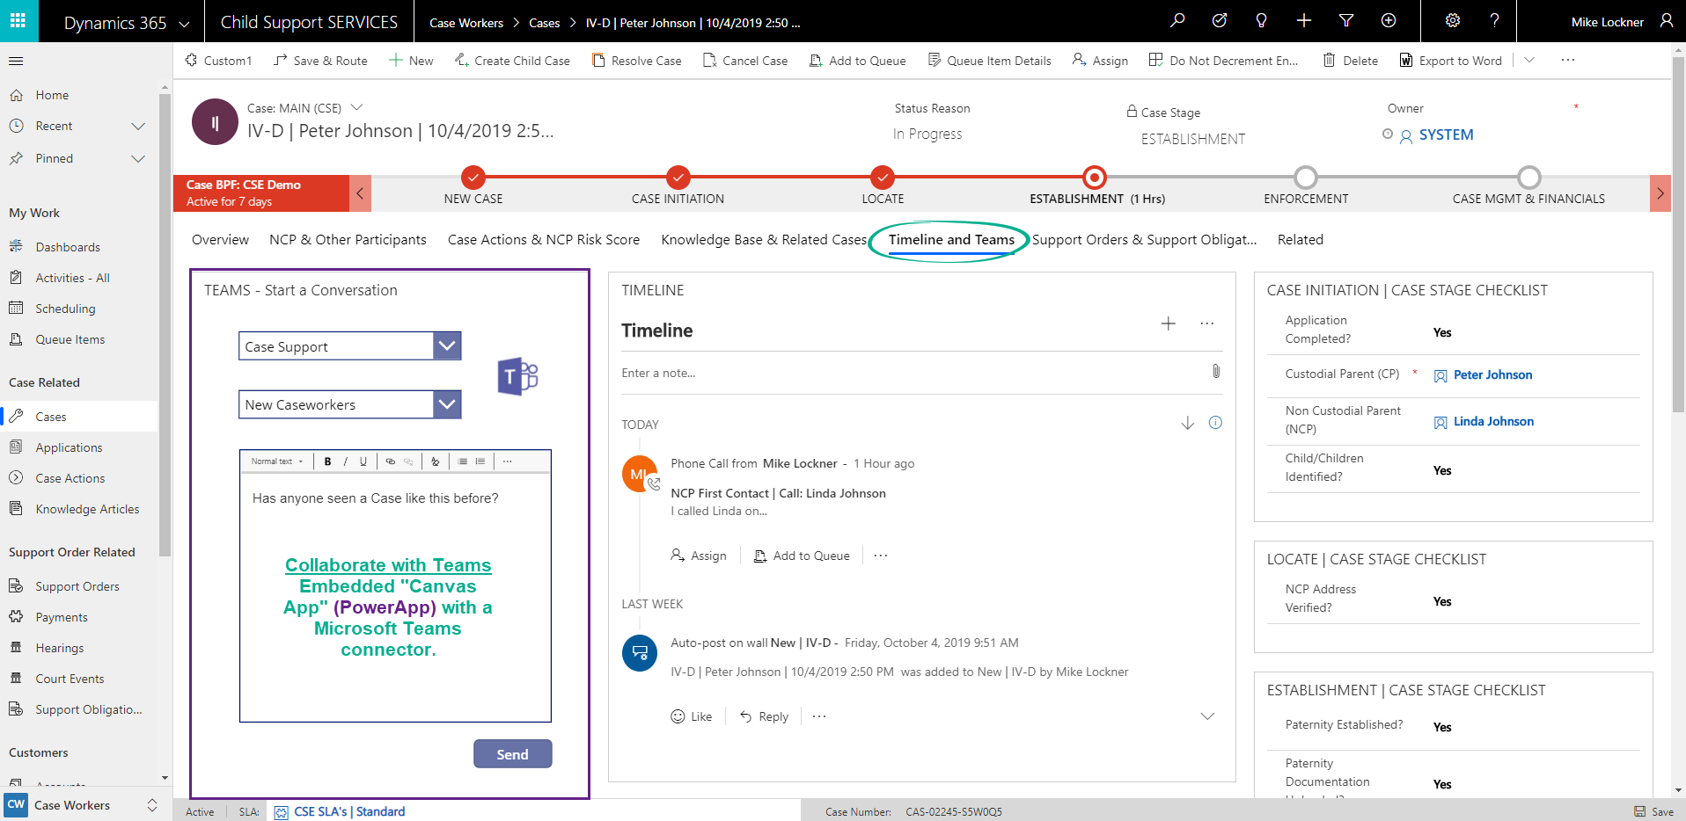
This is a screenshot depicting Microsoft Teams.  In addition to being able to start Teams conversations from within D365, users can also pin D365 Case records from within the Teams application. | 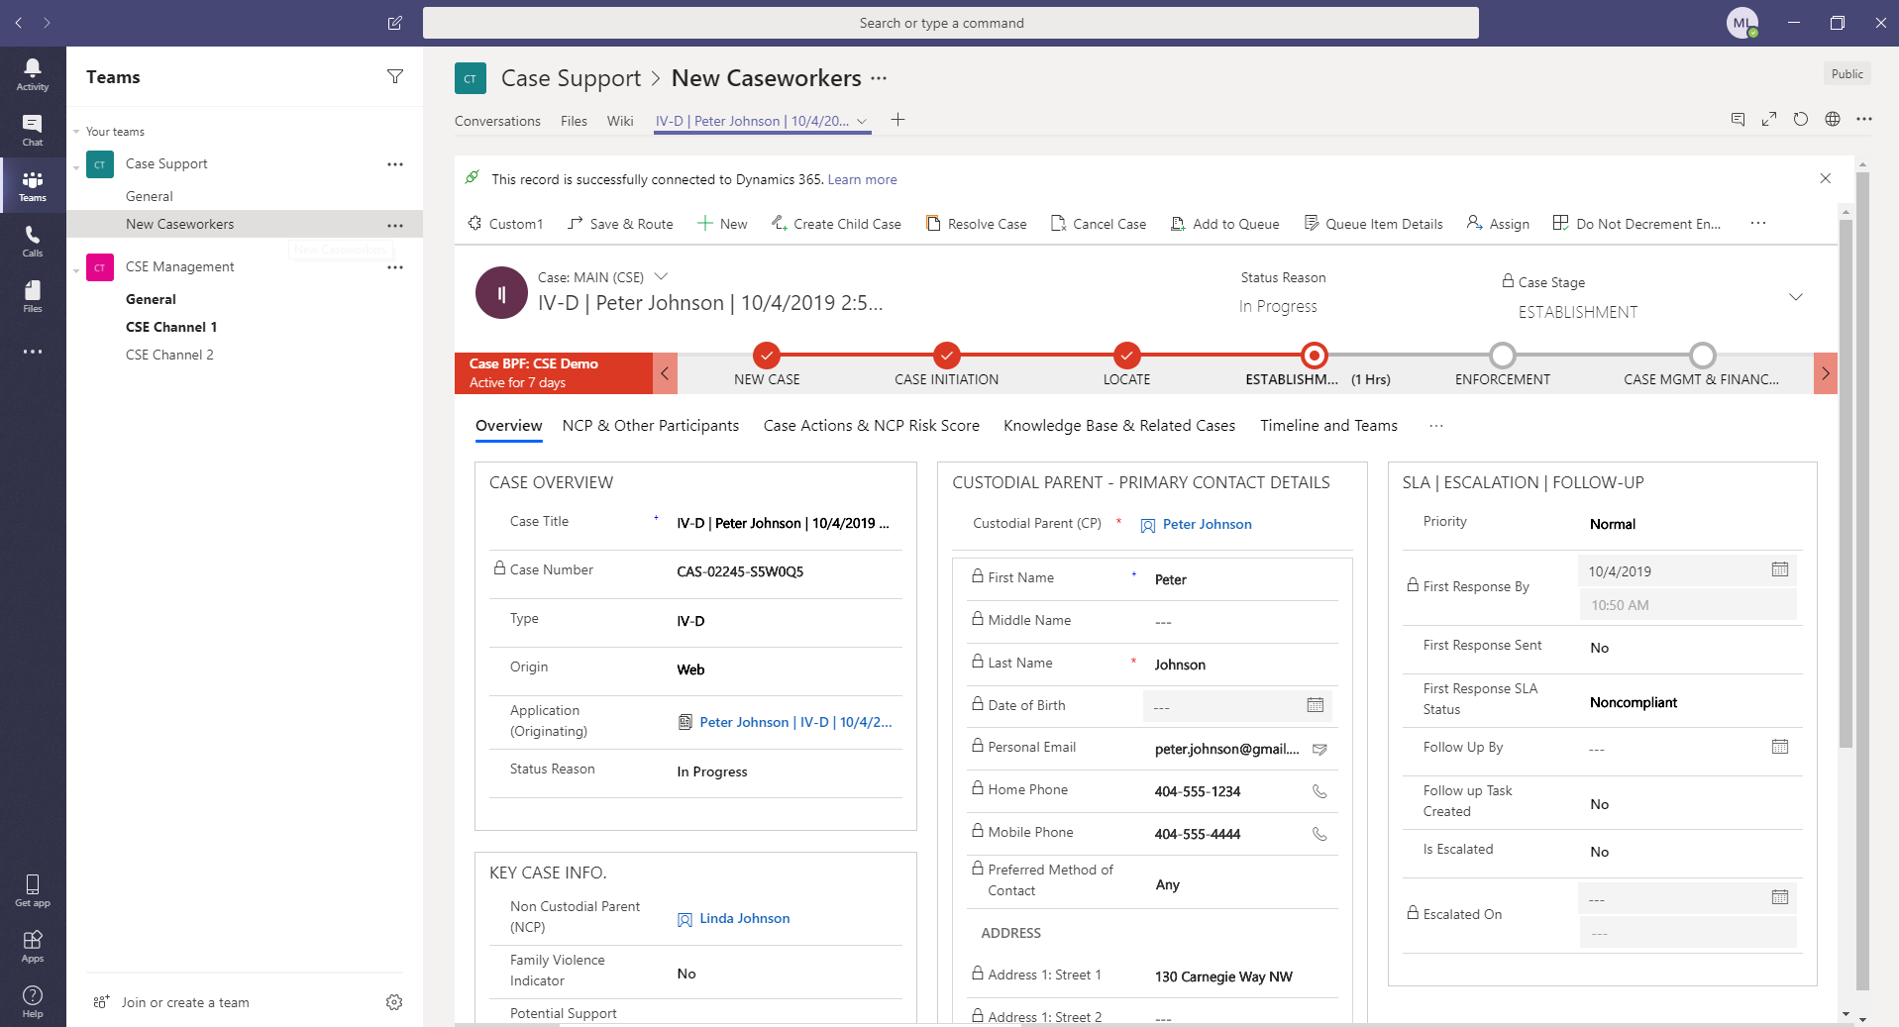

Enforcement
The Enforcement Business Process Flow steps. | 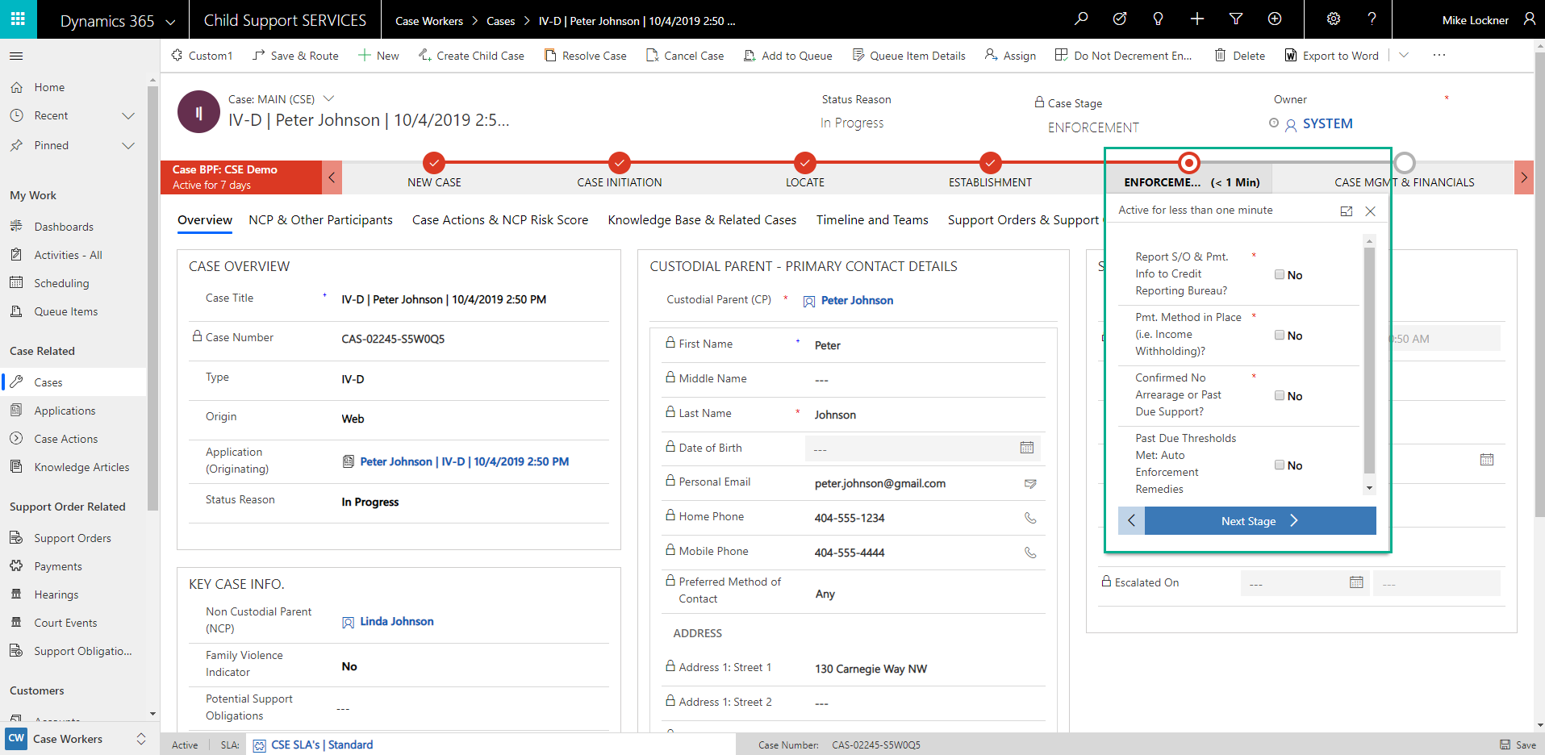
Our solution also involves a separate “App Area” for Case Managers with additional functionality.  Case Managers can create “Action Plans” which are essentially templates. These Action Plan templates can be of type “Early Intervention” or “Enforcement” and they can have one or many Tasks associated to them.  This allows Managers to create or update Action Plans without IT interaction. | 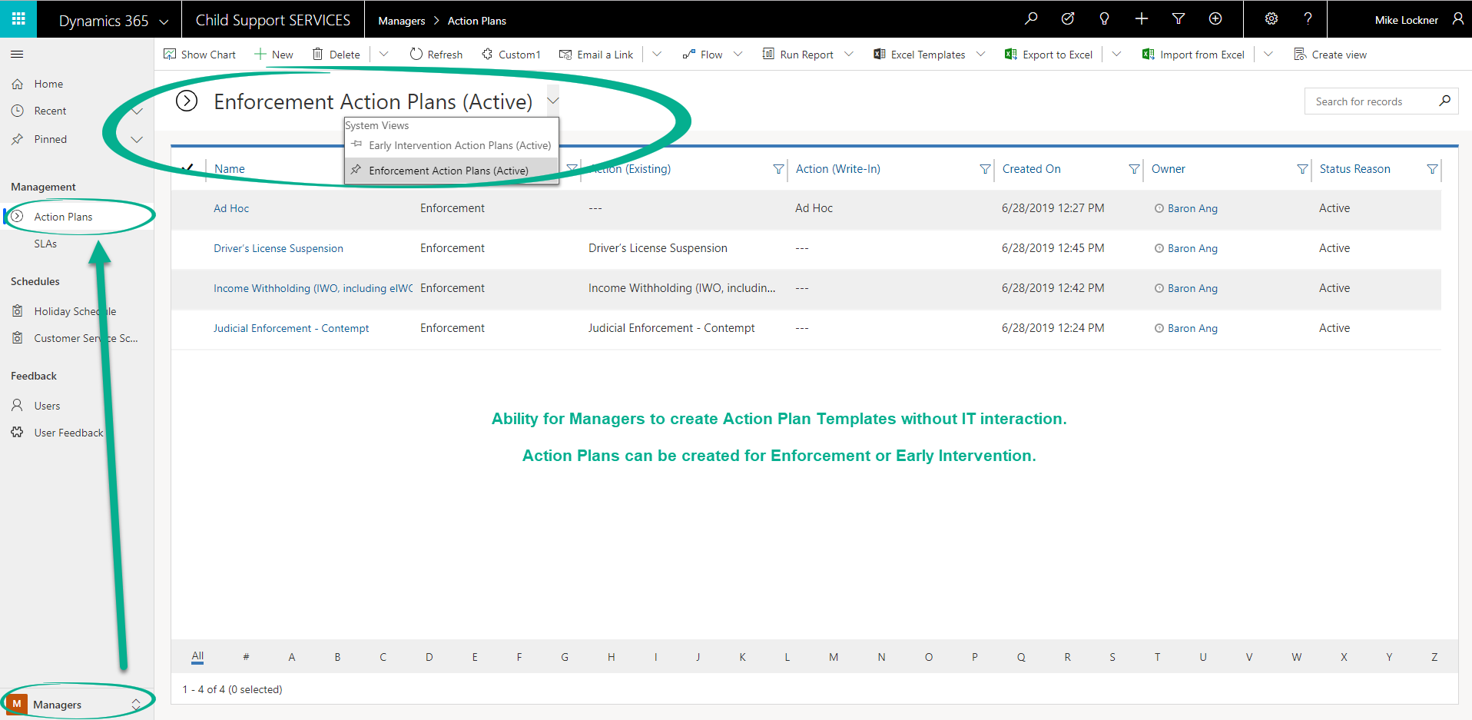
This screenshot shows the Action Plan record. As mentioned above, Action Plans can have one or many “Action Plan Tasks” associated to them. | 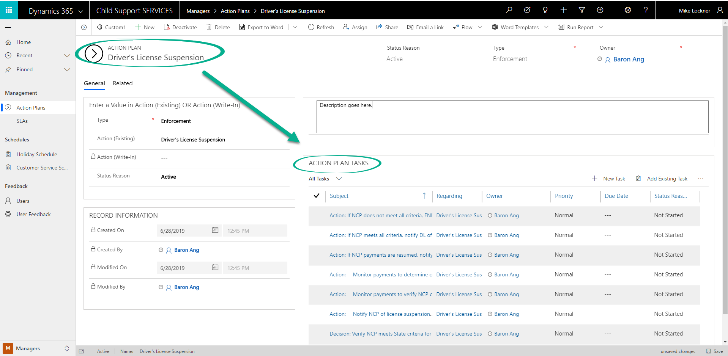
After Case Managers create Action Plans, Case workers can then link Action Plans to Cases via the “Case Action” entity. | 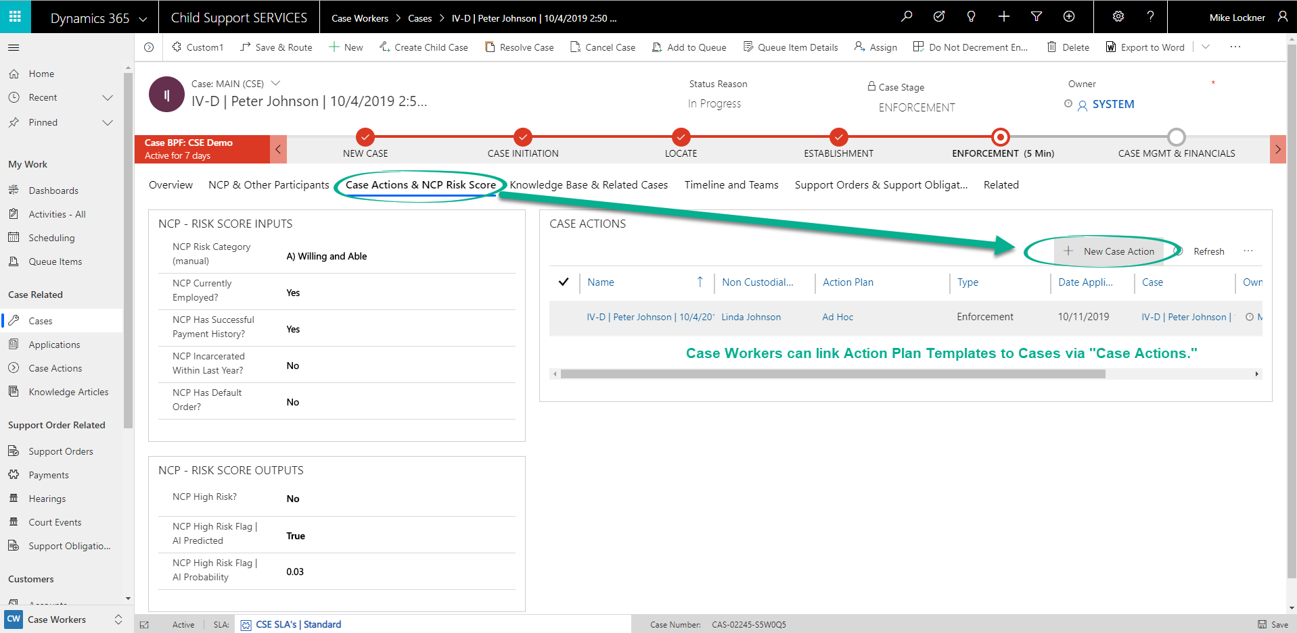
After a Case worker selects “New Case Action,” he/she only needs to select the Action Plan template from a pre-defined list and set the Date Applied.  Microsoft Flow takes care of the rest by cloning the Action Plan Tasks down to the Case Action record. | 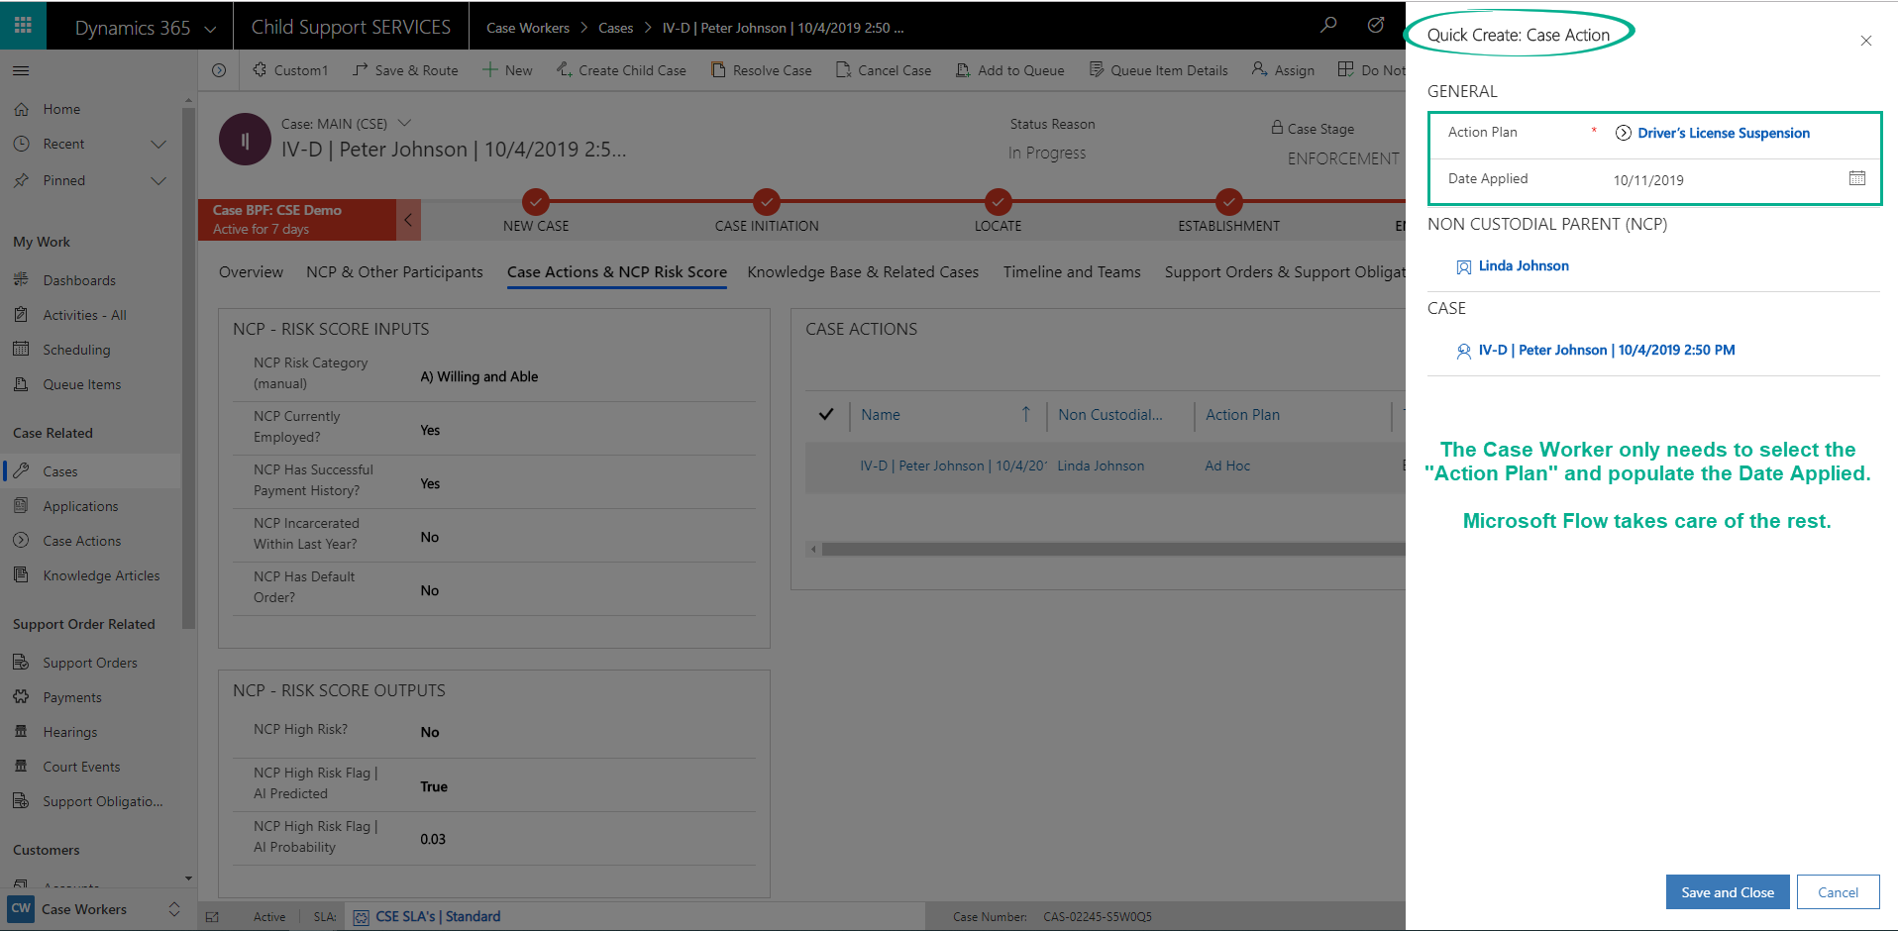
Here is an example of a Case Action record. Notice that it contains the same Tasks listed against the Action Plan template record. | 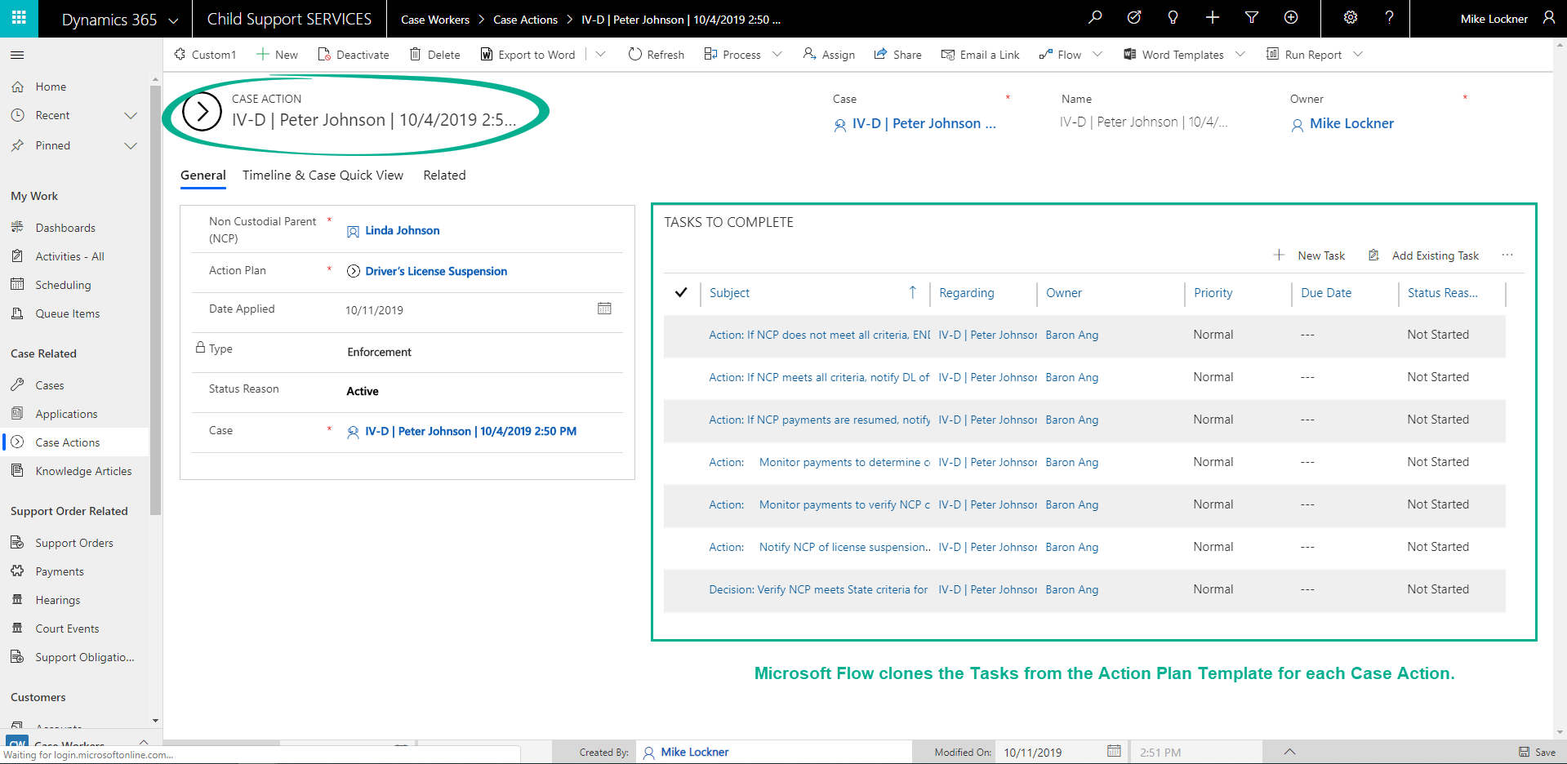

Financial Management
Distribution Rules: Microsoft Dynamics 365 Finance and Operations allows the agency to configure distribution templates based on percentages that can be applied to transactions for financial distributions. In addition, there is also a robust allocation engine that can serve as a distribution mechanism. This would allow rules and formulas to be used to create the additional distributions. Methods include: fixed, percentage, basis of and mathematical calculations.

Arrears Calculations: Transactions for the NCP arrears calculations operate as arrears and allow the agency to track outstanding transactions, overdue payments, calculate interest and apply charges and fees as necessary. The Credit and Collections features allow the agency to manage the collections and dunning process by providing agents collection activities that can be tracked and assigned throughout the collection process.

For more complicated arrears calculations, and/or complex business rules like payment distribution, Team IBM suggests integrating with a 3rd party "Business Rule Management System (BRMS)" like Red Hat’s Process Automation Manager (PAM) – see below for additional details regarding PAM. That said, when building our Child Support Engagement accelerator, we opted not to assume the use of any specific BRMS system, as Microsoft Dynamics 365 has powerful integration capabilities. Some other potential BRMS systems to consider:
- IBM's Operational Decision Manager (ODM)
- InRule: For organizations that need to manage complex business logic for CRM-based applications, InRule for Microsoft Dynamics® CRM provides intuitive software to write, manage, share and execute decision logic and calculations.
Red Hat’s Process Automation Manager (PAM)
Red Hat Process Automation Manager provides tools and runtimes that enable business users to develop applications that automate business decisions and processes. It supports standard notations for describing models of business processes and decisions, which can be deployed as executable automated services. Such services can be modified by changing the underlying models, allowing business users to adapt services to changing requirements without needing IT support to update application code. Red Hat Process Automation Manager includes:
- Business process management (BPM)
- Business rules management (BRM)
- Complex event processing (CEP)
- Resource optimization technologies
- Compliance with industry standards like business process model and notation 2.0 (BPMN 2.0) and decision model and notation 1.2 (DMN 1.2) for process and decision management.
- User experience platform to create engaging user interfaces for process and decision services with minimal coding.

Modern application development projects present technological and organizational challenges. Applications must automate critical business processes and decisions while operating in a modern cloud environment and connecting to a wide range of external and internal systems and data stores. Creating these applications requires a radical change in how software is built—moving away from traditional, IT-led software development to a process that lets developers and business representatives contribute directly to application logic.
- Process Automation Manager gives users the ability to capture business policies and procedures, create applications that automate business operations, and measure the results of business activities.
- It includes easy-to-use graphical tools that foster collaboration between IT and business users and provide better visibility into the rules and procedures that govern business applications (see the figure below).
- It also includes a rich set of application programming interfaces (APIs) that enable straightforward integration with a wide range of complementary solutions. In particular, Process Automation Manager interoperates with Red Hat’s portfolio of middleware products, for example Red Hat Fuse to allow simplified integration to variety of data sources and external applications.

Red Hat Process Automation Manager is designed to run in the cloud and generate cloud-native applications in conjunction with Red Hat OpenShift Container Platform. Components of the product are available as container images, ready for deployment on OpenShift Container Platform. Decision and process models can be built into containers and deployed via OpenShift Container Platform’s source-to-image pipeline. Applications may also be deployed to standalone or clustered servers within more traditional IT environments—accessed via representational state transfer (REST), Java™, and Java Message Service (JMS) application program interfaces.
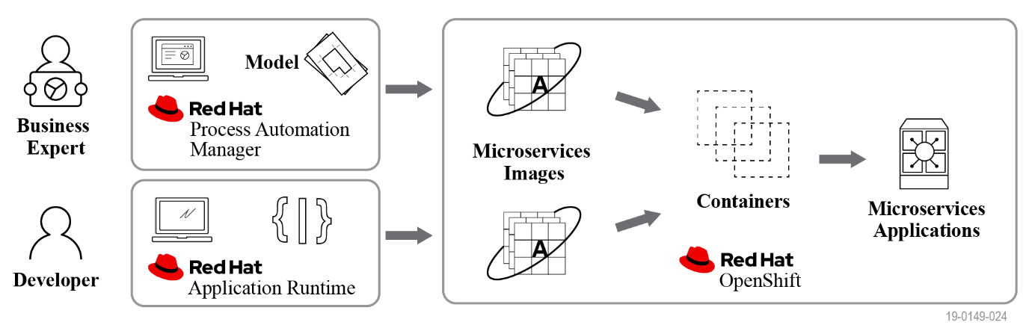

What COTS or other products are used in conjunction with this approach to give a state a fully functional system?

*Note: For all of the products below, an asterisk = required*; no asterisk = suggested.
- Microsoft Dynamics 365 + Power Platform (not all of these are licensed separately)
  - Microsoft Dynamics 365 Customer Engagement – Customer Service App*
  - Microsoft Dynamics 365 Finance and Operations*
  - PowerApps*
  - PowerApps Portal*
  - Microsoft Flow*: for workflow, automation, and some integration.
  - Power BI
- Microsoft Office 365 Products
  - Teams: for collaboration
  - Outlook
  - SharePoint
- DocCorePack – to produce letters, documents, emails from D365 data/records. This optional ISV offers more functionality than the native/out-of-box Word Templates and Mail Merge Templates.
- Rules Engine – as discussed above

Under what circumstances does it make the best sense for a state child support agency to consider this new approach versus other possible means of modernizing its child support system? Are there any characteristics of either a state’s IT system or its business processes that lend themselves more to this approach?

In general, Microsoft Dynamics 365 – or other cloud/SaaS offerings – is the new approach. Technology is growing and changing at a rapid pace – as are people’s expectations of technology. In addition, developing an application with a high volume of custom code no longer makes sense, as the time allotted to build and evolve systems is shrinking, and the cost of such an approach are prohibitive. The way in which our customers expect to be able to interact with the program is also evolving. User engagement needs to span multiple device experiences, and applications need to easily connect and integrate with other applications to be more globally aware.

Microsoft Dynamics 365 provides a high degree of business agility with a lot of flexibility, making it much easier for organizations to implement changes – to both business processes and IT systems (see the figure below).
Microsoft Dynamics 365: High Business Agility & Lots of Flexibility with Minimal Effort to Change
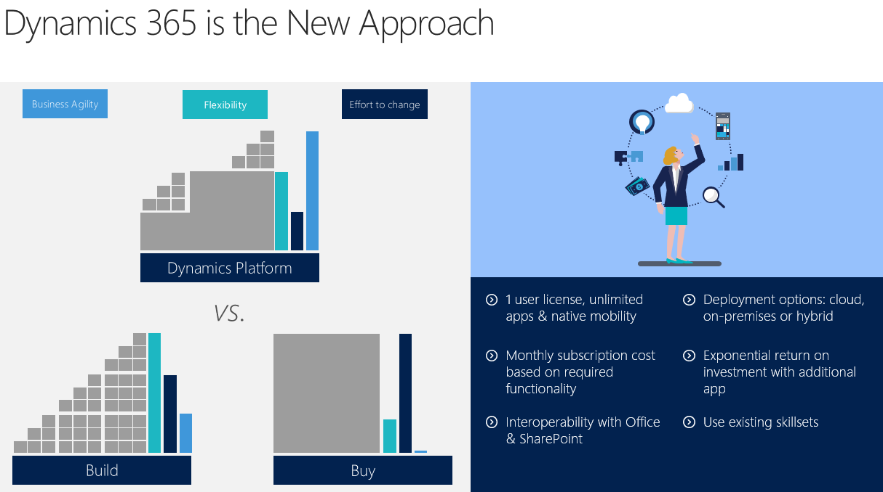

Listed below are some characteristics of a state’s IT system or its business processes that lend themselves very easily to this new approach:
- A state wants a modern and intuitive user-interface to facilitate user adoption and training.
  - Dynamics 365 is built with the end-user in mind.
  - Any configuration or customization work we do will be focused around a user-centric design.
- A state wants a system focused on configuration versus customization. They want the ability to make changes without long and expensive change order processes.
  - Whenever possible, our solution will leverage configuration over customization.
  - One area where customization will be required, however, is integrations (interfaces to share data with other systems such as FPLS as well as state systems).
- A state has standard business processes outlined; they simply need a new system that can adhere to those business processes, while automating as many activities as possible.
  - Dynamics 365 Business Process Flows
  - Dynamics 365 Workflow, Business Rules, and Microsoft Flow
- A state needs the ability to collaborate easily with other caseworkers – for both training and day-to-date operational needs.
  - Microsoft Teams integrates with Dynamics 365, and we’ve built an embedded canvas app that allows Caseworkers to initiate a Teams conversation from within Dynamics 365.
- In addition to the above, our solution and Microsoft Dynamics 365 provides the:
  - Ability to roll-out modules or features quickly and independently.
  - Ability to connect and integrate with any internet-facing system

Generally speaking, what should a state expect on the following: project timeframe, project cost, time to rollout statewide?

The answers to all of the below are dependent upon each state’s overall requirements.

Project Timeframe
At a high-level, there are three major development efforts/components involved with our proposed solution:
- Microsoft Dynamics 365 Customer Engagement (D365 CE)
- Microsoft Dynamics 365 Finance and Operations (D365 FnO)
- PowerApps Portal
These three components can be developed separately or in parallel, with some lag in between each component to account for the interrelated requirements and system dependencies. For example, we would not want to start building the PowerApps Portal until the related forms have been configured in D365 CE. Therefore, the PowerApps Portal build would start after Sprint 1.

Our project execution strategy would also need to take into consideration the client stakeholders, to ensure we are not overloading the IT and business resources who might have input on more than one of the development components. The estimated timeline below is one of many possible options.

Estimated Project Timeframe – by Development Effort
*This does NOT include training and rollout

Project Cost
All projects are unique in the amount of time and complexity required for a successful implementation of Microsoft Dynamics 365 for Child Support Services. Our team will work with the state to produce an estimate based upon detailed requirements to provide a quote for your implementation costs.

Time to Rollout
Time to rollout is dependent upon:
- Training Plan and Training Execution Strategy
  - How many users need to be trained?
  - Does the state need us to train, or will we be utilizing a train-the-trainer model?
  - Will training be done in person or electronically.
  - Etc.
- Rollout Plan
  - Are we initially rolling out to a pilot group, or does the state require a “big-bang” implementation?
  - Pilot Group: Utilizing a pilot group for the initial rollout is the recommended approach, but this can be determined on a state-by-state basis.
  - Feedback from Pilot: Assuming we utilize a pilot group for the initial rollout, we’ll likely need to build in time to incorporate any feedback or lessons learned from the initial pilot.
  - Post-Pilot Rollout: Post-pilot rollout, we will work with each state to determine if a phase rollout is required.

Estimated Timeline: States should plan for a rollout window of ~3 months. This is an average, of course, as rollout is dependent upon many factors. Some rollouts could take as little as 1 month, while others could take as long as 6 months, depending upon the size and complexity of the state.

The states don’t want to again face the major system build and cost challenges once they have modernized. If they choose this approach, what is the continuous improvement model for the platform? Will the states benefit from the vendor efforts without major costs?

There are two parts to this answer:
- What Microsoft does to enhance the core product features.
- What IBM/Grays Peak would need to do to help the states “turn on” and take advantage of new features.

What Microsoft does to enhance the core product features
From Microsoft: “The true value of a cloud service is realized through continuous updates that can provide both improved reliability and new features, while minimizing operational impact. We are optimizing the way we deliver updates for a more consistent, predictable, and seamless experience for every customer. Our monthly update cadence aims to provide predictability, lower upgrade costs, user access to the latest product capabilities and performance improvements, and a better support experience.”

Starting in 2019, Microsoft is pushing Dynamics 365 to a “One Version” Azure-cloud-hosted model. This means that new features will be released monthly, and users can opt to “turn on” and take advantage of these features.

Microsoft Dynamics 365 – “One Version”
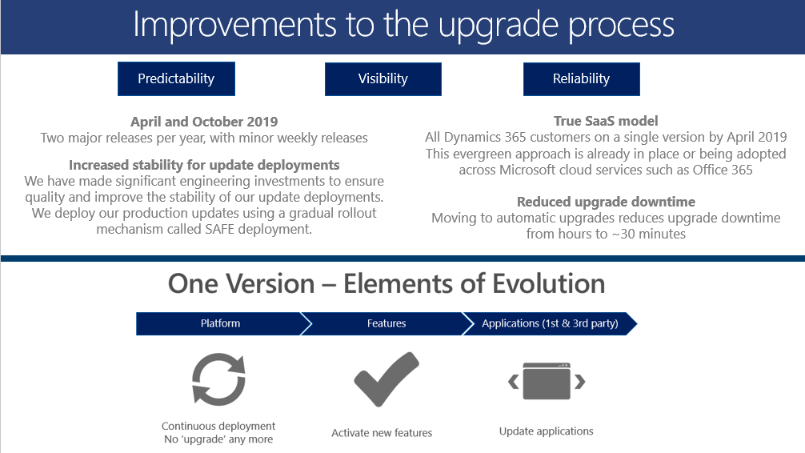

Benefits of Microsoft Dynamics 365 for Government
- Use Modern, High Performing Infrastructure.
- Ready When You Are. Capacity to grow as fast as your business can go.
- Continuously Available. Application and Infrastructure Management is handled for you and backed by a guaranteed, financially backed SLA.
- Secure and Compliant. 3rd party testing, regulatory compliance.
- Speed to Value. Get up and running faster, implement enhancements quicker, realize value sooner.
- Don’t Compromise. Develop and Test on the same configuration and hardware as Production.
- Maintain Flexibility. Change as needed for your business with lots of native tools and flexibility.
- Transform IT, Deliver Higher Value. Focus IT on strategic efforts to achieve better business alignment by reducing complexity associated with hardware, software, support, update, and training activities.

Microsoft’s approach to services embodies three inherent strengths that in combination is something only Microsoft is positioned to deliver:
- Microsoft services are people-focused
The Microsoft cloud brings the same focus on people to the arena of services – mirroring the familiarity and ease-of-use from on-premises products into Cloud services. This all leads to higher user adoption and improved productivity with lower training costs.
- Microsoft has a comprehensive set of high-value services
Microsoft has an integrated portfolio of cloud services across platforms, apps & devices along with one of world’s largest developer base & partner ecosystems.
- Microsoft services are enterprise-grade.
What matters most is working with a company you know that has the experience, reach and footprint you can trust fully. Leading governments, Financial Services organizations and others rely on Microsoft because their Cloud services are global, secure, reliable and fault tolerant.
Dynamics 365 for Government
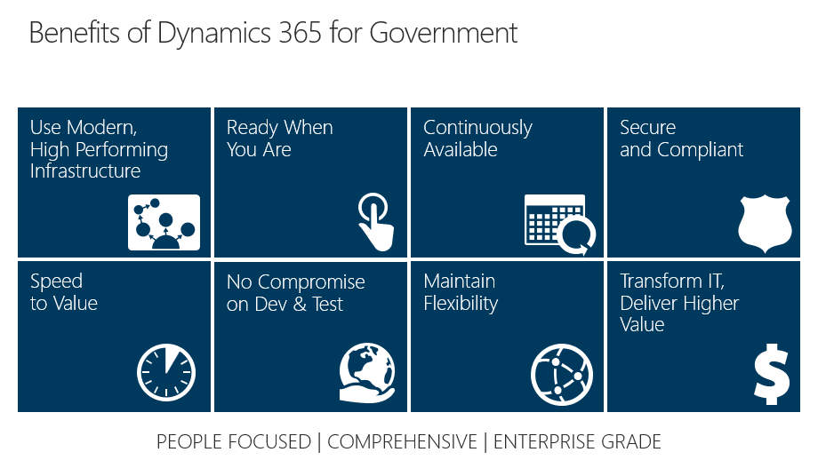

What IBM/Grays Peak would need to do to help the states “turn on” new features
A picture of “Our Solution” is included below. It shows how Users benefit from both the core Microsoft Dynamics 365 Application and the Platform itself. During the state’s Child Support Engagement Project, Team IBM/Grays Peak will build on top of and utilize the “Dynamics Core Features.”

For the purposes of this question, let’s assume that Team IBM/Grays Peak just completed implementing and rolling out a state’s Child Support system on Microsoft Dynamics 365. Post-project, a state will have various support options. If they have a strong IT team and we have incorporated technical training and a transition out plan (see “Example of an IBM Transition Out Plan” below), a state might not need partner/vendor support to utilize new features. If they do require partner/vendor support, a state can opt to sign a small statement of work with Team IBM/Grays Peak to cover turning on and configuring new functionality. This would all be determined on a state-by-state basis, and new features from Microsoft would always be optional.

In addition, Team IBM/Grays Peak will always ensure that all customizations are “supported,” which means that custom code would not break with system updates from Microsoft.

Furthermore, even if a state never wanted to turn on new functionality, they would still benefit from Microsoft Dynamics 365 user interface updates, so their systems would always have a modern look-and-feel.

Our Solution: Microsoft Dynamics 365 Platform
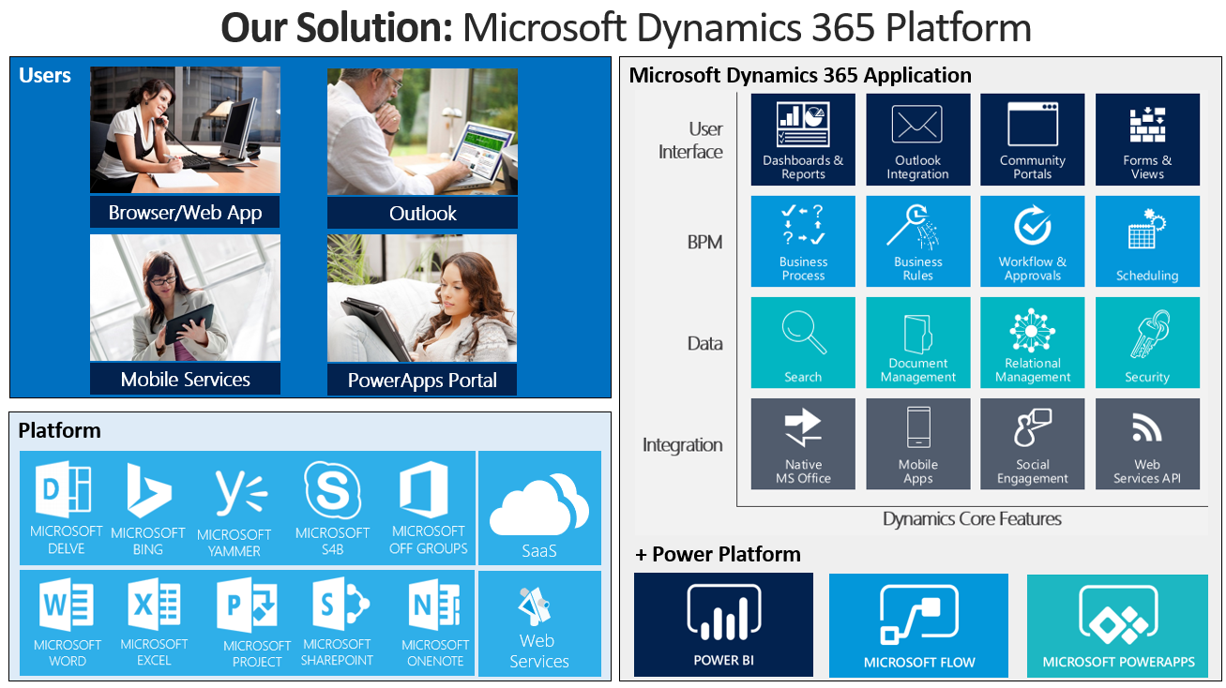
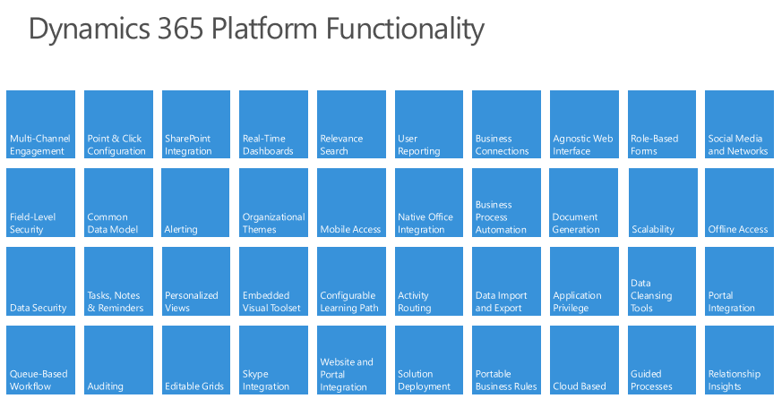

Example of an IBM Transition Out Plan
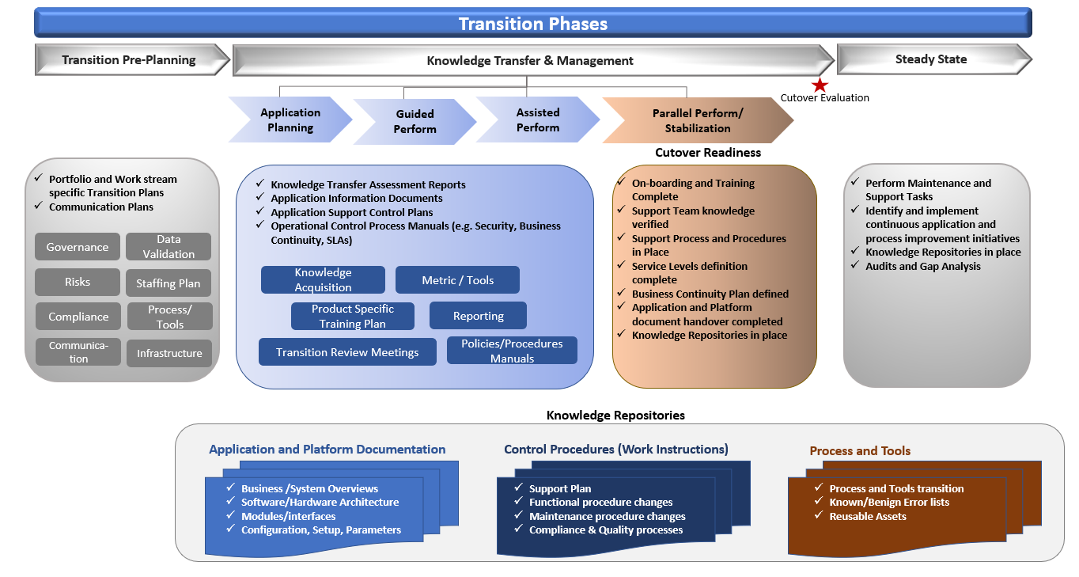

What are the most important things that a state should do to prepare for this approach?

States preparing to implement a system like Microsoft Dynamics 365 should start considering the following:
- Identify Stakeholders – Business and IT
- Identify the state’s Project Team
  - Project Manager
  - Key Business Users – to work with Team IBM/Grays Peak during design sessions.
  - Identify “Super Users” to work in tandem with Team IBM/Grays Peak.
- Develop As-Is System Architecture Diagrams.
- Develop To-Be System Architecture Diagrams – highlighting integrations that must stay in place.
- Start developing a data migration strategy or plan – this would be refined with support from Team IBM/Grays Peak during project execution.
- Refine system Requirements.
- Prepare Project Team for an Agile-like methodology – unless a state prefers a different methodology.
- Develop a training strategy – for example, IBM/Grays Peak to run train-the-trainer sessions in-person. This approach allows us to empower the states to train their own people, which has a positive impact on user adoption. That said, Team IBM/Grays Peak is open to any training strategy that supports state objectives.

How does this type of child support system fit with states who need to have an enterprise approach? Many of the platforms seem to be creating the same old silos on a new platform. Is it possible to have one casefile for each person/family across the systems (child support, SNAP, TANF, family services, etc.)?

*Please note: A state’s IT architecture impacts the answer to this question.

For states with different systems for child support, SNAP, TANF, family services…
It is possible to have a centralized Data Warehouse that holds the master casefile for every CP/NCP. This type of solution would require multiple two-way integrations with firm business rules around which record “wins” if multiple updates are being made to the same casefile within a designated period of time.

In addition, the use of a Data Warehouse for reporting has become common with existing systems. There are data reporting functionalities within Dynamics that will meet the majority of a state’s reporting needs with some configuration. An existing data warehouse can be integrated into this approach, and historic data can be accessed as well.

For states open to moving all systems to Microsoft Dynamics 365…
The ability to use a configuration (low code/no code) approach for the majority of the functionality means the same approach could be used to implement modules to support other programs within the same MS Dynamics implementation.
- Programs could be segmented in terms of security and user access, but all of the case data could reside in one database, and details about case participants in multiple programs could be easily shared across programs.
- There would be no need to enter personal data into multiple systems, and when information is provided to one agency it can be shared instantly with any other appropriate program that may need that information.
- Privacy and confidentiality rules would be applied to ensure that data is safeguarded across programs, while gaining the advantage of utilizing a single point of entry for all potential programs and services supported by the system.

What haven’t we asked that we should have?

- How does your solution handle complex and multi-layered “business rules”?

Microsoft Dynamics 365 has a lot of powerful tools for business rules that are native to the application such as: Business Rules, Workflow, Microsoft Flow, and Business Process Flows.
That said, states will likely have complex business rule requirements that might require a 3rd party business rules application, like RedHat’s Process Automation Manager (see our “Financial Management” response to Question 2).

- What types of “savings” does a solution like your offer?

We believe our solution offers savings in the following areas:
  - Hardware: Our solution is a SaaS offering much like Microsoft Office 365
  - Services: Our solution is more efficient to configure and implement that a custom or re-platformed application.
  - Training and On-Boarding Costs: A more modern and intuitive UI, coupled with our focus on user-centric design, will reduce the costs to train existing staff and to on-board new staff.

