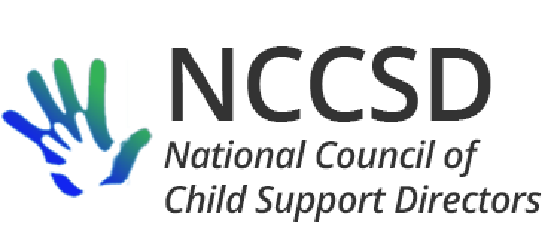

#### President

James C. Fleming, Director

Child Support Division

Department of Human Services

PO Box 7190

Bismarck, ND 58507-7190

701-328-7501

[jfleming@nd.gov](mailto:jfleming@nd.gov)

## **Vice President**

Michele Cristello, Director

Child Support Enforcement Division

Department of Revenue

PO Box 9561

Boston, MA 02114-9561

617-626-4042

[cristellom@dor.state.ma.us](mailto:cristellom@dor.state.ma.us)

### Secretary

Kate Cooper Richardson, Director

Oregon Child Support Program

Department of Justice

1162 Court Street NE

Salem, OR 97301

503-947-4388

[kate.richardson@doj.state.or.us](mailto:kate.richardson@doj.state.or.us)

**Treasurer**

Liesa Stockdale, Director

Office of Recovery Services

515 E 100 S, Suite 100

Salt Lake City, UT 84102

801-536-8901

[lcorbri2@utah.gov](mailto:lcorbri2@utah.gov)

[date]

Department of Health and Human Services

Administration for Children and Families

[nonresidentemploymentRFI@acf.hhs.gov](mailto:nonresidentemploymentRFI@acf.hhs.gov\)

The National Council of Child Support Directors (NCCSD) consists of the directors of the state child support programs in the 54 states and territories in the United States. We write in response to the November 20, 2019, Request for Information (RFI) regarding employment programs for nonresident parents.

NCCSD is significantly interested in improving the capacity of unemployed and underemployed nonresident parents to earn income and support their children. The child support program is erroneously perceived by many to be an adversary of nonresident parents. To the contrary, child support professionals have long recognized that increasing support of children in many cases depends on improving the nonresident’s employment situation rather than firmer and more aggressive collection enforcement actions.

NCCSD applauds the steps taken by ACF so far to remind and reassure states that employment programs can be funded using TANF funds, IV-D incentive funds, and IV-D funds through a Section 1115 waiver. Several states have already taken advantage of this flexibility. These state programs have already demonstrated the effectiveness of such programs, and support continued exploration of additional funding sources.

Several well-established child support actions encourage parents to make payments rather than directly attach income or assets. Examples include federally mandated actions to suspend driver and recreational licenses, deny passports, and report arrears to credit bureaus. These actions are inherent in the child support program and are eligible for IV-D funding. Properly managed, employment programs are similar, except they offer an even more constructive approach. A parent is given the opportunity and assistance needed to improve his or her employment situation. A parent who takes advantage of the opportunity and obtains work is able to become self-supportive and provide for the parent’s children; a parent who does not can expect the child support program to pursue other enforcement strategies.

Many NCCSD members submitted information to support development of the Knowledge Works! website, and NCCSD encourages ACF to review the state information collected on that website. The states which operate such

programs are in the best position to respond to some of the specific questions posed in the Request for Information, and this response will express support for employment programs at a high level.

In response to RFI Question 3.2, a key factor in successful employment programs for nonresident parents is to start by recognizing that many such parents want to earn income and support their children. In fact, many parents contact child support programs for help prior to becoming delinquent when they lose employment. NCCSD encourages flexibility in employment programs so the services can be provided on either a mandatory or voluntary basis to parents who are either delinquent or have experienced job changes but are not yet delinquent.

In further response to RFI Question 3.2, successful programs have also resolved the challenge of balancing suspension of driver licenses for nonpayment with the need for a cooperative parent in an employment program to be able to travel to work.

In response to RFI Questions 3.6 and 3.7, a number of nonresident parents in the child support caseloads have criminal records which can impair their employability. The federal bonding program has been one resource to help in this area.

NCCSD is pleased to send this letter of support, and looks forward to any information that may be made available by ACF as a result of the RFI.

Sincerely,

James C. Fleming, President

National Council of Child Support Directors